

ASSIGNMENT TOP SHEET
Faculty of Applied Informatics

Student No MIA116009 | Unit Code  PRJ

Unit Name  MSc PROJECT |  | Deadline for Submission(s)  30st April 2014, 23:59 PM

Student's Surname  Dhungana |  | Student's Forename  Prakash

Supervisor’s Name  Prof. Dr. Mateus Daniel Almeida Mendes | Supervisor’s Name  Prof. Dr. Marco António Morais Veloso

Assignment Details:

MSc Project – Final Thesis Report

Instructions to Student:

Please note: Work presented in an assessment must be your own. Plagiarism is where a student copies work from another source, published or unpublished (including the work of another student) and fails to acknowledge the influence of another’s work or to attribute quotes to the author. Plagiarism is an academic offence and the penalty can be serious. The college’s policies relating to Plagiarism can be found in the regulations at http://websrv2.estgoh.ipc.pt/portal2/escola/regulamentos/.

I have read the above information and I confirm that this work is my own and that it may be processed and stored in the manner described.

Signature:…………………………… Date: 30 April 2014

Prakash Dhungana
MIA116009

Application For Quick Reduction Of GPS Data For Urban Mobility Analysis

MSc. In Applied Informatics
Masters Thesis Report
Science and Technology Department
College of Management and Technology of Oliveira do Hospital
Polytechnic Institute of Coimbra

Advisors:
Prof. Dr. Mateus Daniel Almeida Mendes
Prof. Dr. Marco António Morais Veloso

2011-2014

Abstract
The potential requirement of using data reduction application as an assistive tool for the student and researchers has been designed, developed and deployed. For that, numerous researches have been carried for this project. During the process, several modifications on architectural design, development and implemention have been done. The idea of further advancement of this application to the further development has been explored. Primarily, open source software for data reductions have been developed to suit the needs of the data analysis enthusiastic. Requirement for the project were drawn upon a thematic analysis carried on the data collected via the statement of arts and supervisors. Six evaluation sessions were carried out with various sectors of data reduction techniques to establish the acceptance, suitability, usefulness and efficiency of the product. The results were outstanding and indicate strong prospects of the product for the targeted arena.
[Keywords: Data reduction, Principal Components Analysis, Discrete wavelet transforms, Empty rows, Duplicate records, Noise, Urban Mobility, Technological Impact on Urban Mobility, Polynomial Regression, Naïve Bayes Classifier]

Acknowledgements:
Foremost, I would like to thank my supervisors Dr. Mateus Mendes and Dr. Marco Veloso for giving me directions and assistance to successfully accomplish this project. Without their support, I would never have achieved my goals so efficiently. I admire their patience and will to help their students even during their busy schedule. I will cherish the moments and always be inspired by their enthusiast, intelligence and caring attitude.
I would also like to thank my friends, family and college administration who have supported me during this tough time.

This page is intentionally left blank

How the report is organized
The report has been organized into six chapters. Brief description of each chapter is given below.
Chapter 1: This chapter provides an overview of the nature of the project. It starts by discussing Urban Mobility Analysis challenges and concludes with the main aims, motivation, problems and objectives of the project. The chapter helps the reader to comprehend the several Urban Mobility challenges for the Information Technology and the necessity of the data reduction application.
Chapter 2: This chapter provides an overview of the data reduction techniques used in the project. It starts by discussing the data reduction techniques and concludes with the main ways to implement in the project. The successes and failures of using data reduction have also been presented. This chapter helps the reader to comprehend the different data reduction techniques and different clustering techniques carried out by analyst and how a software intervention can help them make their job easier.
Chapter 3: This chapter deals with how the evaluation process was carried out to determine the usability of the data reduction application and the results derived from the different data reduction techniques for Urban Mobility analysis. Various metrics that have been obtained from the feedback received from the supervisors have been discussed.
Chapter 4: This chapter deals with different stages of the software development life cycle. Each of those stages has been dealt in-depth. Processes involved in each of those stages during the lifetime of the software have been mentioned.
Chapter 5: This chapter deals with the summary obtained from the results of several experiments and verification of them using polynomial regression and by Naïve bayes classifier. And the author has given the different experiments with the huge datasets to prove and validate the project.
Chapter 6: This chapter forms the final chapter of this project. Conclusions drawn as a result of carrying out the project have been discussed. It elaborates the contributions made by the project as well as the future directions of the project.
Table of Contents

Chapter 1 1
1 Urban Mobility 1
1.1 Urban mobility Analysis 2
1.2 Technical Opportunities and challenges for Urban Mobility 3
1.3 Motivation 5
1.4 Problem Statement 6
1.5 Objectives 7
Chapter 2 9
2 Methods of Data reduction 9
2.1 Principal Component Analysis 9
2.2 Data Cleaning Techniques 15
2.3 Advantages of Using PCA and Data Cleaning 18
2.4 Outlier Discovery 19
2.5 Polynomial Regression 21
Chapter 3 29
3 Experiments using R and Matlab 29
3.1 Evaluation Preparation 29
3.2 Pre-evaluation 30
3.3 Evaluation 34
3.4 Post-Evaluation 38
3.5 Validation 42
3.6 Measures of quality 46
3.7 Probability plot 48
Chapter 4 65
4 Application Proposed 65
4.1 Preliminary Study Phase 65
4.2 Analysis Phase 67
4.3 Specification Phase 68
4.4 Thematic Analysis 73
4.5 Development Phase 81
4.6 Evaluation Phase 83
4.7 Algorithms Developed for the Data Reduction Application 83
4.8 Data Reduction Application Overview 85
4.8.1 PCA 86
4.8.2 Empty Records: 91
4.8.3 Duplicate 91
4.8.4 Remove Outliers / Normalize data 92
4.9 Future Directions 94
Chapter 5 95
5 Results 95
5.1 Result Validation 103
5.2 Thesis Summary 118
5.3 Research Contributions 119
5.4 Contribution to State of Arts 120
5.5 Data reduction for the urban mobility analysis 120
5.6 Data reduction Open Source application 121
5.7 Data reduction open source community 121
Chapter 6 122
6.1 Future development Projections 122
6.2 Conclusions 123
References 127
Appendix I
Data Reduction Application I
Application configuration I
Database Configuration I
Application Setup II
Installation IV
Techniques VIII
Principal Component Analysis VIII
Data Cleaning Techniques XIII
Empty Records: XIII
Duplicate XIII
Remove Outliers / Normalize data XIV
Experiments result XV

List of Tables
Table 3-1 Datasets used for the pre-evaluation 30
Table 3-2 T-Drive Trajectories dataset example 31
Table 3-3 T-Drive trajectories dataset example without minutes 31
Table 3-4 Segregating time and combining location (Latitude, Longitude) 32
Table 3-5 Result of Data Reduction Using Matlab 34
Table 3-6 Experiment result from the R application 34
Table 3-7 Experiment conducted using Data reduction application 35
Table 3-8 The result comparison between other application and data reduction application. 36
Table 3-9 Result of Data Reduction Using Matlab for without minutes 37
Table 3-10 Result of Data Reduction Using R without Minutes 37
Table 3-11 Result of Data Reduction Using Data Reduction Application for without minutes 37
Table 3-12 Result comparison between the different techniques for without minutes 38
Table 3-13 Polynomial Regression Prediction for Validation with minutes 43
Table 3-14 Polynomial Regression Prediction for Validation without minutes 44
Table 3-15 Prediction points in the dataset 2 without minutes 44
Table 3-16 Polynomial prediction for the Dataset 3 44
Table 3-17 The Origin-destination matrix for the GPS data before reduction for 50 meters grid 56
Table 3-18 The Origin-destination matrix for gps data after reduction for 50 meters grid 57
Table 3-19 comparison and accuracy prediction using Naïve Bayes for 50 meters grid 57
Table 3-20 The Origin-destination matrix for gps data before reduction for 50 meters grid 60
Table 3-21 The Origin-destination matrix for gps data before reduction for 500 meters grid 60
Table 3-22 comparison and accuracy prediction using Naïve Bayes for 500 meters grid 60
Table 3-23 The Origin-destination matrix for gps data before reduction for 50 meters grid 62
Table 3-24 The Origin-destination matrix for gps data after reduction for 50 meters grid 63
Table 3-25 comparison and accuracy prediction using Naïve Bayes for 1000 meters grid 63
Table 3-26 Comparison and differences between each technique 64
Table 4-1 Requirements category 75
Table 4-2 List of identified requirements 81
Table 5-1 Result of Data Reduction using Matlab tools 95
Table 5-2 Result of Data Reduction using R tools 96
Table 5-3 Result for Data Reduction using Data Reduction Application 96
Table 5-4 Result comparison between the different techniques 96
Table 5-5 Accuracy comparison between several algorithms using Rapid Miner tools 97
Table 5-6 Polynomial Regression Prediction for Validation for dataset 2 - without Minutes using Rapid miner 98
Table 5-7 Accuracy computation using Naive Bayes Classifier 99
Table 5-8 Top data reduction techniques based on Accuracy 99
Table 5-9 Prediction Probability using Polynomial Regression for dataset 2 using Rapid Miner 100
Table 5-10 Naive Bayes accuracy using Dataset 2 - Without Minutes 100
Table 5-11 top 5 techniques suitable for each files in the data reduction of the GPS data 101
Table 5-12 Two attributes views of GPS data 102
Table 5-13 Data sample for segregating date 103
Table 5-15 Testing Geo Trajectories datasets with three months data 104
Table 5-16 PCA computation - 3 months Geo Trajectories data 104
Table 5-17 Accuracy prediction for the project verification using Polynomial regression with Rapid Miner tools. 106
Table 5-18 Naives Bayes Classifier Comparison between techniques 107
Table 5-19 Accuracy table for 3 months data from geo trajectories 107
Table 5-20 Randomly generated data for the validation of this project 108
Table 5-21 Randomly generated 90000 records PCA Result 108
Table 5-22 Accuracy comparison with several techniques on Random generated records using Rapid Miner tools 110
Table 5-23 Naive Bayes comparison with different techniques on Random generated data 110
Table 5-24 3-months data from Geo Trajectories 111
Table 5-25 Geo Trajectories datset sample for the result verification 111
Table 5-26 Accuracy for the 50 meters grid of the Geo.trajectories using Rapid Miner tools 114
Table 5-27 Accuracy of the 50 meters grid of the geo trajectories using Naive Bayes Classifier 114
Table 5-28 Polynomial regression accuracy computation for the 500 meters grid using Rapid Miner tools 116
Table 5-29 Naïve Bayes classifier prediction in the 500 meters geo-trajectories data, Time to Distance In Geo Trajectories 116
Table 5-30 Polynomial regression accuracy prediction for the 1000 meters grid of Geo-trajectories using Rapid Miner tools 117
Table 5-31 Naive Bayes Classifier for the 1000 Meters grid, Time to Distance In Geo Trajectories 118
Table 6.2-1 Result comparisons with different techniques with taxi drive trajectories 124
Table 6.2-2 Top data reduction techniques based on Accuracy for GPS data of Urban Mobility Analysis with Geo trajectories. 124
Table 6.2-3 Advantages and disadvantages of the research 126
Table 0-1 Result of Data Reduction Using Matlab XVI
Table 0-2 Experiment result from the R application XVI
Table 0-3 Experiment conducted using Data reduction application XVII
Table 0-4 The result comparison between other application and data reduction application. XVII
Table 0-5 Result of Data Reduction Using Matlab for without minutes XVIII
Table 0-6 Result of Data Reduction Using R without Minutes XIX
Table 0-7 Result of Data Reduction Using Data Reduction Application for without minutes XIX
Table 0-8 Result comparison between the different techniques for without minutes XIX
Table 0-9 Polynomial Regression Prediction for Validation with minutes XX
Table 0-10 Polynomial Regression Prediction for Validation without minutes XX
Table 0-11 Prediction points in the dataset 2 without minutes XXII
Table 0-12 The Origin-destination matrix for the GPS data before reduction for 50 meters grid XXII
Table 0-13 The Origin-destination matrix for gps data after reduction for 50 meters grid XXIII
Table 0-14 The Origin-destination matrix for gps data before reduction for 50 meters grid XXIII
Table 0-15 The Origin-destination matrix for gps data before reduction for 500 meters grid XXIV
Table 0-16 The Origin-destination matrix for gps data before reduction for 50 meters grid XXV
Table 0-17 The Origin-destination matrix for gps data after reduction for 50 meters grid XXV
Table 0-18 Result of Data Reduction Using Matlab XXVI
Table 0-19 Result of Data Reduction Using R XXVI
Table 0-20 Result for Data Reduction using Data Reduction Application XXVII
Table 0-21 Result comparison between the different techniques XXVII
Table 0-22 Accuracy comparison between several algorithms XXIX
Table 0-23 Accuracy computation using Naive Bayes Classifier XXX
Table 0-24 Top data reduction techniques based on Accuracy XXXI
Table 0-25 Prediction Probability using Polynomial Regression for dataset 2 XXXII
Table 0-26 Naive Bayes accuracy using Dataset 2 - Without Minutes XXXIII
Table 0-27 Top 5 techniques suitable for each files in the data reduction of the GPS data XXXIII
Table 0-28 Accuracy prediction for the project verification using Polynomial regression XXXIV
Table 0-29 Accuracy for the 50 meters grid of the Geo trajectories XXXV
Table 0-30 Accuracy of the 50 meters grid of the geo trajectories using Naive Bayes Classifier XXXVI
Table 0-31 Naïve Bayes classifier prediction in the 500 meters geo-trajectories data, Time to Distance In Geo Trajectories XXXVII
Table 0-32 Polynomial regression accuracy prediction for the 1000 meters grid of Geo-trajectories XXXVIII
Table 0-33 Naive Bayes Classifier for the 1000 Meters grid, Time to Distance In Geo Trajectories XXXIX
Table 0-34 Result comparisons with different techniques with taxi drive trajectories XL
Table 0-35 Top data reduction techniques based on Accuracy for GPS data of Urban Mobility Analysis with Geo trajectories. XL

List of Figures
Figure 2-1 Principal components analysis. Y1 and Y2 are the first two principal components for the given data, Source: Data Mining Concepts and Techniques p [80], Jiawei Han University of Illinois at Urbana-Champaign, Micheline Kamber 10
Figure 2-2 Bins presentation for sample data of Equal width 17
Figure 2-3 Data presentation of Equal depth Binning 17
Figure 2-4 In the normal distribution graph above between probability and data values, user can assume a model underlying distribution that generates data set (EMILY NAMEY, 2001). 19
Figure 2-5 In the above figure, all the dots are the n number of data points, Xaxis is for X and Yaxis is for the Y of the above equation. 22
Figure 2-6 Diagram of AGNES (Agglomerative NESting) and DIANA (Divisive ANAlysis) 25
Figure 2-7 Process of Agnes 25
Figure 2-8 Process of DIANA 26
Figure 2-9 Process of DBSCAN Clustering 27
Figure 2-10 Process of the algorithms 28
Figure 3-1 Evaluation Process 29
Figure 3-2 Plotting the z scores in Normal distribution curve 40
Figure 3-3 Normal Distribution diagram for dataset without minutes 41
Figure 3-4 Normal probability graph before reduction and graph after reduction 45
Figure 3-5 Normal probability graph before reduction and graph after reduction for dataset 2 46
Figure 3-6 Normal probability graph before reduction and graph after reduction 47
Figure 3-7 Normal probability graph before reduction and graph after reduction 47
Figure 3-8 Normal probability graph before outliers removal using Matlab 49
Figure 3-9 Normal probability graph after outliers removal using matlab 50
Figure 3-10 Normal probability graph before outlier’s removal using R 51
Figure 3-11 Normal probability graph after removal using R 51
Figure 3-12 Probability plot of the data set 2 without using Minutes 52
Figure 3-13 Normal Q-Q plot for the Dataset without time 52
Figure 3-14 Before reduction for the Taxi drive trajectories for 3 months data 54
Figure 3-15 After reduction for the Taxi drive trajectories for 3 months data 54
Figure 3-16 Before reduction for the Taxi drive trajectories with grid in different colors on size for 50 m Grid using Quantum GIS application 55
Figure 3-17 After reduction for the Taxi drive trajectories with grid in different colors on sample size for 50m Grid using Quantum GIS Application 56
Figure 3-18 Before reduction for the Taxi drive trajectories with grid in different colors size for 500m Grid using Quantum GIS Application 58
Figure 3-19 After reduction for the Taxi drive trajectories with grid in different colors on sample size for 500m Grid using Quantum GIS Application 59
Figure 3-20 Before reduction for the Taxi drive trajectories with grid in different colors size for 1000 m Grid using Quantum GIS Application 61
Figure 3-21 After reduction for the Taxi drive trajectories with grid in different colors on size for 1000m Grid using Quantum GIS Application 62
Figure 4-1 General methodology of artefact development. 65
Figure 4-2 Keywords used for searching 66
Figure 4-3 Thematic Analysis Process 67
Figure 4-4 Use Case diagram for the data reduction application 69
Figure 4-5 Communication diagram for data reduction using PCA, and Data cleaning 70
Figure 4-6 Sequence diagram for the data import 71
Figure 4-7 Sequence diagram for the data reduction application 71
Figure 4-8 Class diagram of the data reduction application 72
Figure 4-9 Thematic analysis carried out on the data 73
Figure 4-10 Iterative Development Methodology 82
Figure 5-1 PCA result for the 2 attributes - timestamp and location using Weka tools 102
Figure 5-2 result of the cumulative frequency for above data using Weka tools 103
Figure 5-3 Normal distribution of above data reduction 105
Figure 5-4 Probability Plot before and after reduction 106
Figure 5-5 Normal distribution curve generated from above Z values computation 109
Figure 5-6 Probability plot for Normal Distribution 109
Figure 5-7 Before Reduction data in the Open street view of geo trajectories 112
Figure 5-8 After Reduction data in the Open street view of geo trajectories using Quantum GIS tools 113
Figure 5-9 After Reduction data in the Open street view of geo trajectories for 50 meters using Quantum GIS tools 113
Figure 5-10 After Reduction data in the Open street view of geo trajectories for 500 meters using Quantum GIS tools 115
Figure 5-11 Before Reduction data in the Open street view of geo trajectories for 1000 meter using Quantum GIS tools 117
Figure 6-1 Future projection of the project 122
Figure 6-2 Normal probability graph before reduction and graph after reduction 125
Figure 0-1 Polynomial regression accuracy computation for the 500 meters grid XXXVII

List of Abbreviation
GPS Global Positioning System
TCT Technological and Communication technology
IDE Integrated Development Environment
PCA Principal Component Analysis
KL Method Karhunen-Loeve method
MSE Mean Square Error
T ̅ Transformation design
DWT Discrete Wavelet Transform
SDLC Software Development Life Cycle
RS_N R#Serial_Number
DR Data Reduction
SQL Structure Query Language
TSQL Transact Structure Query Language

Chapter 1

Urban Mobility
The history of the urban mobility goes back to the Walking-Horse car Era (1800-1890), (Rodrigue, 1998) during the beginning of the industrial revolution, the dominant means of mobility was by foot. At those days, cities were typically less than 5 kilometers in diameter, making it possible to walk from the downtown to the city edge in less time. After sometime, the rail station and horse-cars were introduced and stretched out to an adequate distance from the city center of that era results to the means of mobility much easier. (Rodrigue, 1998)
Then another era was Electric Streetcar or Transit Era (1890 - 1920s) on which invention of the electric traction motor created as a revolution in urban travel. The first electric trolley line opened in 1888 in Richmond. (Rodrigue, 1998) The operating speed of electric trolley was three times faster than that of horse-drawn vehicles. The city spread outward 20 to 30 kilometers along the streetcar lines, creating an irregular, star-shaped pattern. The urban areas became the areas for the rapid residential development. Trolley corridors became commercial strips. (Documentation, 2011) The city core was further entrenched as a mixed-use, high density zone. Overall densities were reduced to between 50 and 100 people per hectare and land use patterns reflected social devision where suburban outer areas were typically middle class while the working class continued to concentrate in the central city. As street congestion increased in the first half of the 20th century, the efficiency of streetcar systems deteriorated and fell of favor therefore many were abandoned. (Rodrigue, 1998)
And finally, Automobile Era (1930 onward), the automobile was introduced in European and North American cities in the 1890's, but only the wealthy could afford that innovation. (Rodrigue, 1998) From the 1920s, ownership rates increased dramatically, with lower prices made possible by Henry Ford's revolutionary assembly-line production techniques. (University, 1992) As automobiles became more common, land development patterns changed. Developers were attracted to green-field areas located between the suburban rail axes, and the public was attracted to these single-use zones, thus avoiding many inconveniences associated with city, mainly pollution, crowded places and lack of space. (University, 1992) Transit companies ran into financial difficulties and eventually transit services throughout North America and Europe became subsidized, publicly-owned enterprises. As time passes by, commercial activities also began to suburbanize. Within a short time, the automobile was the dominant mode of travel in all cities of North America and Europe. The automobile has reduced the friction of distance considerably which has lead to urban sprawl. (Rodrigue, 1998)

Urban mobility Analysis

As the time goes by, the field “Urban Mobility” was researched by several researchers. Actually in layman term, Urban Mobility refers to the movement of the people from rural region to the cities. In fact, all the economic activities are accumulated with complex spatial transport systems in urban areas. (Rodrigue, 1998) This has direct impact to the size of the city, complexity and potential disruption caused by each of them. Most of the transport problems are related to the urban areas due to reliable transport system to move labor, consumers and freight between different origins and destinations. (University, 1992) In addition, all the major transportation terminals like ports, airports, undergrounds, and train yards are located within urban areas. Eventually, in average at least 10% of the populations are relocating each year in search of better opportunities every year in Europe itself. (University, 1992)
Apparently, some of those difficulties that people faced from urban mobility are:
Traffic congestion and parking:
In the large urban agglomerations, above 1 million inhabitants, congestion is the most common problem. (Jolliffe, 2002) That is usually due to motorization and automobile diffusion, which increases the need of the transport infrastructures and supply of the infrastructures that had never been enough to fulfill the growth of mobility. In fact, most of the vehicles are parked majority of the time expanding the need for the parking space causing the need of the space consumption difficulties in the cities and one need to devote lot of time in search of parking space that makes them to pay for parking facility that could be compensated by the monetary saving if alternative tools is designed. That illustrates the need of the spatial imprint of the parked vehicles. (Rodrigue, 1998)
Longer commuting:
Another is, to get rid of the pollution, traffic congestion, people these days are commuting between their residence and workplace spending an increasing amount of time. And the reasons beside this could be affordability. (Documentation, 2011) Thus, commuters are trading time for residence affordability and that creates several social problems like isolation and obesity.
Insufficient Public transport:
Most of the public transit systems are misuse during pick hours and that affects temporary in demand. (Rodrigue, 1998) In sub-urban areas low ridership makes many financial services unsustainable. Despite of significant subsidies and other facilities, almost all public transit systems can’t generate satisfactory income to maintain its operating and capital costs adding the further burden to recession. (Documentation, 2011) That is the one of the major reason for insufficient public transport.
Public Space loss:
In cities, majority of roads are publicly owned and are free of access to public. Similarly, increased traffic has adverse impacts on public activities such as markets, agoras, parades and processions, games, and community interactions. Those are gradually disappeared to be replaced by automobiles. (Rodrigue, 1998) Meanwhile, those activities have shifted to shopping malls and other has been vanished. High traffic influence the pedestrians and others passengers to use street space that impedes street activities and social interactions. (University, 1992)
Impacts on Environment and energy consumption:
Urbanization has increased pollution and that is deteriorating the environment which effects the blood circulation, and other serious impediments to the health of urban commuters. (Rodrigue, 1998) Furthermore, urbanization has made us dramatically dependable on petroleum product making the country’s economy dependable by raising the price of petroleum products frequently. (Transport, 2013) Adding, especially in developing countries, regular growing traffic in cities is linked with increasing number of accidents and fatalities.
Freight distribution:
The Globalization and the materialization of the economy have caused to increase quantities of freight moving within urban areas. (Transport, 2013) The freight traffic normally travels same way to the other passenger traffic that has become mobility of freight in cities increasingly problematic. (Rodrigue, 1998)

Technical Opportunities and challenges for Urban Mobility

Above, the author describes about the different problems that the society is having due to the cause of the Urbanization. Here, the author focused on the different technical opportunities and challenges that are due to the urban mobility. They are as follows:
Information Technologies and Transportation:
The emergences of information and telecommunication technologies have many economic and social hurdles on functions related to information processing. One is information and telecommunication technologies that can offer a form of substitution for physical mobility. (Levine, 1997) Particularly, it can be expected that work-related movements can be mollify through telecommuting, perform work at a location away from the actual environment, through remotely. Therefore, with the emergence of Information Technology, the transactional structures of the economy have changed drastically towards a networked organizational form to which information and telecommunication technologies support improved and more intensive interactions. (HAMILTON, 1998) Those interactions involve three major parts as following:
- Personal: Information and telecommunication technologies enables individuals to maintain contact through several mediums like email and through portable personal computing devices like notebook, smart phones, tablet etc to perform various tasks far from traditional office settings (Rodrigue, 1998). Nonetheless, many other applications like Edge, Global Positioning Systems (GPS), and Bluetooth enable end user to better manage their mobility. (Zheng, 2011)
- Customer / Retailer: Customer and retailer transactions have entered into new era because of various viable applications to overcome the conventional shopping strategies and customer relationship. Thus, at present most of the retail transaction takes place online reducing sufficient amount of cost for transportation and communications. (Lizhu Zhang, 2012)
- Business to business: The increasing scale and intensity of business transactions is commonly linked with new efficiencies, particularly through supply chain management. (Transport, 2013)
Telecommuting and Office Space:
After Information Technologies and Transportation another is telecommuniting and office space. Actually, good location and huge building sizes have dominated offices and business houses since Second World War. (Rodrigue, 1998) Due to which newer and larger stores overtook other smaller rivals based on mass retailing as a result the standard 2,000 square feet market of 1950s became the 20,000 square feet supermarket in the 1960s, evolved into the 50,000 square feet superstore in 1990s, and above 80,000 square feet in 2012s. (Transport, 2013) Following the similar trend, other administrative, business functions performed in downtown areas in the skyscraper has increased significantly high.
The expected impacts of telecommuting on office space and on the general urban environment can be summarized by the following:
The rapid development of electronic communications to promotes the expected impacts of telecommuting on office space and the general urban environments are:
- Cellular phones,
- Intranets and
- Teleconferencing
- GPS
- Portable high-tech devices like computers
- Applications

Advantages of Technological and Communication technology (TCT) for Urban Mobility (Rodrigue, 1998)

- TCT is part of a standard where organizational structures are being transformed to a network of collaborators.
- TCT changes the parts of the retail sector by changing some location structures and by minimizing the inventory costs.
- TCT helps lower office space requirements by decentralizing a set of tasks to a low cost environment. That could be a corporate strategy to improve the productivity of labor.
- TCT helps to reduce the usage of the urban transport system and may reduce congestion.
- TCT improves the flexibility of a wider array of location choices.

Motivation

After the different problems and challenges of the Urban Mobility Analysis, the author has emphasized on the motivation of this project. Most of the work illustrated in this thesis was designed and verified at the Polytechnic Institute of Coimbra, ESTGOH, Portugal. The reasons of motivatiion to the research work at this institution were:
- The author has served as a Database Administrator in several Multi National companies for more than 5 years, thus, has a good understanding of assessment practices in the data warehouse projects;
- The authir has been actively involved in the process of data reduction for urban mobility analysis proposal preparation with the different curriculum change and its implementation;
- Over the past years, the author has achieved massive knowledge in the data warehouse field and has demonstrated great success in creating and maintaining database applications;
- IPC, ESTGOH is situated almost at the center of Portugal where the different research relating to the database and other fields have been carried out and that is influencing to the resources provided to the limitations which is absolutely impacting the data reduction research in Portugal;
- In both, Undergraduate and Postgraduate computer science programmes, at IPC, ESTGOH are located within database particularly due to the lack of sufficient, experienced off-campus researchers that is a familiar challenge to all involved in computer science programme;
The above reasons fall out most powerfully for the research work conducted. In addition, the experience of implementing assessment practice advances in an increasingly resource-constrained environment, in some instances approaching the resource constraints and renders the research findings potentially useful to other data reduction researchers facing similar challenges. This is particularly true of the work conducted with colleagues from other non technical backgrounds. Besides, actually, GPS data was proposed to the author for this project by the professors. Coincidently, after doing huge research, the need to compute best possible data reduction techniques for the GPS data seems to be fruitful for the Urbanization problem. Therefore, the author had decided to focus on generating algorithms using the existing algorithms of Data Reduction, Data Mining and Machine Learning to generate the reduced output without losing relevant information for the GPS data of Urban Mobility Analysis.

Problem Statement

After being motivated the author starts to look at the different aspects of the project then found that the practicality of using Interactive data reduction techniques for the different dimensional data still remains vague as the procedure has only been a subject of research so far. Those problems are elaborated below:
- The problem of reducing the GPS data without loosing information would not be tolerated due to presence of several different unverified ways;
- Another one was to determine the proper data reduction algorithm for the different dimensional data in this data reduction research due to presence of several data reduction techniques;
- The problem of the choosing proper analysis testing application was also vague and problematic due to huge commercial applications in the research arena;
- Another problem determined was to find the suitable techniques to evaluate the information loss using several GIS application; to verify the information loss and the author needs to test each existing algorithm and verify with the newly created algorithm was challenging, most of all, there was no possible best data reduction algorithm developed for verifying information loss;
- Similarly, to choose the criteria for considering the accepted information loss was also crucial point to be taken into consideration. As, we could easily say that least the ratio least would be the chances of information loss, however, to choose the test and verify using several application was problematic as per the research done by several researchers in the past;
- Another one is, as the application would be created for the data reduction for the urban mobility analysis and to choose the proper language either .Net or PHP would be challenging due to not availability of different research libraries and most of all some languages doesn’t support all the algorithms present due to incapability of languages itself.
To resolve the problem the author decided to carrying out further research in this area and by introducing software that will be specifically modified for the data reduction activities necessary during the Urban mobility analysis, this project will be a form of realization for all the previous researches. The project will demonstrate the practical feasibility of using such software for the data reduction techniques by meeting all, if not most of those techniques.

Objectives

After the problem statement the author made objectives of using the algorithm of Data mining, Data reduction and computing the data reduction of the GPS traces. That will be calculated by several algorithms on desktop application using C# for frontend and Sql Server 2012 for backend. That computation will be tested on other data mining tools like Weka, Knime, RapidMiner, SPSS along with the programming in Matlab and R application. And finally that will be verified using the data prediction techniques to verify GPS data information loss. In addition, the detail objectives are pin pointed below:
- Analyse the different aspects of the Urban Mobility analysis;
- Create the suitable data reduction algorithms and techniques for the data reduction application;
- Test different software engineering methodologies of software development and implement them in practice;
- Implement different quality measures techniques for the GPS data verification for urban mobility analysis;
- Create a data reduction application using .Net framework using C# for the front end with different data research components and SQL Server 2012 for the backend;
- Use several data reduction application like R, Matlab, Weka, Knime for data testing and verification;
- Determine the appropriate techniques for the verification of the information loss for the GPS data for urban mobility analysis;
- Use Quantum GIS application for the data verification using several grid and its algorithms;
- Create and maintain the research time layout and be in regular communication with the supervisors, for example every fortnight, for continuous development of the data reduction application;
The further development of the above illustrated objectives with regards to the problem statement for this research could be withnessed in the consecutive chapters.

Chapter 2

Methods of Data reduction

This chapter presents all the techniques to address those problems as in chapter 1. Basically, in previous chapter the author describes all the different aspects of the Urban Mobility analysis and its challenges and difficulties that society is facing at present.
Eventually, this chapter will describe all the necessary techniques available to reduce the dimensionality of GPS data for urban mobility analysis. In brief, the user can find detail theoretical background of Principal Component Analysis, Data Cleaning Techniques and to verify all those computation the author has use Polynomial Regressions and several clustering algorithms.

Principal Component Analysis

This is a renowned and highly used dimensionality reduction techniques for high-dimensional data, Principal Component Analysis (PCA) is one of the simplest, robust and the oldest one (Jolliffe, 2002). PCA is computed by the dependencies between the variables to co-relate in a lower dimensional form without losing important data. PCA is also known as “Karhunen-Loweve Transformation”, KL transformation (Jolliffe, 2002).

Basically, a mathematical procedure that transforms a number of correlated variables into smaller uncorrelated variables is called as Principal Components. The first principal component accounts for as much of the variability in the data as possible and following components signify remaining possible variability. (Boersma, 2012)

Principal components analysis (PCA), also called as Karhunen-Loeve, or K-L, method. This method search for k n-Dimensional vector to represent the data. Let us say k>=n. The original data are much smaller in projected space resulting to dimensionality reduction (Jolliffe, 2002). The procedure of these techniques starts by, first of all the data are normalized causing the data to fall in equal range. That makes large domains attributes will not suppress attributes with smaller domains. Then, PCA computes the value of K, orthonormal vectors, to provide the basis for the normalized input data. Those generated unit vectors will point in perpendicular direction to each others. Those input data are the linear combination of principal component. After that those principal components are aligned in significance manner, in the following figure 2.1, the first axis shows the variance among the data, the next axis tells next highest variance and the list goes on. The figure 2-1 below shows the first two principal components, Y1 and Y2 are mapped to the axes X1 and X2. This technique helps to find the different patterns within data also. Serially, the data with the low variance are eliminated with the strongest principal parts that are possible to restructure a proper approximation of the original data. PCA is a method of dimensionality reduction without much sacrificing the accuracy. Here, dimensions are equals to the number of independent variables (Jolliffe, 2002). And PCA redistributes total variance in such a way, that first K component explains as much as possible of the total variance. In the mean time, total variance in case would be following:

N independent variables = variance of variable 1 + variance of variable 2 + variance of variable N.

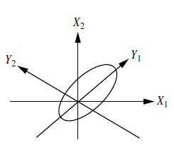
Figure 2-1 Principal components analysis. Y1 and Y2 are the first two principal components for the given data, Source: Data Mining Concepts and Techniques p [80], Jiawei Han University of Illinois at Urbana-Champaign, Micheline Kamber
This PCA is equally better at maintaining sparse data and can be deployed to order and unordered attributes especially for the multidimensional data by decreasing the problem of two dimensions (Boersma, 2012).

- Numerosity reduction, here the data is replaced or estimated by alternative, smaller data representations such as parametric models (which need to store the model parameters instead of the actual data) or nonparametric methods such as clustering, sampling, and the use of histograms.

- Discretization and concept hierarchy generation, where raw data values for attributes are replaced by ranges or higher conceptual levels. Data discretization is a form of numerosity reduction that is very useful for the automatic generation of concept hierarchies. Discretization and concept hierarchy generation are powerful tools for data mining, in that they allow the mining of data at multiple levels of abstraction.

Summering, Principal component analysis aims to (Jolliffe, 2002)

- Data with many independent variables to a smaller set of derived variables.
- In such a way, that first component has maximum variance, followed by second, followed by third and so on.
- The covariance of any of the component with any component is zero.

Now, let us see the process of Computation of Principal Components. Here, input data is in the form of M dimensional data that is not separable.

 | $\overline{x}$ =(x₁ x₂ x₃ x₄……………. x_{m0} ………………………. x_{m0+1}..x_{m} ) | Equation 2-1
Let us suppose, x is the m dimensional input vector and for the dimensionality reduction need to discard data other than x_{m0}. And we need to reduce data other then x_{m0} and we could do that by eliminating x_{m0+1} (Jolliffe, 2002).

Therefore, if we take out those data without taking consideration of the mathematical ways of PCA, then we could introduce Mean Square Error.

MSE= sum of the variances of the elements are of small quantity.

To systematically introduce the procedure to chop the data, we have to follow the following process,

For that, let us say, $\overline{x}$ is m- dimensional vector and $\overline{T}$ is m by m matrix therefore,

If we multiplies m-dimensional vector to m-by-m matrix the output will be new vector as below:
 | $\overline{x}$ $\overline{T}$ = ${\overline{X}}_{new}$ | Equation 2-2

If we consider, Equation 2-1, then the new ${\overline{X}}_{new}$ vector contains

 | $\overline{x}$ =(x₁ x₂ x₃ x₄……………. x_{m0} ………………………. x_{m0+1}..x_{m} ) | Equation 2-3
So, now we have to cleverly design $\overline{T}$ (transformation design). This transformation design is crucial in several other fields as orthogonal transform like fodia transform, cosiac transform and all those give the above t transform in some form and transform space to it then we could wipe all other points beside x_{m0} of equation 2-1 with very low MSE with very low variances. (Jolliffe, 2002)

Therefore, now we will be designing the $\overline{T}$ to chop the data having very low variance.

Let us consider,
$\overline{x}$ = m-dimensional random vector

So,

 | E [$\overline{x}$] = 0 | Equation 2-4
Here, we are assuming expectation of $\overline{x}$ is zero. Practically, we usually found the positive elements of the $\overline{x}$ , in such cases we simply subtract the mean of the individual element that result to the zero mean random vector.

So,

$\overline{q}$ = m-dimensional unit vector

As $\overline{q}$ is unit vector, therefore, Euclidean norm of unit vector is 1 so,

$\left\|\left.\overline{q}\right\|\right.$= 1

Now, if we do Projection of $\overline{x}$ onto $\overline{q}$ like in the following figures,

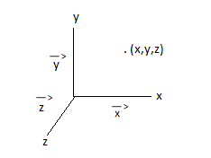
Figure 2-2 Projection of q ̅ to x ̅ (Jolliffe, 2002)

Then, A = $\overline{x}$ ^{T}$\overline{q}$ = $\overline{q}$^{T}$\overline{x}$ that can subject to

 | $\left\|\left.\overline{q}\right\|\right.$ = ($\overline{q^{T}} *$ $\overline{ q}$ ) ^{½ =} 1 | Equation 2-5

The Equation 2-6 is the constant in the vector.

Now based on A = $\overline{x}$ ^{T}$\overline{q}$ = $\overline{q}$^{T}$\overline{x}$ , the expectation of A, E[A] = $\overline{q}$^{T} E[$\overline{x}$] = 0

The variance of the quantity is represented by,

δ² = E[A²] = E[($\overline{q}$^{T} $\overline{x}$ ) ($\overline{x}$ ^{T}$\overline{q}$)]
= $\overline{q}$^{T} E[$\overline{x}$ $\overline{x}$ ^{T}] $\overline{q}$
= $\overline{q}$^{T} $\overline{R}$ $\overline{q}$

Where $\overline{R}$ is the correlation matrix given by $\overline{R}$ = E[$\overline{x}$ $\overline{x}$ ^{T}]
Also, $\overline{R}$ = $\overline{R}$ ^{T}

From the above property, $\overline{a}$ ^{T} $\overline{R}$ $\overline{b}$ = $\overline{b}$ ^{T} $\overline{R}$ $\overline{a}$

If we use q vector to search then we could find the minimum variance. For this we have to find following,

 | δ² = $φ$($\overline{q}$) = $\overline{q}$^{T} $\overline{R}$ $\overline{q}$ | Equation 2-7

Where, $φ$($\overline{q}$): variance probe

For minimal value of the variances,

 | $φ$($\overline{q}$ + δ$\overline{q}$ ) = $φ$($\overline{q}$) | Equation 2-8

$\overline{q}$ is the minimal vector reaches minimum point, then the vector can wipe out easily without any effect and it is like the least point of the U (Jolliffe, 2002). So, from the definition of the probe variation we could say:

$φ$($\overline{q}$ + δ$\overline{q}$ ) = ($\overline{q}$ + δ$\overline{q}$ )^{T} $\overline{R}$($\overline{q}$ + δ$\overline{q}$ )
= $\overline{q}$^{T} $\overline{R}$ $\overline{q}$ +2 (δ$\overline{q})$^{T} $\overline{R}$ $\overline{q}$ + (δ$\overline{q})$^{T}$\overline{R}$ (δ$\overline{q}$
For extremal value of the variances,

 | $φ$($\overline{q}$ + δ$\overline{q}$ ) = $φ$($\overline{q}$) | Equation 2-9

Where, $\overline{q}$ is the minimal vector reaches minimum point, then the vector can wipe out easily without any effect and it is like the least point of the U. So, again from the definition of the probe variation we could say:

 | $φ$($\overline{q}$ + δ$\overline{q}$ ) = ($\overline{q}$ + δ$\overline{q}$ )^{T} $\overline{R}$($\overline{q}$ + δ$\overline{q}$ ) | Equation 2-10

For the extremal points, comparing equation 2-9 and equation 2-10 we could do (δ$\overline{q})$^{T}$\overline{R}$ (δ$\overline{q}$) = 0
= $\overline{q}$^{T} $\overline{R}$ $\overline{q}$ +2 (δ$\overline{q})$^{T} $\overline{R}$ $\overline{q}$ + (δ$\overline{q})$^{T}$\overline{R}$ (δ$\overline{q}$)
= $\overline{q}$^{T} $\overline{R}$ $\overline{q}$ +2 (δ$\overline{q})$^{T} $\overline{R}$ $\overline{q}$ + (δ$\overline{q})$^{T}$\overline{R}$ (δ$\overline{q}$)

So, final equation is following,

$φ$($\overline{q}$ + δ$\overline{q}$ ) = 2 (δ$\overline{q})$^{T} $\overline{R}$ $\overline{q}$ = 0

 | (δ$\overline{q})$^{T} $\overline{R}$ $\overline{q}$ = 0 | Equation 2-11

The above equation is O because, $\overline{q}$ is unit vector, and from equation 2-12 and equation 2-13 computation.

In the meantime, according to Euclidian norm of $\overline{q}$ and δ$\overline{q}$is 1, which is represented as

$\left\|\overline{q} + \left.δ\overline{q}\right\|\right.$ ² = 1

Or equivalently,

($\overline{q}$ + δ$\overline{q}$ ) ^{T}($\overline{q}$ + δ$\overline{q}$ ) = 1
$\overline{q}$^{T}$\overline{q}$ + 2 (δ$\overline{q}$)^{T}$\overline{q}$ + (δ$\overline{q})$^{T} δ$\overline{q}$ = 1

So, based on our above calculation, we could say,

$\overline{q}$^{T}$\overline{q}$ = 1 and (δ$\overline{q})$^{T} δ$\overline{q}$ = 0

So,

 | (δ$\overline{q}$)^{T}$\overline{q}$ = 0 | Equation 2-14

Based on the equation 2-13 and equation 2-14, we could say, (δ$\overline{q}$) and $\overline{q}$ are the orthogonal therefore, only the change in the direction on them are permitted.

If we analyze the equation 2-13 and equation 2-14, we see, (δ$\overline{q}$) and $\overline{q}$ as Unit vector (dimensional vector) in equation 2-14, in contrast, we have $\overline{R}$in Equation 2-13 that is m-dimensional vector. So, if we combine them, we could introduce some scalar quantity $Λ$ with same dimension as$\overline{R}$ (Jolliffe, 2002). So,

(δ$\overline{q})$^{T} $\overline{R}$ $\overline{q}$ = $Λ$((δ$\overline{q})$^{T} $\overline{q}$ = 0

(δ$\overline{q})$^{T} [ $\overline{R}$ $\overline{q}$ – $Λ$ $\overline{q}$] = 0 so, here based on the extremal condition above $\overline{R}$ $\overline{q}$ = $Λ$ $\overline{q}$, Then

 | $\overline{R}$ $\overline{q}$ = $Λ$ $\overline{q}$ | Equation 2-15
Here in the equation 2-15, scalar $Λ$ is Eigen value of Matrix $\overline{R}$ therefore,

 | $Λ_{1}$, $Λ_{2}$, $Λ_{3}$, $Λ_{4}$, $Λ_{n}$ | Eigen Values
 | ${\overline{q} }_{1}$,${\overline{q} }_{2}$,${\overline{q} }_{3}$,${\overline{q} }_{4}$,${\overline{q} }_{n}$ | Eigen Vectors

These above are the Eigen components of $\overline{R}$ correlation matrix. Given that, so if we compute like following

 | $\overline{R}$ $\overline{q}$_{j} = $Λ$_{j} $\overline{q}$_{j} j = 1,2,3……..n | Equation 2-14

Accordingly, $Λ_{1}$> $Λ_{2}$ > ………. > $Λ_{j}$ > ……………………..> $Λ_{n}$

$Λ_{1}$ = $Λ_{max}$

Now, let us define a matrix composed of following,

$\overline{Q}$ = [${\overline{q} }_{1}$,${\overline{q} }_{2}$,${\overline{q} }_{3}$,${\overline{q} }_{4}………………………$,${\overline{q} }_{n}$ ]

If we write equation 2-14 in combine way with above one, we get

 | $\overline{R}\overline{Q}$ = $\overline{Q}$ $\overline{Δ}$ | Equation 2-15
Where

$\overline{Δ}$ = diagonal[ $Λ_{1}$, $Λ_{2}$, $Λ_{3}$, $Λ_{4}$, $Λ_{n}$ ]

$\overline{Q}$ = orthogonal matrix satisfying orthogonal property where,

${\overline{q} }_{i}$ ${\overline{q} }_{j}$ = $\left\{\begin{aligned}1 \\ 0 \end{aligned}\right.$ and $\overline{Q} \overline{Q}$^{T} = $\overline{I}$ (an identity matrix)

From the above we deduce that, $\overline{Q}$^{T} = $\overline{Q}$⁻¹

Using equation 2-15 by
 | $\overline{Q}$^{T}$\overline{R}\overline{Q}$ = $\overline{Δ}$ | Equation 2-16

In expanded form,
$\overline{q}$^{T}_{J} $\overline{R}$ $\overline{q}$_{k} = $\left\{\begin{aligned}Λ_{j} \\ 0\end{aligned}\right.$ k= j, k $≠$j

Then,
 | $\overline{R}$ = $\sum_{i=1}^{m}{Λ_{1}{\overline{q} }_{i}\overline{q} }$^{T}_{i} | Equation 2-17

So, using equation 2-7
 | $φ$ (q_{i}) = $Λ_{j}$ | Equation 2-18

Here in equation 2-18, $Λ_{j}$ is the Eigan value of the correlation matrix that represents the Principal Component Analysis (Jolliffe, 2002).

What to be taken out using PCA?
Summering the above computation, if we consider, equation 2-1, and then the new ${\overline{X}}_{new}$ vector contains

 | $\overline{x}$ =(x₁ x₂ x₃ x₄……………. x_{m0} ………………………. x_{m0+1}..x_{m} ) | Equation 2-19
So, now we have to cleverly design $\overline{T}$ (transformation design) and all those gives the above t transform in some form and transform space to it then we could wipe all other points beside x_{m0} of equation 2-1 with very low MSE with very low variances. (Jolliffe, 2002)

Therefore, now we will be designing and implementing the $\overline{T}$ to chop the data having very low variance in chapter 5. The further description of the same can be found in the chapter 5 with several data sets.

The above described is the detailed overview of the PCA. The further explanation and practical implementation can be found in chapter 4 and chapter 5 along with several recommendations and findings.

Data Cleaning Techniques

After the detailed computation of PCA, the author is now going to focus on the most common data reduction techniques in the field of data analysis. Basically, data cleaning also known as the data cleansing, is the process where valid data is separated. In practice, the extracted data from the database are not consistent. Those data can be faulty due to several reasons but most common can be application error, human error or any other transmission error (Ian H. Witten). Common aspects of data cleaning transformations include the following:
- Incomplete data: Those data that lack the attribute or column values. (Levine, 1997) That can be due to application, data not entered due to misunderstanding, not important data etc. for example latitude=””

The user can handle missing data by following ways:
- If the values are consistent and the class label is missing then the user can ignore the tupple.
- The user can fill the missing value manually as per the table data.
- The user can define the global constant and put in all missing data
- The user can also take the mean of the column and put as replacement of missing data.
- The user take the inference based probable value using Bayesian formula or decision tree.

- Noisy data: These types of data contain outliers, noise, random errors, duplicate record, incomplete data etc (Michael R. Berthold). Some information from noise data could be useful. The example of the noisy data can be, longitude=-390.
The Noisy data can be handled by using following ways
- Binning: In this approach, the user first off all, sort data and partition the attribute into equal-frequency bins after that the mean of each bin is taken, then the bin mean median and bin boundaries (Ian H. Witten). By this approach the missing value can be systematically replaced with the new one.

Several discretization techniques are often called 'binning' and they are:

– Equal Width
– Equal Depth
– Class Dependent
– Entropy

Equal Width:
Firstly, in this process of the equal width, the user needs to take the data and divide by the number of bins to create. For example latitude values between 64 and 85 in the sample data set. 85 - 64 = 21. Create 7 bins, each of which is between x and x+3 as in following figure:

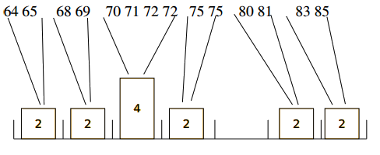
Figure 2-2 bins presentation for sample data of Equal width
However, this may produce bad results when there are many occurrences of 1 range, and very few of the other ranges (Michael R. Berthold). For example, salaries in a big corporation may range from 10k to 500k per year. But most will be right at the bottom of any such scale. This would likely be useless for most data mining tasks. Instead, the user can use equal depth binning, such that the number of instances in each bin is the same and the ranges covered are different. This is also called 'equal height', 'equal frequency' and 'histogram binning'.
Equal depth Binning:
For this technique the user can create separate bin based on the nature and type of value like in the following figure and should not merge in the other bin and breakpoints of the bin should be integers and readable. (Michael R. Berthold)
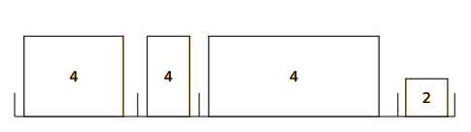
Figure 2-3 Data presentation of Equal depth Binning

Class Dependent
For this technique the user can use the class value to determine where to set the break points. For example, a minimum of 3 values of any one class per bucket, and break as soon as a new class is found (Michael R. Berthold).

For example, taking consideration of our sample data,

64 65 68 69 70 | 71 72 72 75 75 | 80 81 83 85
Yes No Yes Yes Yes | No No Yes Yes Yes | No Yes Yes No
So, the breakpoints are 64­70, 71­75 and 80­85 (Michael R. Berthold).
The author has implemented all these three techniques in the Data Reduction Application and the several tests were conducted on the data analysis software like SPSS, Weka, RapidMiner, Knime, R and Matlab along with the Data Reduction Application. Consequently, the user can find the detail information of the data cleaning in the R, Matlab and Data Reduction Application.

Advantages of Using PCA and Data Cleaning

In above sections the user saw the computation of the data reduction techniques for the GPS data for Urban Mobility Analysis. Now, the user can find the advantages of using the PCA and data cleaning techniques.
The main advantages of principal component analysis are:
- The robustness of the least squares approach to approximate the covariance or correlation matrix. (M S Swaminathan Research Foundation, 1988)
- The data is not compulsion to be in multivariate normal, however, sometimes significance testing is necessary.
- The user can see the contribution made by the attributes to each component present in the dataset.
- In PCA, the first principal component accounts for as much of the variability in the data as possible, and each successive orthogonal component accounts for as much of the residual variability as possible. (Bugli, 2008)
Similarly, the advantages of data cleaning are:
- Remove all the duplicate records and to identify abnormal data records that must be removed manually.
- It can remove invalid records and leave only valid data to be used for analysis and decisions.
- Maintains the user databases to clean unnecessary data that will definitely contribute to the success of user’s studies. Eventually, enhances and reinforces the credibility of user research by standardizing the data in your database.

Outlier Discovery

Till now, the author illustrated all the available feasible data reduction techniques for the GPS data for the Urban Mobility Analysis. But, most importantly, after those techniques have been applied, the user needs to find out the proper way to spot and reduce the data. Therefore, the author has implemented the Outlier Discovery to find all those negligible data with less information in the datasets of the Urban Mobility Analysis.
Basically, Outlier is a topic of concern in clustering. As, there might be some crucial knowledge in outliers and some may be just rubbish. Therefore, user needs to consider outlier also. In reality, the set of objects are considerably dissimilar from the remainder of the data are outliers (McDonald, 2009).
Some of the things that user can extract from outliers are Credit card fraud detection, Telecom fraud detection, Customer segmentation, Medical analysis and so forth (Pei, 2009).
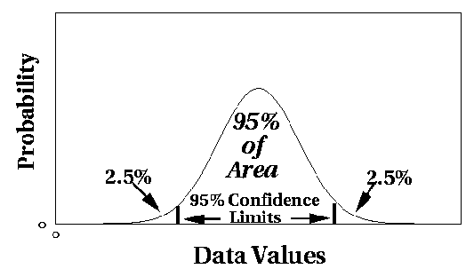
Figure 2-4 In the normal distribution graph above between probability and data values, user can assume a model underlying distribution that generates data set (EMILY NAMEY, 2001).
To find out outliers the user can do
- data distribution
- distribution parameter (e.g., mean, variance)
- number of expected outliers
The drawbacks of the above process to find outliers are
- Most tests are for single attribute
- In many cases, data distribution may not be known

As due to the drawback in the statically approach to find outliers user need multi-dimensional analysis without knowing data distribution. Therefore, following points needs to be taken into account (Pei, 2009).
- Distance-based outlier: Let us say, an object in a dataset where a fraction of the objects lies at a distance greater from. For that the following algorithms for mining distance-based outliers are applied.
- Index-based algorithm
- Nested-loop algorithm
- Cell-based algorithm

- Combined computer and human inspection: In this approach the user can predict a value depending on the nature and type of data store on the particular table.
- Inconsistent: In the database, after extraction, the user can find data that are not consistent to each other. That means in one table a column is number and in another table the same column is varchar.
- Intentional: Sometime the extracted data can be intentional mistakes like inserting wrong value on the different field.
- Merging data from different data sources
- NULL value handling – conversion to a default value
- Data Type conversion – to synchronize data from different systems, i.e. the taxiid in one system may be an integer but another system may store the integer as a character data type.
- Splitting of source files into multiple staging files that can be used to drive multiple target table loads.
- Inclusion of metadata to help describe the data in the Data Warehouse such as source system identifiers, end date etc.
After the Outliers have been discovered, those will be reduced from the datasets. Then the user needs to be more focused on the validating that result. Basically, our objective as in chapter 1 was to reduce the GPS data of Urban Mobility analysis without much information loss. Therefore, to validate that information loss - author has illustrated the polynomial regression algorithm below.

Polynomial Regression

Usually, when the user analyze data with correlation and linear regression, then the user may notice that the relationship between the independent (X) variable and dependent (Y) variable looks like it follows a curved line, not a straight line. In that case, the linear regression line will not be very good for describing and predicting the relationship, and the P-value may not be an accurate test of the hypothesis that the variables are not associated.
The first choice when the user faced with a curved relationship between two measurement variables should be to try data transformations on one or both of the variables. Often, this will straighten out a simple J-shaped curve. If that does not work, the user can try curvilinear regression, in which a more complicated equation than the linear regression equation is fit to the data. Equations with a variety of terms will produce curved lines, including exponential (involving bX, where b is a constant), power (involving Xb), logarithmic (involving log(X)), and trigonometric (involving sine, cosine, or other trigonometric functions). For any particular form of equation involving such terms, it is possible to find the equation for the curved line that best fits the data points, and to compare the fit of the more complicated equation to that of a simpler equation (such as the equation for a straight line).
The regression model y = ᵝ₀ + ᵝ₁x + ᵝ₂x² + ԑ is called a second-order model or a quadratic model in one variable. The expected value of y is a parabola in x. Here, ᵝ₀ can still be interpreted as the y-intercept of the parabola. ᵝ₁ is called the linear effect parameter and ᵝ₂ is called the quadratic effect parameter. The regression model

y =ᵝ₀ + ᵝ₁x + ᵝ₂x² +…. +ᵝ_{k}x^{k} + ԑ is called a k-th order polynomial model in one variable.

Algorithms and Computation
To compute - the user can do following,
Let us suppose, the N data point,
Given (X₁,Y₁), ……………….,(X_{N},Y_{N})
Now, let us best bit the N data points,
Y= a₀+a₁x+…….+a_{m}x^{m}
Where, M ≤ n-1 , because to fit the polynomial.
So if we plot the n data points in the graph the figure would be,
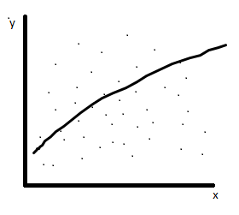
Figure 2-5 In the above figure, all the dots are the n number of data points, Xaxis is for X and Yaxis is for the Y of the above equation.
So, to compute the polynomial regression of this, we need to do the following,
As we know the sum of the square of the residuals. The sum of the square of the residuals means that the difference between observed value and predicted value.
$$Sr=\sum_{i=0}^{n}{(Yi – (a0+a1x+…….+amxm))2}$$
Where Y_{i} = observed value
a₀+a₁x+…….+a_{m}x^{m} = predicted value
Expanding the above equation,
$$Sr=\sum_{i=0}^{n}{(Yᵢ – a0-a1xᵢ-……-amxm2)2}$$
Now making all the numbers as smallest as possible, so we need to change a₀, a₁, a_{m}. So taking the derivatives of each of them, we get following:
δSr / δa₀ = 0; δSr / δa₁ = 0; δSr / δa_{m} = 0;
Setting up the above,
δSr / δa₀= $\sum_{i=0}^{n}{m(Yᵢ – aₒ-a₁xᵢ-……-amxm²)}$ (-m) = 0
δSr / δa₁= $\sum_{i=0}^{n}{m(Yᵢ – aₒ-a₁xᵢ-……-amxm²)}$ (-x_{ᵢ}) = 0
δSr / δa_{m}= $\sum_{i=0}^{n}{m(Yᵢ – aₒ-a₁xᵢ-……-amxm²)}$ (-x_{ᵢ} ²) = 0
To set up in the equation form we need to expand the above form,
 | δSr / δa₀= $-2\sum_{i=0}^{n}{Yᵢ+2aₒ \sum_{i=0}^{n}{ 1+2a₁ \sum_{i=0}^{n}{Xᵢ+}…+}2}am \sum_{i=0}^{n}{Xᵢ²}$ = 0 | Equation 2-20

 | δSr / δa₁= $-2\sum_{i=1}^{n}{XᵢYᵢ+2aₒ \sum_{i=0}^{n}{ Xᵢ+2a^{1}\sum_{i=1}^{n}{Xᵢ^{2}+ }…+}2}am \sum_{i=1}^{n}{Xᵢ³}$ = 0 | Equation 2-21

 | δSr / δa₂= $-2\sum_{i=1}^{n}{Xᵢ²Yᵢ+2aₒ \sum_{i=1}^{n}{ Xᵢ²+2a^{1}\sum_{i=1}^{n}{Xᵢ^{2}+ }…+}2}am \sum_{i=1}^{n}{Xᵢ⁴}$ = 0 | Equation 2-34

Here in the above equation, the middle portion could be solved based on the known data and predicted data and dividing both side by 2, therefore the resulting equation will be,
naₒ + $a₁\sum_{i=1}^{n}{Xᵢ+a2 \sum_{i=0}^{n}{ Xᵢ+am \sum_{i=1}^{n}{Xᵢ² }=}}\sum_{i=1}^{n}{Yᵢ}$
aₒ$\sum_{i=1}^{n}{Xᵢ+a1 \sum_{i=0}^{n}{ Xᵢ²+am \sum_{i=1}^{n}{Xᵢ³ }=}}\sum_{i=1}^{n}{XᵢYᵢ}$
aₒ$\sum_{i=1}^{n}{Xᵢ²+a1 \sum_{i=0}^{n}{ Xᵢ³+am \sum_{i=1}^{n}{Xᵢͫ }=}}\sum_{i=1}^{n}{XᵢYᵢ}$
As they are simultaneously linear equation, and these equation can be written in matrix form that is written as:
$\left|\begin{matrix}n & \sum_{i=1}^{n}{xᵢ} & \sum_{i=1}^{n}{xᵢ}² \\ \sum_{i=1}^{n}{xᵢ} & \sum_{i=1}^{n}{xᵢ}² & \sum_{i=1}^{n}{xᵢ}³ \\ \sum{xᵢ²} & \sum_{i=1}^{n}{xᵢ}³ & \sum_{i=1}^{n}{xᵢ}⁴\end{matrix} \right|$ $\left|\begin{matrix}ḁ \\ a₁ \\ a₂\end{matrix} \right|$ = $\left|\begin{matrix}\sum_{i=1}^{n}{yᵢ} \\ \sum_{i=1}^{n}{xᵢ}yᵢ \\ \sum_{i=1}^{n}{xᵢ}²Yᵢ\end{matrix} \right|$ | Equation 2-22
In the above equation 2-32, the matrix form a₀, a₁, a₂ are unknown quantities and left hand side is known quantities along with the right hand side first square. So, we can use any method like Gauss-Seibel, LU decomposition method to calculate a₀, a₁, a₂
We should be very careful while doing polynomial regression specially fourth or fifth order regression due to its nature of well conditioned or not. So, our regression model for the polynomial regression is
Y = a₀ + a₁ x + a₂X²
The above is the equation for the polynomial regression. The user can see the implementation of the above equation in the verification of the result obtained from the data reduction for urban mobility analysis in chapter 5 and chapter 6 consecutively.
Accordingly, here the aurhor has compared the following techniques to find the superior data reduction techniques with the different clustering methods. Therefore, the user can find the following techniques in the result comparision section of Chapter 4, Chapter 5, and Chapter 6. The brief introductions of all those clustering techniques are as follows:
K-Means:
Here in this method, a partition on the database of n objects can be done taking “k” into consideration for partitions/Cluster. The cluster similarity is calculated with the mean value of the object in a cluster that can be calculated by cluster centroid or center of gravity. (M. Ester, 1995)
E= | Equation 2-23
Construct a partition of a database D of n objects into a set of k clusters, s...t., min sum of squared distance.
Here, k is less than or equal to n that summarize (Fisher, 1987)
1. Each group must contain atleast one object and
2. Each object must belong to one group.
The process of the K-means algorithm is divided into four steps: (D. Gibson, 1998)
  - Partition objects into k nonempty subsets
  - Compute seed points as the centroids of the clusters of the current partition (the centroid is the center, for example, mean point, of the cluster)
  - Assign each object to the cluster with the nearest seed point
  - Go back to Step 2, stop when no more new assignment
Hierarchical methods:
This method is based on the hierarchical arrangement of the datasets. This can be classified into:
Agglomerative or bottom-up: This method suggests to start with each object forming a separate group with successively merges the objects or groups that are close to one another till all the groups are combined into one until certain termination criteria are satisfied. (D. Gibson J. K., 1998)
Divisive approach or top-down: This method suggests segregating a cluster into smaller clusters until each object is in one cluster until certain termination criteria are satisfied. (D. Gibson J. K., 1998)

Figure 2-6 diagram of AGNES (Agglomerative NESting) and DIANA (Divisive ANAlysis)

In the above diagram of AGNES (Agglomerative Nesting) and DIANA (Divisive Analysis), five objects are taken {a,b,c,d,e}. Initially, AGNES places each object into a cluster of its own. (D. Gibson J. K., 1998) The clusters are then merged step-by-step according to some criteria. Here, object a and b are merged in step 1 resulting d and e in step 2 that leads to compile c and forming CDE in step 3 and all object in one at step 4 during AGNES process. In contrast, DIANA works in opposite direction to AGNES. The same above figure can be seen below
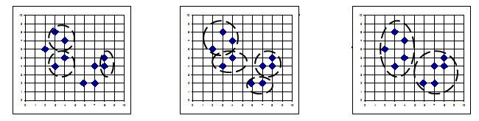
Figure 2-7 Process of Agnes
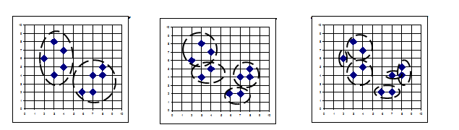
Figure 2-8 Process of DIANA
Density based methods:
This method suggests that the cluster object is based on the distance between objects. These methods can find only spherical-shaped clusters and encounter difficulty at finding clusters of arbitrary shapes. (S. Guha, March 1999. ) Typically, in the given cluster as long as the density for watch data point within a given cluster the neighborhood object of a given radius has to contain at least minimum number of points. These methods can be used to separate the noise and find our arbitrary shape.
DBSCAN
This is the acronym of Density-based spatial clustering of application with Noise. (Dubes., 1988.) This algorithm is based on the density of the given objects to find the clusters of the arbitrary shape in spatial databases with noise.
The common idea of the DBSCAN can be illustrated as below: (Dubes., 1988.)
- The E-neighborhood of the object is a neighborhood radius E of a given object.
- If the E-neighborhood of an object contains at least a minimum number (MinPts) of objects then the object is known as a core object.
- In a given set of objects, D, an object can be directly density-reachable from object q if p is in the E-neighborhood of q and q is a core object.
- Let’s say object p is density-reachable to object q compare to E and MinPts in a set of objects, D, if there is chain of objects like p₁=q and p_{n}=p like pi+1 is directly density-reachable from p_{i} with respect to E.
- Let’s say, object p is density-connected to object q with respect to E and MinPts in a set of objects, D, if there is an object 0 D such that both p and q are density-reachable from o in compare to E and MinPts.

Process of the DBSCAN
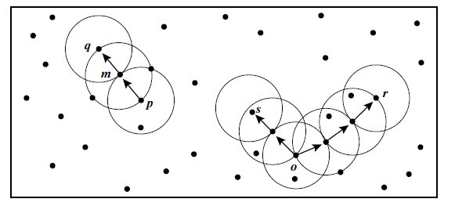
Figure 2-9 Process of DBSCAN Clustering
Here in the above figure, DBSCAN seeks for clusters by fetching the E-neighborhood of each point in the database. (Dubes., 1988.) The E-neighborhood of a point p has more than MinPts, let us say new cluster with p as an object. DBSCAN then continuously collects directly density-reachable objects from these core objects that start to combine of a few density-reachable clusters. This process continues until no new points are found to add.
Expectation-Maximization Algorithm:
This is also known an EM algorithm, used for solving parameter estimation problems. It can be used as in extension of the K-means algorithm that assigns an object to the cluster is pretty similar to the cluster mean. Here, it assigns each cluster as per the weight signifying the probability of membership. (L. Parsons, 2004)
This algorithm starts with estimation of the parameters of the mixture models. That iteratively associates the object to the collection density created by the parameter vector. (Schikuta.) That objects are used to update the parameter estimates. The detailed process can be describes as: (L. Parsons, 2004)
1. Estimate the parameter vector. Let’s say k objects.
2. Refine the estimated parameters using two steps like:
a) Assign each object x_{i} to cluster C_{k} with the probability
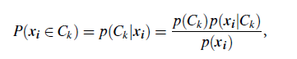 | Equation 2-24
In the formula above, it computes the probability of the cluster membership of object x_{i} for individual clusters.
b) The probability from above is being used to re-estimates the model parameter by following formula.
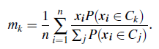 |  | Equation 2-25
The user can find the basic flow below:

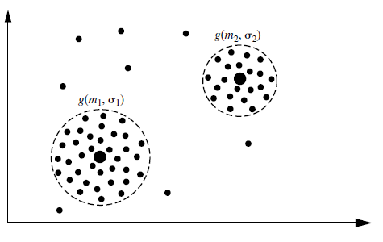
Figure 2-10 Process of the algorithms
In the figure above, each cluster shows the probability distribution, a mean, and standard deviation on the two clusters as g(m1, 1) and g(m2, 2), respectively and the dashed circles represent the first standard deviation of the distributions.

That shows the simplicity and easiness on implementing this algorithm in practice in Chapter 4 and Chapter 5.

Chapter 3

Experiments using R and Matlab

In chapter 2, the author discussed different techniques identified for the effective data reduction for the GPS data for the urban mobility analysis. In this chapter the author further elaborated to testify the above mentioned techniques into practice. Basically to verify all those techniques several methods like Pre-evaluation, Evaluation, Post-Evaluation, Validation, and Measures of quality and Probability plot are taken into consideration.
All this above identified techniques have been tested with more than 1000 datasets of GPS traces for the Urban Mobility analysis. The user can find all the details below.

Evaluation Preparation

At first, to understand the real success of the project, the project was evaluated with a set of experiments. The whole evaluation process can be divided into three distinct phases namely pre-evaluation, evaluation and post-evaluation. The following figure demonstrates the process:

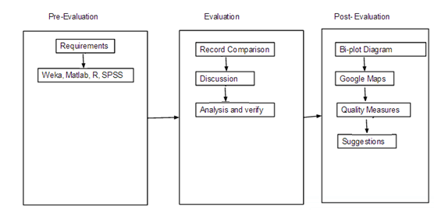
Figure 3-1 Evaluation Process

Pre-evaluation

As mentioned above, the “Data Reduction” application was developed based on the solution to the problem statement illustrated in chapter 1 then the pre-evaluation process was carried out. It dealt with the search for the appropriate software that is professionally used in the market. Those selected softwares were Weka, SPSS, Knime, Weka, Rapid Miner, xlstd, Matlab, and R and the reasons for selecting these applications are to test the data reduction techniques and to find the appropriate solution before commencing the software development process. Following that, different experiments were selected to gather results from various ways and to determine the acceptance and applicability of the product in the data analysis field. For that more than 1000 datasets were tested using the different experiments.
Those experiments were conducted on several products, the output of R and matlab are found to be similar. And other tools like Weka, SPSS, Knime, Xlstd also have the similar result. The table below describes the total number of files tested in these experiments.
Description | No. of files
Matlab | 1005
R | 1005
SPSS | 1005
Knime | 1005
Weka | 1005

Table 3-1 Datasets used for the pre-evaluation
The above table 3-1 has list of files used for this experiment. Those files description are as follows:
T-Drive Taxi Trajectories:
This contains the GPS trajectories of 10,357 taxis during the period of February 2 2008 to February 8, 2008 within Beijing, China (Zheng, User Guide of T-Drive Data, August 16, 2011) with total number of around 15 millions points in this dataset and the total distance of the trajectories reaches to 9 million kilometers. The average sampling interval is about 177 seconds with a distance of about 623 meters. (Zheng, User Guide of T-Drive Data, August 16, 2011) Each file of this dataset, which is named by the taxi ID, contains the trajectories of different taxi.
The above illustrated datasets is experimented and verified for the information loss using three different data patterns. They are:
- With time
- Without time and location
- Segregating time and combining location(Latitude, Longitude)
DataSet 1 - With time:
Taxi Number | Dateandtime | Longitude | Latitude
8717 | 2/2/2008 13:30 | 116.3947 | 39.84351
8717 | 2/2/2008 13:30 | 116.3944 | 39.84353
8717 | 2/2/2008 13:30 | 116.3944 | 39.84353
8717 | 2/2/2008 13:31 | 116.3945 | 39.84386
8717 | 2/2/2008 13:31 | 116.3946 | 39.84423
8717 | 2/2/2008 13:31 | 116.3945 | 39.84501
8717 | 2/2/2008 13:31 | 116.3945 | 39.84555
8717 | 2/2/2008 13:31 | 116.3945 | 39.8467

Table 3-2 T-Drive Trajectories dataset example
Here, in the above tables, first column specifies the Taxi Number, second column for Dateandtime, third for the Longitude and fourth for the Latitude respectively of the T-drive taxi trajectories.
DataSet 2 - Without minutes
Taxi Number | Year | Time | Latitude | Longitude | Location
7146 | 2/2/2008 | 13 | 116.3294 | 39.9751 | 116.32939 , 39.9751
8179 | 2/2/2008 | 13 | 116.3057 | 40.03564 | 116.30572 , 40.03564
8662 | 2/2/2008 | 13 | 116.32 | 39.89004 | 116.31995 , 39.89004
9109 | 2/2/2008 | 13 | 116.3541 | 39.86716 | 116.35408 , 39.86716
9754 | 2/2/2008 | 17 | 116.682 | 39.82631 | 116.68201 , 39.82631
366 | 2/2/2008 | 13 | 116.4535 | 39.90732 | 116.45353 , 39.90732
1131 | 2/2/2008 | 13 | 116.458 | 39.86973 | 116.45804 , 39.86973
1277 | 2/2/2008 | 13 | 116.3141 | 39.89454 | 116.31412 , 39.89454
2237 | 2/2/2008 | 13 | 116.3037 | 39.97505 | 116.30368 , 39.97505
2560 | 2/2/2008 | 13 | 116.4716 | 39.89802 | 116.47157 , 39.89802
2669 | 2/2/2008 | 13 | 116.4508 | 39.98665 | 116.4508 , 39.98665
3015 | 2/2/2008 | 13 | 116.4101 | 39.89176 | 116.41009 , 39.89176
3557 | 2/2/2008 | 20 | 116.1682 | 39.94461 | 116.16817 , 39.94461
3579 | 2/2/2008 | 13 | 116.4005 | 39.90341 | 116.40049 , 39.90341
3781 | 2/2/2008 | 15 | 116.3705 | 39.9604 | 116.37053 , 39.9604
4798 | 2/2/2008 | 13 | 116.3503 | 39.89919 | 116.35029 , 39.89919
5075 | 2/2/2008 | 13 | 116.2935 | 39.98698 | 116.29346 , 39.98698
5099 | 2/2/2008 | 13 | 116.3026 | 39.94262 | 116.30259 , 39.94262

Table 3-3 T-Drive trajectories dataset example without minutes
As per the sampling techniques mentioned in chapter 3, the above datasets sample has been used for the testing experiments in several ways. Here, in the above datasets the user can see the following columns:
- Taxi Number: Number of taxi used in the trajectories
- Year: Year of the sample generation to taxis
- Time: Time of the sample generation in respect to taxis
- Latitude: Latitude of the sample generation in respect to taxis
- Longitude: Longitude of the sample generation in respect to taxis
- Location*: combination of the latitude and longitude.
Note: The * denotes that the column was used only for the verification of the result for the GIS application and several experiments illustrated below. Moreover, this column is the concatenation of the latitude and longitude and used for the verification only.
With the above datasets of more than 3 months data and 10% of the total datasets available for the T-Drive trajectories, results as in chapter 6 have been obtained on Matlab, R and Data Reduction Application.
DataSet 3 - Segregating time and combining location (Latitude, Longitude)
The same datasets as table 3-2, have been modified into the following to test the experiments,
TaxiNumber | Year | Month | Day | Hour | Location
7146 | 2008 | 2 | 2 | 13 | 116.33179, 39.975
8179 | 2008 | 2 | 2 | 13 | 116.33184, 39.97477
8662 | 2008 | 2 | 2 | 13 | 116.33184, 39.9746
9109 | 2008 | 2 | 2 | 13 | 116.33183, 39.97448
9754 | 2008 | 2 | 2 | 13 | 116.33182, 39.97412
366 | 2008 | 2 | 2 | 13 | 116.33187, 39.97391
1131 | 2008 | 2 | 2 | 13 | 116.3321, 39.97216
1277 | 2008 | 2 | 2 | 13 | 116.33213, 39.97183
2237 | 2008 | 2 | 2 | 13 | 116.33218, 39.97139
2560 | 2008 | 2 | 2 | 13 | 116.33223, 39.97101
2669 | 2008 | 2 | 2 | 13 | 116.3323, 39.97068
3015 | 2008 | 2 | 2 | 13 | 116.33241, 39.97028
3557 | 2008 | 2 | 2 | 13 | 116.3325, 39.96994
3579 | 2008 | 2 | 2 | 13 | 116.33253, 39.96976
3781 | 2008 | 2 | 2 | 13 | 116.33255, 39.96971
4798 | 2008 | 2 | 2 | 13 | 116.33254, 39.96965
5075 | 2008 | 2 | 2 | 13 | 116.33251, 39.96966

Table 3-4 Segregating time and combining location (Latitude, Longitude)

Here, in the above datasets the user can see the following columns:
- Taxi Number: Number of taxi used in the trajectories
- Year: Year of the sample generation to taxis
- Month: Time of the sample generation in respect to taxis
- Day: Day of the sample generation in respect to taxis
- Hour: Hour of the sample generation in respect to taxis
- Location: Combination of the latitude and longitude.
Basically, the above datasets table 3-4 is particularly use for the cross validation of the result obtained from several experiments in the chapter 5 under Result section. Eventually, the pickup time in the above data sets is 13 and 14 hours in February 2008 for different taxis. They are calculated by the GIS application as in chapter 5. First, the datasets are passed into the application and the focal points have been examined.

At this instance, the user should be wondering. How was the sampling size chosen?
Therefore, the sample sizes of above datasets have been chosen through following process:
- Defining the Population of Interest:
This project will reduce the datasets stored in the GPS trajectories of 110,357 taxis during the period of February 2 2008 to February 8, 2008 (Zheng, User Guide of T-Drive Data, August 16, 2011).
- Choose Data Collection Method:
Based on the information provided in the GPS data repositories for the GPS trajectories that has the average sampling interval is about 177 seconds with a distance of about 623 meters. (Zheng, User Guide of T-Drive Data, August 16, 2011) Each file of this dataset, which is named by the taxi ID, contains the trajectories of one taxi. So, the author would be using Probability sampling. This was chosen based on the following
- The objectives of the study
- Time limitations
- The nature of the problem statement in Chapter 1.
The probability sampling is calculated by,

Skip Interval = $\frac{Population List Size}{sample size}$

Determine Sample Size
Taking consideration of confidence level of 95%, the sample size was determined based on the average sampling interval is (Zheng, User Guide of T-Drive Data, August 16, 2011) 177 seconds with a distance of about 623 meters, total population size of 10357. The average 9.65% $\sim$ 10 % samples were chosen as in table 3.2. That is equal to 1000 files from the GPS trajectories.
Based on the above sampling techniques, the table 3-2 datasets are used in experiments.

Evaluation
While finding proper solution for the problem illustrated in chapter 1. Several experiments were conducted with PCA and Data cleaning techniques. And the comparison was done based on the result obtained as in table 3-5. Basically the experiment was done with the PCA, Data cleaning techniques on Matlab and R. And the results of Matlab, R and Data Reduction application are shown below.
For the dataset 1 - with time datasets as in table 3-2 - T-Drive Trajectories dataset example. Following is obtained:
Techniques | Description | Before Reduction | After Reduction | Difference |  | %
PCA | 8117.CSV | 9000 | 6840 |  | 2160 | 24
PCA | 7006.CSV | 2642 | 2635 |  | 7 | .2749
PCA | PCA1  PCA2  PCA3 | 2642 | 7 |  | 2635 | 99.723
PCA | PCA1  PCA2  PCA3 | 2642 | 2635 |  | 7 | .2749
PCA | PCA1  PCA2  PCA3 | 2642 | 2641.89 |  | 0.11 | .0045
Data Cleaning | 7006.CSV | 2642 | 2486 |  | 156 | 5.90
Data Cleaning | Empty Rows  Duplicate & Invalid Records | 2642 | 2642 |  | 0 | 0
Data Cleaning | Empty Rows  Duplicate & Invalid Records | 2642 | 2486 |  | 156 | 5.90

(Details of above data can be found in the appendix)
Table 3-5 Result of Data Reduction Using Matlab
In the above figure 3-5, the user can find the result obtained from the testing done on the Matlab for the PCA, Empty rows, duplicate and invalid records. The above result was obtained from the computation done in the Matlab. And the above table shows that the result from the PCA is effective in compare to the data cleaning techniques. Similarly, table 3-6 is the result obtained from the R application.
Techniques | Description | Before Reduction | After Reduction | Difference | (%)
PCA | 8117.csv | 85637 | 78686 | 6861 | 8
PCA | 7006.CSV | 2642 | 2589 | 53 | 2
PCA | PCA1  PCA2  PCA3 | 2642 | 53 | 2589 | 98
PCA | PCA1  PCA2  PCA3 | 2642 | 2589 | 53 | 2
PCA | PCA1  PCA2  PCA3 | 2642 | 2616 | 26 | . 01
Data Cleaning | 7006.CSV | 2642 | 2486 | 156 | 5.90
Data Cleaning | Empty Rows  Duplicate & Invalid Records | 2642 | 2642 | 0 | 0
Data Cleaning | Empty Rows  Duplicate & Invalid Records | 2642 | 2486 | 156 | 5.90
(Details of above data can be found in the appendix)
Table 3-6 Experiment result from the R application
Following that, here in table 3-7, the user can see the result obtained from the data reduction application. In this table the experiment was conducted on all the files that was illustrated in table 3-2, however the summary is only mentioned here. And the result is similar to that of above table 3-5 and table 3-6. That suggests the PCA is the reliable techniques for the data reduction for the GPS data reduction for the urban mobility analysis. Nevertheless, the verification and reasons for choosing the PCA can be found chapter 5.
Techniques | Description | Before Reduction | After Reduction | Difference | (%)
 | 7006.xls | 2642 | 2537 | 105 | 3.965
 | PCA1  PCA2  PCA3 | 2642 | 107 | 2535 | 95.969
 | PCA1  PCA2  PCA3 | 2642 | 2537 | 105 | 3.965
 | PCA1  PCA2  PCA3 | 2642 | 1641.8295 | .1705 | .06455
Data Cleaning | 7006.xls | 2642 | 2486 | 156 | 5.90
Data Cleaning | Empty Rows  Duplicate Records  Invalid Records | 2642 | 2642 | 0 | 0
Data Cleaning | Empty Rows  Duplicate Records  Invalid Records | 2642 | 2488 | 154 | 5.8289
Data Cleaning | Empty Rows  Duplicate Records  Invalid Records | 2642 | 2640 | 2 | .0757

(Details of above data can be found in the appendix)
Table 3-7 Experiment conducted using Data reduction application
Discussions:

In the above table 3-5, table 3-6 and table 3-7, there is variation in the reduced percentage on PCA using Matlab and R. This is due to the number of the rows involved in the datasets. Further details on the same could be found in the chapter 5 under result section. Accordingly, the above table also gives us the statistics of the outliers under the reduced number. The importances of those outliers are:
- The user can find the least variances variable of the datasets.
- The user can get the information of those traces those are away from the center data or principal components.
- In data warehouse, this type of outliers plays a major role in finding the different pattern of GPS traces.
- In case of behavior studies, those outliers tend to compute the distinct behavior of the individuals or periphery.

Following all the experiments illustrated in table 3-4, table 3-5, and table 3-6, now the user can see the comparison of the results obtained from them in table 3-7.

Techniques | Application | Description | Before Reduction | After Reduction | Difference | (%)
PCA | MATLAB | 7006.csv | 2642 | 2635 | 7 | .2749
PCA | MATLAB | 7016.txt | 2643 | 2570 | 73 | 2.67
PCA | MATLAB | 7834.txt | 4003 | 4001.6 | 14 | .0364
PCA | MATLAB | 8018.txt | 2783 | 3992.2 | 9.8 | .3547
PCA | R | 7006.csv | 2642 | 2589 | 53 | 2
PCA | R | 7016.txt | 2643 | 2141 | 502 | 19
PCA | R | 7834.txt | 4003 | 3883 | 720 | 18
PCA | R | 8018.txt | 2783 | 2769 | 14 | 5.90
PCA | Data Reduction  Application | 7006.xls | 2642 | 2537 | 105 | 3.965
PCA | Data Reduction  Application | 7016.xls | 2643 | 2202 | 441 | 16.68
PCA | Data Reduction  Application | 7834.xls | 4003 | 3427 | 576 | 14.38
PCA | Data Reduction  Application | 8018.xls | 2783 | 2495 | 288 | 10.36
Data cleaning | Matlab | 7006.csv | 2642 | 2486 | 156 | 5.90
Data cleaning | Matlab | 7016.txt | 2643 | 2202 | 440 | 16.6540
Data cleaning | Matlab | 7834.txt | 4003 | 3427 | 575 | 14.3678
Data cleaning | Matlab | 8018.txt | 2783 | 1904 | 878 | 31.5600
Data cleaning | R | 7006.csv | 2642 | 2486 | 156 | 5.90
Data cleaning | R | 7016.txt | 2643 | 2202 | 440 | 16.6540
Data cleaning | R | 7834.txt | 4003 | 3427 | 575 | 14.3678
Data cleaning | R | 8018.txt | 2783 | 1904 | 878 | 31.5600
Data cleaning | Data Reduction  Application | 7006.xls | 2642 | 2486 | 156 | 5.90
Data cleaning | Data Reduction  Application | 7016.xls | 2643 | 2202 | 441 | 16.68
Data cleaning | Data Reduction  Application | 7834.xls | 4003 | 3427 | 576 | 14.38
Data cleaning | Data Reduction  Application | 8018.xls | 2783 | 1905 | 878 | 31.56

(Details of above data can be found in the appendix)
Table 3-8 The result comparison between other application and data reduction application.
In the above figure 3-8, data reduction application means the application created in this project. Similarly, the user can compare using table 3-8, the result between the outputs generated by the Matlab, R and Data cleaning show that PCA is superior to other techniques, however, several other techniques and validation of the above tests are done in chapter 5 for further verification. In fact our main motto of conducting these experiments is to reduced datasets without losing information.

In the other hand the user can find other data cleaning techniques in these experiments. Basically, that is a data trimming techniques alternatively people termed as data cleaning or data cleansing techniques also. But, in our experiment, there are lots of duplicate data in latitude, longitude, DateandTime in several datasets under the T-Taxidrive trajectories. So, based on the algorithm illustrated under data cleaning techniques the user can see 65.28% reduction (in average if treated individually). The user may find all the details of this computation in the table 3-5, table 3-6 and table 3-7.

Moreover, from the above experiment of the with time datasets the data that was reduced using the above techniques, information will be lost but only 8% using R using Data reduction application. While 65.28% using data cleaning application because the data cleaning uses its own principal to clean the data as described in chapter 2. The entire summary about the outliers and data before and after reduction in datasets can be seen in above tables and the validation of those can be found in chapter 5.

Similarly, for the dataset 2 - without minutes as table 3-3, following results are obtained:

With the above datasets as table 3-3 of more than 3 months data and 10% of the total datasets available for the T-Drive trajectories, following results have been obtained on Matlab, R and Data Reduction Application.

Techniques | Description | Before Reduction | After Reduction | Difference | (%)
PCA | TaxiDriveTrajectories.csv | 95000 | 92587 | 2413 | 3%
PCA | PCA1 | 95000 | 950 | 94050 | 99%
PCA | PCA2 | 95000 | 49400 | 45600 | 48%
PCA | PCA3 | 95000 | 73150 | 21850 | 23%
PCA | PCA4 | 95000 | 82650 | 12350 | 13%
PCA | PCA5 | 95000 | 92587 | 2413 | 3%
Data Cleaning | TaxiDriveTrajectories.csv | 95000 | 89395 | 5605 | 6%
Data Cleaning | Empty Rows  Duplicate & Invalid Records | 95000 | 95000 | 0 | 0%
Data Cleaning | Empty Rows  Duplicate & Invalid Records | 95000 | 89395 | 5605 | 6%

(Details of above data can be found in the appendix)
Table 3-9 Result of Data Reduction Using Matlab for without minutes
Similarly the result obtained from the R application is:

Techniques | Description | Before Reduction | After Reduction | Difference | (%)
PCA | TaxiDriveTrajectories.csv | 95000 | 93537 | 1463 | 3%
PCA | PCA1 | 95000 | 1900 | 93100 | 98%
PCA | PCA2 | 95000 | 51300 | 43700 | 46%
PCA | PCA3 | 95000 | 76000 | 19000 | 20%
PCA | PCA4 | 95000 | 83600 | 11400 | 12%
PCA | PCA5 | 95000 | 93537 | 1463 | 2%
Data Cleaning | TaxiDriveTrajectories.csv | 95000 | 66500 | 28500 | 30%
Data Cleaning | Empty Rows  Duplicate & Invalid Records | 95000 | -95000 | 190000 | 200%
Data Cleaning | Empty Rows  Duplicate & Invalid Records | 95000 | 68400 | 26600 | 28%

(Details of above data can be found in the appendix)
Table 3-10 Result of Data Reduction Using R without Minutes
Similarly, result obtained from the data reduction application is:

Techniques | Description | Before Reduction | After Reduction | Difference | Proportion
PCA | TaxiDriveTrajectories.csv | 95000 | 94994.87 | 5.13 | 0.000054
PCA | PCA1 | 95000 | 1900 | 93100 | 0.980000
PCA | PCA2 | 95000 | 90725 | 4275 | 0.045000
PCA | PCA3 | 95000 | 92910 | 2090 | 0.022000
PCA | PCA4 | 95000 | 94853.7 | 146.3 | 0.001540
PCA | PCA5 | 95000 | 94994.87 | 5.13 | 0.000054
Data Cleaning | TaxiDriveTrajectories.csv | 95000 | 66500 | 28500 | 0.30000
Data Cleaning | Empty Rows  Duplicate & Invalid Records | 95000 | 93100 | 1900 | 0.02000
Data Cleaning | Empty Rows  Duplicate & Invalid Records | 95000 | 68400 | 26600 | 0.28000

(Details of above data can be found in the appendix)
Table 3-11 Result of Data Reduction Using Data Reduction Application for without minutes
In addition to compare the above result following comparison has been made:

Techniques | Application | Description | Before Reduction | After Reduction | Difference | Percentage
PCA | MATLAB | TaxiDriveTrajectories.csv | 95000 | 92587 | 2413 | 3%
PCA | R | TaxiDriveTrajectories.csv | 95000 | 93537 | 1463 | 2%
PCA | Data reduction  Application | TaxiDriveTrajectories.csv | 95000 | 94994.87 | 5.13 | 0.000054
Data cleaning | Matlab | TaxiDriveTrajectories.csv | 95000 | 89395 | 5605 | 6%
Data cleaning | R | TaxiDriveTrajectories.csv | 95000 | 66500 | 28500 | 30%
Data cleaning | Data reduction  Application | TaxiDriveTrajectories.csv | 95000 | 66500 | 28500 | 0.3

(Details of above data can be found in the appendix)
Table 3-12 Result comparison between the different techniques for without minutes
In the above figure, data reduction application is the one created in this project. Similarly, the author presented the experiment on the different datasets presented in table 3-2, table 3-3, and table 3-4 using R, Matlab and Data Application. Now, the user can find the post-evaluation below.

Post-Evaluation

Here, after the evaluation experiment for the GPS data reduction for the urban mobility analysis to resolve the problem illustrated in chapter 1. The user can find the details on post evaluation of those tests. For that the author has focused on the several techniques. They are illustrated in this section of post evaluation. And that first technique is Z-scores.
Actually, in statistics the Z-scores is commonly referred as the standard score that allows us to calculate the probability of a score occurring within normal distribution and that enables user to compare two scores that are from different normal distributions. Alternatively, those scores are also use to plot in the normal distribution curve as mentioned in chapter 2 under outliers detection that helps to segregate the outliers from the average data.

The use of z-scores in this particular project is due to the unknown sample size that is bigger than 30 in numbers. Usually, researchers choose either P-scores or Z-scores based on the sample size of the datasets. If, the sample size is less than 30 then statistician use P-scores. Nevertheless, in this project the sample or input data to the application is unknown and can be varied drastically. So, putting the assumption of the sample scores more than 30 the author has used Z-scores for the computation and testing of the project.

In this project – the author used Z-scores for following two reasons:

- This score is used to test the hypothesis based on the result from previous experiments in evaluation calculation under chapter 3. For example, here the user can see from the several experiments of the PCA, Data Cleaning and the data reduction rate was calculated as 8% from table 3-10 for 8117.csv. Means the user can extract the 8% of the data present in the datasets presented. Therefore, based on the hypothesis testing following two equation can be extracted.

For dataset 1 - with minutes:

H₀ : μ = .08
H_{A} : μ ≠ .08

Here in the above, the first one is considered as the null hypothesis. That says the outliers are 8%. Consequently, the alternative hypothesis says outliers are more or less than 8%. So, to rectify that the author has used the Z-scores.

For dataset 2 – without minutes:

H₀ : μ = .03
H_{A} : μ ≠ .03

Here in the above, the first one is considered as the null hypothesis. That says the outliers are 3%. And the alternative hypothesis says outliers are not equal to 3%. So, to rectify that the author has used the Z-scores.

- Alternatively, in the data reduction application the user can see the Z-scores of the values from the computation of the Principal Components Analysis. That has pivotal role in the determining the validation of the data reduction for the GPS data for the Urban Mobility Analysis. That is computed by the standard deviation vectors from the square root of each element with the main diagonal of the diagonalized covariance matrix. And that Z-score is plotted in the normal distribution curve that separates the outliers from the standard data.

In addition, the author has used Z-scores to prove the following:

- The hypothesis testing from the data reduction application reduced data result.
- To compute the Z-scores in the principal components that is done using the standard deviation vectors from the square root of each element with the main diagonal of the covariance matrix.

Therefore, let us see the value of the Z-scores for one data file (8117.csv) from table 3-6 and this technique is same for all the data files as mentioned in table 3-7. For that according to the above experiment from table 3-4, we have Ẋ =7.0753e-08, mean (μ) =.08, significance level (α)= 95% or .95 means .05 in computation, sigma( б) = 0.1361 and n = 85,637.

Because we have sigma known, we are going to conduct the Z test for hypothesis testing, therefore the corresponding formulae for that is:

For dataset 1,

Ƶ = $\frac{Ẋ - μ}{б/√n}$ , Ƶ = $\frac{ 7.0753e-08-.08 }{0.1361/√85,637}$ , Ƶ = $\frac{0.079999929247}{0.1361/292.638}$ , Ƶ = -172.017

Therefore, from the above testing the value of Ƶ is -172.017.

For dataset 2,

Let us see the value of the Z-scores for dataset 2 based on table 3-12 and this technique is same for all the data files as mentioned in table 3-4. For that according to the above experiment from table 3.5, we have Ẋ =.03, mean (μ) = 116.2885376, significance level (α)= 95% or .95 means .05 in computation, sigma( б) = 3.220435246 and n = 95000.

Ƶ = $\frac{Ẋ - μ}{б/√n}$ , Ƶ = $\frac{ .03-116.2885376 }{3.220435246 /√95000}$ , Ƶ = $\frac{-116.2585376}{3.220435246/308.22}$ , Ƶ = -11126.8209

Therefore, from the above testing the value of Ƶ is -11126.8209.

Normal distribution curve for dataset 1:

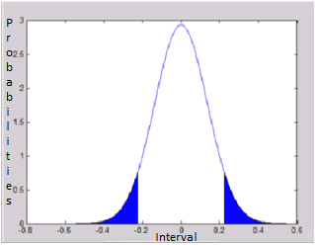

Figure 3-2 Plotting the z scores in Normal distribution curve
Here in the above figure 3-4, the user can find the information with the graph of interval in x-axis and probabilities in the y-axis. That shows the mean of .08 and standard deviation of 0.1361 for the 85,637 number of records.
Normal Distribution for dataset 2:

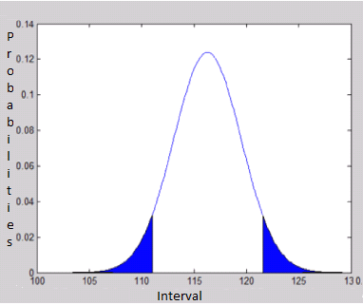

Figure 3-3 Normal Distribution diagram for dataset without minutes

Here in the above figure 3-5, the user can find the information with the graph of interval in x-axis and probabilities in the y-axis. That shows the mean of 116.2885376 and standard deviation of 3.220435246 for the 95000 number of records.
Discussions:

Based on the computed z values we could say that the null hypothesis is not true and thus rejected. However, the alternative hypothesis is true because z values are not equals to the .08 or 8%. It is less or more than the 8% in the gathered sample of the 85687 records. The reasons for the Z values not equal to the 8% or rejects null hypothesis because:

- The number of the observation is very large around 85637 records.
- According to the hypothesis theory, the hypothesis is carried out with the number $μ$subtracted to the mean of the data sets to the variances of the datasets. That variance is calculated by the standard deviation to the number of samples. And if the number of samples is too high then the Z scores will be higher or lower than the null hypothesis. The same happened in this situation.
- In addition, the sample and the hypothesis testing is done in the PCA of the attributes. So, the standard deviation and mean is less. Eventually, dividing the small value by the big value of the number of observations results the small Z values.

After getting the Z value, the author has computed the evaluation of the data based on the information loss. For that author has used Polynomial Regression. That has been illustrated in the result section of Chapter 5.

Validation

Till now the author has shown the several experiments and the processes of different experiment in above chapters and sections. However, the user shall be wondering on how those data reduced are assured of information loss? How one can trust the experiment is true? To answer those questions, the author has focused on Polynomial Regression, Naïve bayes classifier and Quantum GIS application. The detail theoretical background has already been presented in chapter 2 under Polynomial regression. Now, let us see the validation of those experiments. Basically, the validation of the result and the prediction of the data are done using following processes.
  - Get the datasets and apply the data reduction techniques on each of them.
  - Check the result before and after reduction on Weka, R, Matlab, K-Nime, SPSS and the detail results are in appendix.
  - Apply Polynomial-regression and Naïve Bayes classifier for checking accuracy of data reduction.
  - Apply quality measures techniques and show the different graphs before and after reduction.
  - Use Quantum GIS application to plot those datasets in the open layer and vefiry using different grid size of 50 meters, 500 meters, and 1000 meters grids.
The above described process is illustrated practically below.

Polynomial regression

Here the author has used Polynomial regression for the validation of the result obtained from the above experiment. Basically, the theory of the polynomial regression has already mentioned in the chapter 2. But to co-relate, the following equation is illustrated again.

Y = a0 + a1 x + a2X2

Based on the assumption and theory provided in chapter 2, following conclusion can be withdrawn for the datasets with minutes as in table 3-3. In fact, the experiment was conducted in the data analysis tool called Rapid Miner. The results are as follows:

Tools | Techniques | Data Sets | Before Reduction  Coordinates | After Reduction  Coordinates | Generated Equation
Rapid Miner | Polynomial Regression | 7006.csv | 2/8/2008  17:38, 116.1587,  39.81083 | 2/8/2008 17:36,  116.159,  39.8108 | - 0.001 * COLUMN 2 ^ 1.000 + 9.705 * COLUMN 3 ^ 4.000  - 49.768 * COLUMN 4 ^ 4.000 - 67.108
(Details of above data can be found in the appendix)
Table 3-13 Polynomial Regression Prediction for Validation with minutes
In the above prediction table, we have following description of each column

Tools: The tools used to compute the above details are from the RapidMiner 5.3.03.

Techniques: The techniques use for this above prediction and computation is Polynomial Regression. The further details about Polynomial Regression can be seen in the chapter 2.

Datasets: This column is for the name of the datasets file that is used for computation.

Before Reduction Coordinates: This column shows the points before the data reduction.

After Reduction Coordinates: This column shows the points after the data reduction.

Generated Equation: This column is the main driver of the whole procedure to predict the value for table 3-13. Basically, the equation will be computed by the Rapid Miner automatically after feeding the datasets. Here, the individual column in the datasets will be multiplied by the value as computed by the polynomial regression. Then, that value is used for computing the future coordinates as in the after reduction coordinates column.

From the above table 3-13, it shows that the data reduction techniques experiment used in this project are validated because the points in the files before and after reduction are similar. That makes us to say that there is less information loss using the Principal Component Analysis. Alternatively, the author has provided more evidence on the validation of the experiment conducted in this thesis. So, the accuracy of above illustrated and other techniques can be seen in chapter 6.

Similarly for datasets 2, following is obtained:

Tools | Techniques | Data Sets | Before Reduction  Coordinates | After Reduction  Coordinates | Generated Equation
Rapid Miner | Polynomial Regression | TaxiDriveTrajectories.csv | 8018,4,  116.31692,  40.03934 | 8018,4,  116.30999,  40.03834 | - 9.557 * TaxiNumber ^ 1.000 + 1 * year ^ 1.000 - + 9.507 * time ^ 4.000 - 46.768 * latitude ^ 4.000 - 49.776 * longitude ^ 4.000 - 67.108
(Details of above data can be found in the appendix)
Table 3-14 Polynomial Regression Prediction for Validation without minutes
As the author presented the prediction points in the dataset 2 without minutes above in table 3-14, now the user can find the accuracy for each taxi number present in that dataset below:
Tools | Techniques | TaxiNumber | Coordinates | Predicted  Coordinates | Generated Equation | Accuracies
Rapid Miner | Polynomial Regression | 7146 | 116.33088 , 39.97506 | 116.33088 , 39.97506 | - 9.507 * TaxiNumber ^ 1.000 + 1 * year ^ 1.000 - + 9.507 * time ^ 4.000 - 46.768 * latitude ^ 4.000 - 49.776 * longitude ^ 4.000 - 67.108 | 98%
Rapid Miner | Polynomial Regression | 8179 | 116.30572 , 40.03564 | 116.30672 , 40.03564 | - 9.506 * TaxiNumber ^ 1.000 + 1 * year ^ 1.000 - + 9.506 * time ^ 4.000 - 46.786 * latitude ^ 4.000 - 49.777 * longitude ^ 4.000 - 67.108 | 90%
Rapid Miner | Polynomial Regression | 8662 | 116.31995 , 39.89004 | 116.31996 , 39.89003 | - 9.505 * TaxiNumber ^ 1.000 + 1 * year ^ 1.000 - + 9.505 * time ^ 4.000 - 46.767 * latitude ^ 4.000 - 49.775 * longitude ^ 4.000 - 67.108 | 80%
Rapid Miner | Polynomial Regression | 9109 | 116.35408 , 39.86716 | 116.35408 , 39.86716 | - 9.504 * TaxiNumber ^ 1.000 + 1 * year ^ 1.000 - + 9.507 * time ^ 4.000 - 46.768 * latitude ^ 4.000 - 49.776 * longitude ^ 4.000 - 67.108 | 98%

(Details of above data can be found in the appendix)
Table 3-15 Prediction points in the dataset 2 without minutes
Similarly for datasets 3, following is obtained

Tools | Techniques | TaxiNumber | Coordinates | Predicted  Coordinates | Generated Equation | Accuracies
Rapid Miner | Polynomial Regression | 7146 | 116.33088 , 39.97506 | 116.33088 , 39.97506 | - 0.001 * Taxiid ^ 1.000 + 9.750 * month ^6.000 - 24.7867 + day ^6.000 - 24.768 –  hour ^6.000 - 24.568 -  location ^6.000 - 51.768 - 67.108 | 98%
Rapid Miner | Polynomial Regression | 8179 | 116.30572 , 40.03564 | 116.30672 , 40.03564 | - 0.001 * Taxiid ^ 1.000 + 9.750 * month ^6.000 - 24.7867 + day ^6.000 - 24.768 –  hour ^6.000 - 24.568 -  location ^6.000 - 51.768 - 67.108 | 90%
(Details of above data can be found in the appendix)
Table 3-16 Polynomial prediction for the Dataset 3

The above experiment was done using the Polynomial regression on the datasets illustrated above. On which, different accuracy were found and only the relevant ones and the nearest to the location are accurately described above in the accuracy column.

From the above experiment, the user can get the information of the junctions for each of these taxis also. That means, the above illustrated locations are the hugely visits location of those taxis because they are computed by the polynomial regression and average of the output obtained from the several experiments on each taxis were similar. Now, to verify further following Bi-Plot test has been carried out.

Bi-plot diagram

Here in this validation, the user can see the validation of the data without outliers. On which, the result obtained from the above table 3-5, table 3-6 and table 3-7 are plotted. This can be done using any data analysis application, however, the author used Matlab and R application. For this user need to feed the before reduction and after reduction data for the Bi-plot that results the following figures.
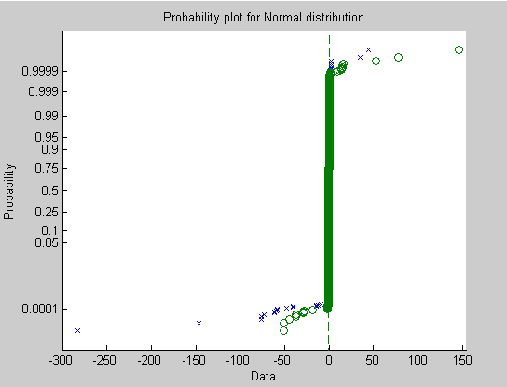
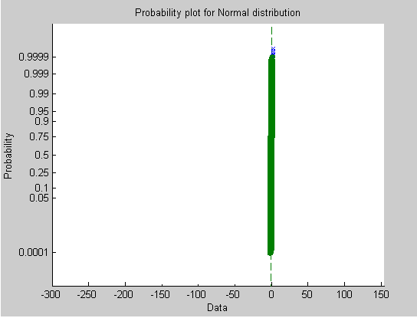
    - (b)
Figure 3-4 normal probability graph before reduction and graph after reduction
In the above figure 3-5 (a) and 3-5 (b), X-axis represent for the total principal components scores while y axis represents the probability of those principal components scores. In the same way, there are two different colors in the above graph because one is blue for PCA1 and another green is for PCA2. Here, the user can see the trend of the data in the probability plot as shown in the figure 3-5 (a) and 3-5 (b). In figure 3-5 (a), the user can see the data below 0 and above 0.999 are widely dispersed before data reduction. In contrast, after feeding the data after reduction the user can see figure 3-5 (b) a straight line without any point below 0 and above .999. This graph can be obtained to all the datasets used in this project. For dataset 2,
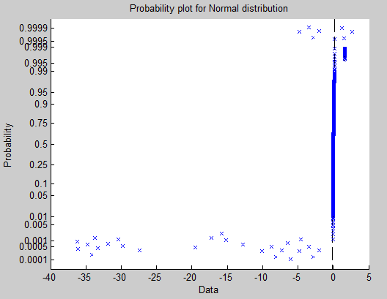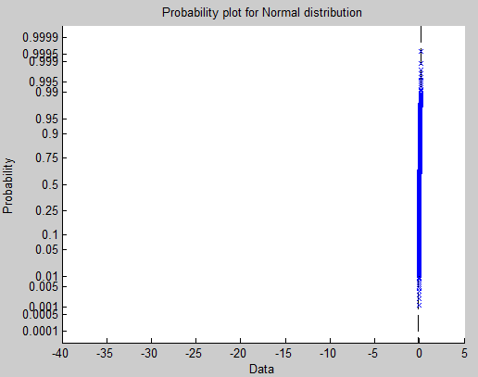
- (b)
Figure 3-5 normal probability graph before reduction and graph after reduction for dataset 2

The reasons for showing the above graph is to assure that only the outliers are being reduced from the datasets and the accuracy of the reduction can be seen in Chapter 6.

Measures of quality

Basically, there are several ways of measuring the quality of the experiment in data analysis. Nevertheless, the author focused on the quality of the reduced data for the GPS data for urban mobility analysis in following ways,
Confidence level:
For dataset 1:
Here, the author first applied the confidence level for the measures of quality. The confidence level is calculated based on the PCA computed from the table 3-5. On which, mean= 7.0753e-08, standard deviation= 0.1361, and in significance level of 95%. The user can see the following graph:

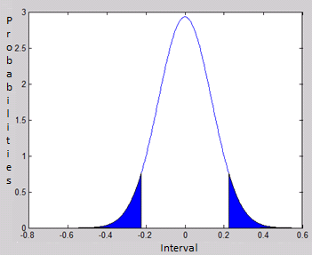
Figure 3-6 normal probability graph before reduction and graph after reduction

For dataset 2:

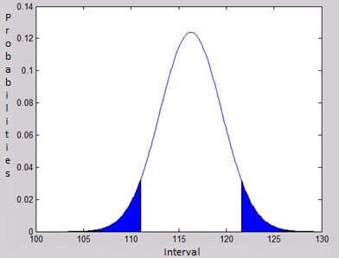
Figure 3-7 normal probability graph before reduction and graph after reduction

Discussion:
The figure 3-6 and 3-7 is displayed from the Matlab and difference of 0.5 and .02 range respecitvely in the axis. As user can see mean = 7.0753e-08, sigma = 0.1361 and significance level is 5% because default is 0.05 for 95% confidence intervals. That illustrates, that the computed data falls in the 95% significance level.
Amazingly, the correlation coefficient of the above figure 3-7 is +1 means all the points fall in the straight line. The function I have used is corrcoef() in matlab. Eventually, that graph produced from the corrcoef() function in matlab represents the straight line with all the points in it. That graph will be of the z-scores in the x-axis and PCA in the y-axis.
Using each data from the experiments shown in table 3-3, table 3-4 and table 3-5 the above figure 3-7 can be seen after the GPS data reduction for the urban mobility analysis.
Based on the theoretical computation of chapter 2 and the experiment of the table 3-3, the rate of data reduction in the average sample dataset is 24% of the total number of rows. That means, all those data whose variation are far beyond the principal components can be reduced either by Matlab or R.
So, approximately the data reduced is based on the PCA is 24% of 9000 that is, 2160 rows as in table 3-4.
Literally, the above line means to say that Principal Components Analysis delivered us that 24% of the total data are deviated or away from the principal components. Further details about the principal components can be found in chapter 2 and experiment regarding the PCA, Data Cleaning can be found in table 3-4, table 3-5 and table 3-6 respectively.
In this section there can be confusion on the result given to user by the data reduction techniques. However, the results are shown based on the table 3-5, table 3-6 and table 3.7. Therefore, another 8% of 85,637– 6851 rows are from the R application using the data reduction with PCA techniques as in table 3-6.
Actually, the R and Matlab both are the data analysis and business intelligence application and performance is based on the implemented logic. Nevertheless, for this project the author checked the result given by PCA with the same dataset used in Matlab to the R and got the same result.

Probability plot

Another technique for the quality measures is the probability measures. This technique is similar to the bi-plot diagram. Actually, the bi-plot diagram is the part of the Probability plot. In fact, there are several ways of measuring the quality as described chapter 2 under data reduction techniques and based on that the author has created several algorithms which trim the duplicate rows, blank rows, and noise from the dataset. Similarly, the probability plot was created using Matlab application.
The probability plot computed using Matlab is by Probplot(scores) command.
The user can see the result obtained from the PCA in Matlab and R in table 3-5, and table 3-6. So, the author would like to show you the process to measuring the quality of the datasets using PCA in Matlab and R respectively. Therefore, let us first take a look at the quality measures and separation in Matlab.
In Matlab, we have computed the Principal Component Percentage, Principal Component’s scores, from the chapter 2 and programmatically using the code in data reduction application and experimentally from the table 3-5, and table 3-6. Therefore, using the same, let us plot the normal probability plot for the normal distribution with the Principal components scores that is equal to the number of rows in datasets. After that, the user can see the trend of the data in the probability plot as shown in the figure below. It is clearly visible that all the data that are below 0 and above (0.999) are widely dispersed in compare to the rest as in following graph.

Figure 3-8 normal probability graph before outliers removal using Matlab
In the above diagram, X-axis represent for the total principal components scores while y axis represents the probability of those principal components scores. In the same way, there are two different dots in the above graph because one is blue are PCA1 and green is PCA2.
After computation the user can see the following graph.
Figure 3-9 normal probability graph after outliers removal using matlab
In the above diagram, X-axis represent for the total principal components scores while y axis represents the probability of those principal components scores.
Similarly, like in the Matlab, the user can follow the same process in R. However, the command we used here is little bit different as qqnorm(scores) and qqline(scores) instead of Matlab. So, before excluding the outliers we could see the following diagram.
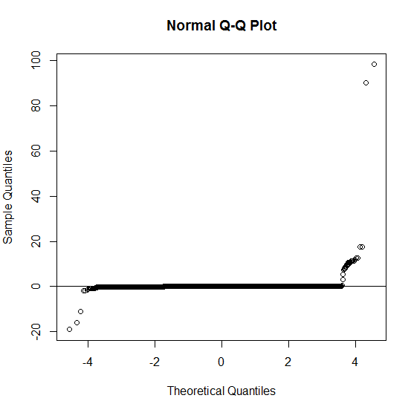
Figure 3-10 normal probability graph before outlier’s removal using R
In the above figure x-axis represents the range of those Principal components scores i.e. from -4 to 4 and Y-axis represents the Principal components scores and above PCA calculation. Similarly, here due to same color in the plots the user can see the same color in the diagram; black.
However, the process of computation is entirely same. Basically the user needs to feed the data before and after reduction in the R and matlab application to get this result.
After doing all above we could receive the graph as below.
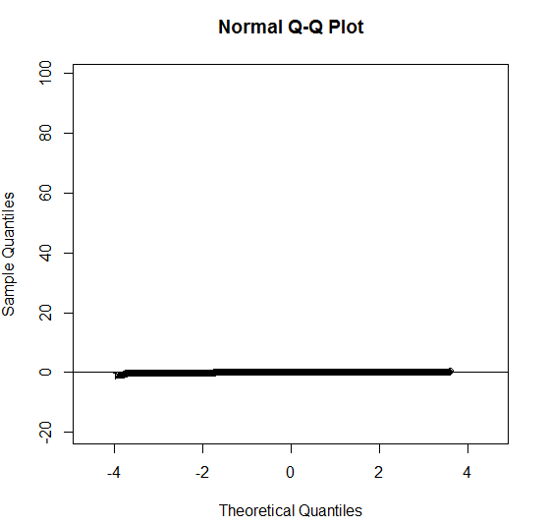
Figure 3-11 Normal probability graph after removal using R
In the above figure x-axis represents the range of those Principal components scores for example, from -4 to 4 and Y-axis represents the Principal components scores computed as in the appendix and above PCA calculation. Similarly, here due to same color in the plots we could see the same color in the diagram; black.
Similarly for the dataset 2 without using Minutes:
- (b)
Figure 3-12 Probability plot of the data set 2 without using Minutes
Here, in the above figure 3-12, the user can see the probability plot before and after reduction. In the figure 3-12 (a) the X-axis represents the data and Y-axis represents the probability. Similarly in Figure 3-12 (b), the user can see the after data reduction probability plot which has data as x-axis and probability as y-axis.

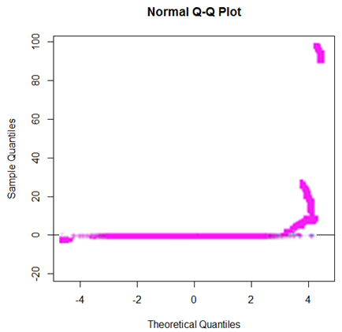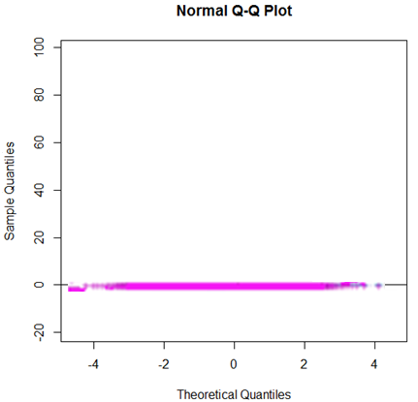
- Q-Q plot before reduction (b) Q-Q plot after reduction
Figure 3-13 Normal Q-Q plot for the Dataset without time
Hence, the author shows that the data reduced from using the data reduction techniques illustrated in the chapter 2 and experiment illustrated from table 3-3 till table 3-13 shows that the GPS data reduction for the Urban Mobility analysis is reliable. Alternatively the author also has given the further explanation in the final result section of Chapter 5.
Besides, for the further verification, the user can see the some predicted points in the above files. Furthermore, the user can see the result in the quantum GIS application also. In this application, the experiments was done creating different grid with size of 50 meters, 250 meters, 500 meters, 750 meters, 800 meters, 1000 meters etc. And the process of computing the grid and the ways to find the information loss is using following process.
I. Plotting data in open street layer
II. Create a grid on the area
III. Assign each individual GPS sample to nearest cell
IV. Assign colors to each cell indicating more or less samples
V. Origin-destination matrix
VI. Compute and compare them

The above defined process is validated for each grid and datasets describes in chapter 2 under figure 3-2, table 3-2, and table 3-3 also. Basically, the dataset of table 3-3 has been used for this part. Here, the user can find polynomial regression and naïve bayes classifier predicting the next and existing location from the before and after reduction of the GIS data for the urban mobility analysis.

Plotting data in open street layer

Here the user can see the T-drive trajectories data as in figure 3-2, table 3-2 and table 3-3 data in the GIS application with the open street map.

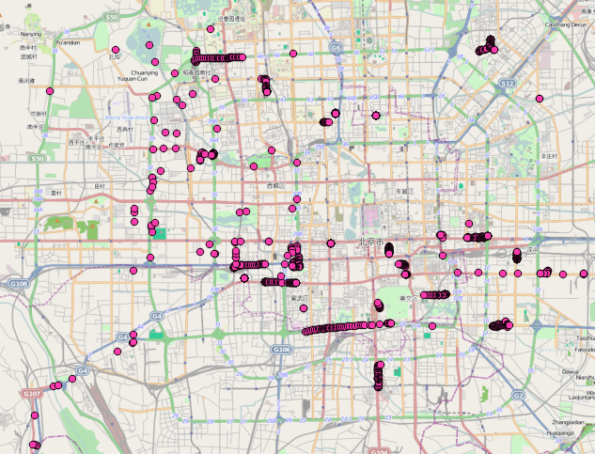

Figure 3-14 Before reduction for the Taxi drive trajectories for 3 months data

Figure 3-15 After reduction for the Taxi drive trajectories for 3 months data

Create a grid on the area and assign each individual GPS sample to nearest cell with different colors:

In this section the user can see the different grid size that has been created to find the different location and next probable location and to verify the information loss by using polynomial regression and naïve bayes classifier. Therefore, several grids are created as follows:

Grid for 50 meters

Here the 50 meters grid is created on which several colors were allocated to find the location of maximum sample size.

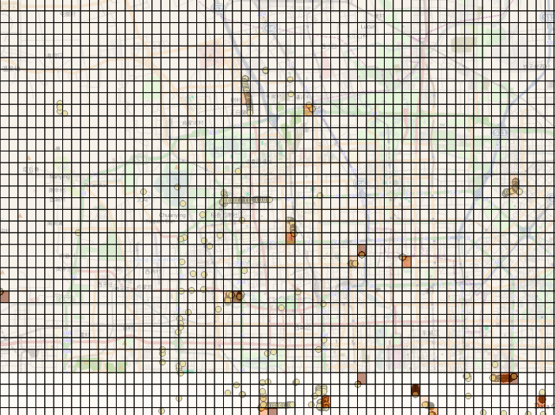

Figure 3-16 Before reduction for the Taxi drive trajectories with grid in different colors on size for 50 m Grid using Quantum GIS application

The sample size colors are as follows:

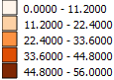

Similarly, again the grid of 50 meters is created for the GPS data after reduction using data reduction application and other techniques as of the dataset format of table 3-3.

Figure 3-17 After reduction for the Taxi drive trajectories with grid in different colors on sample size for 50m Grid using Quantum GIS Application

Here also, the sample size has been segregated based on the number of points occurring in particular grid.The sample size colors are as follows:

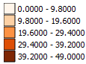

After creating the grid the user can find the origin-destination matrix. Basically, this the matrix used in Quantum GIS to find the origin and destination information and the distance between data of the above plotted data is the Open streat layer. So the result for the 50 meters grid of the T-drive trajectories is as follows:
InputID(Taxi Number) | TargetID(Location) | Distance
8662 | 116.31996 , 39.89003 | 1.41E-05
8662 | 116.31995 , 39.89004 | 1.41E-05
8662 | 116.32 , 39.89005 | 2.00E-05
8662 | 116.31999 , 39.89007 | 1.00E-05
(Details of above data can be found in the appendix)
Table 3-17 The Origin-destination matrix for the GPS data before reduction for 50 meters grid

Similarly, the origin-destination matrix after data reduction for the GPS data for the urban mobility analysis for 50 meters grid is as follows:

InputID(TaxiNumber) | TargetID(Location) | Distance
8179 | 116.30548, 40.03559 | 0.000245
8179 | 116.30572, 40.03564 | 0.000245
8179 | 116.30486, 40.03424 | 0.000372
8179 | 116.30467, 40.03456 | 0.000372
8179 | 116.30519, 40.0333 | 0.000373
(Details of above data can be found in the appendix)
Table 3-18 The Origin-destination matrix for gps data after reduction for 50 meters grid

After creating the Origin- destination matrix the result before and after reduction for the GPS data for urban mobility analysis has been analysed. That comparison and accuracy prediction using Naïve Bayes is shown below.

 | Before |  | After
Taxi Number | Location | Distance | Location | Distance | Comments | Accuracy
7146 | 116.33184, 39.97477 | 0.000235 | 116.33184, 39.97477 | 0.000235 | Same | 100%
8179 | 116.30656, 40.02912 | 0.000696 | 116.30656, 40.02912 | 0.000696 | Same | 100%
8662 | 116.32004, 39.89005 | 1.00E-05 | 116.32004, 39.89005 | 1.00E-05 | Same | 100%
9109 | 116.3573, 39.86763 | 0.000983 | 116.3573, 39.86763 | 0.000983 | Same | 100%
9754 | 116.68199, 39.8263 | 2.24E-05 | 116.68199, 39.8263 | 2.24E-05 | Same | 100%
366 | 116.44955, 39.90726 | 4.24E-05 | 116.44955, 39.90726 | 4.24E-05 | Same | 100%
1131 | 116.45828, 39.8697 | 0.000242 | 116.45828, 39.8697 | 0.000242 | Same | 100%
1277 | 116.31719, 39.89534 | 9.85E-05 | 116.31719, 39.89534 | 9.85E-05 | Same | 100%
2237 | 116.20257, 39.8191 | 122.8357 | 116.20257, 39.8191 | 122.8357 | Same | 100%
2560 | 116.47156, 39.89803 | 1.41E-05 | 116.47156, 39.89803 | 1.41E-05 | Same | 100%
2669 | 116.45138, 39.98728 | 0.0005 | 116.45138, 39.98728 | 0.0005 | Same | 100%
3015 | 116.41028, 39.8917 | 8.06E-05 | 116.41028, 39.8917 | 8.06E-05 | Same | 100%
3557 | 116.16817, 39.9446 | 1.00E-05 | 116.16817, 39.9446 | 1.00E-05 | Same | 100%
3579 | 116.40049, 39.90341 | 9.06E-05 | 116.40049, 39.90341 | 9.06E-05 | Same | 100%
3781 | 116.37052, 39.96039 | 1.00E-05 | 116.37052, 39.96039 | 1.00E-05 | Same | 100%
(Details of above data can be found in the appendix)
Table 3-19 comparison and accuracy prediction using Naïve Bayes for 50 meters grid

Discussions: here in the above table 3-19, the user can see the accuracy - percentage of the data occurance before and after reduction, to be of 100%. Because, the input datasets of the above result is table 3-3 and that has been segregated in several parts separating each components of timestamp along with combining latitude and longitude into location and not taking minutes and seconds into consideration. Eventually, all traces generated in single minutes were merged into hours creating lots of duplicate record and rest distinct records were found to be similar. So that the previous location and after reduction location were matched and the accuracy was 100%.
Accordingly, the same process of generating grid and computing has been done for the 500 meters. That is as follows:

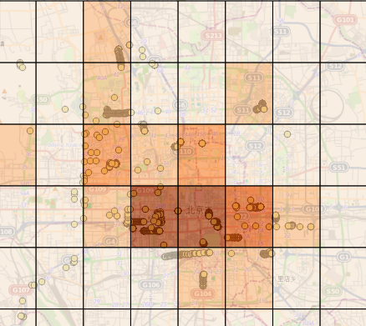

Figure 3-18 Before reduction for the Taxi drive trajectories with grid in different colors size for 500m Grid using Quantum GIS Application

Here in above Figure 3-18 the sample size has been divided based on the following data.

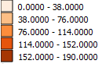

Similarly, the user can see the after reduction GPS data for the 500 meters grid below:

Figure 3-19 After reduction for the Taxi drive trajectories with grid in different colors on sample size for 500m Grid using Quantum GIS Application

And, the sample size colors are has been defined in the following ways for figure 5-7:

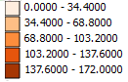

Based on the above layer illustrated for the 500 meters grid of after reduction for the taxi-drive trajectories the following distance matrix is for the Taxi drive trajectories to location, taxi number in Distance.

InputID(Taxi Number) | TargetID(Location) | Distance
8662 | 116.31996 , 39.89003 | 1.41E-05
8662 | 116.31995 , 39.89004 | 1.41E-05
8662 | 116.32 , 39.89005 | 2.00E-05
8662 | 116.31999 , 39.89007 | 1.00E-05

(Details of above data can be found in the appendix)
Table 3-20 The Origin-destination matrix for gps data before reduction for 50 meters grid

The user can find above table 3-20 for the origin-destination matrix for gps data before reduction. Similarly, the after reduction matrix is shown below:

InputID(TaxiNumber) | TargetID(Location) | Distance
8179 | 116.30548, 40.03559 | 0.000245
8179 | 116.30572, 40.03564 | 0.000245
8179 | 116.30486, 40.03424 | 0.000372
8179 | 116.30467, 40.03456 | 0.000372
(Details of above data can be found in the appendix)
Table 3-21 The Origin-destination matrix for gps data before reduction for 500 meters grid

Now, the user can see the comparison of the 500 meters grid for the GPS T-drive trajectories for the Urban mobility analysis.The computing is based on the Naive bayes Classifier and the comparison is between the before and after reduction data using data reduction application.

 | Before |  | After
Taxi Number | Location | Distance | location | Distance | Comments | Accuracy
7146 | 116.33184, 39.97477 | 0.000235 | 116.33184, 39.97477 | 0.000235 | Same | 100%
8179 | 116.30656, 40.02912 | 0.000696 | 116.30656, 40.02912 | 0.000696 | Same | 100%
8662 | 116.32004, 39.89005 | 1.00E-05 | 116.32004, 39.89005 | 1.00E-05 | Same | 100%
9109 | 116.3573, 39.86763 | 0.000983 | 116.3573, 39.86763 | 0.000983 | Same | 100%
9754 | 116.68199, 39.8263 | 2.24E-05 | 116.68199, 39.8263 | 2.24E-05 | Same | 100%
366 | 116.44955, 39.90726 | 4.24E-05 | 116.44955, 39.90726 | 4.24E-05 | Same | 100%

(Details of above data can be found in the appendix)
Table 3-22 comparison and accuracy prediction using Naïve Bayes for 500 meters grid

Here in the above table 3-22, the reason for showing the 100% accuracy- percentage of the data occurance before and after reduction is similar. Basically, the experiment was conducted using several datasets and with different tools and found the same result. That explains the same coordinates have been formed by dividing the timestamp because in every minutes and seconds many traces can be generated in each co-ordinates.

Basically, several experiments have been conducted to validate the information loss. However, only 50 meters, 500 meters and 1000 meters grid are shown here. Rest can be found in the thesis repositories. So, the user already saw for 50 and 500 meters. Now, let us take a look at the 1000 meters grid.

For 1000 meters grid

The user can find the 1000 meters segregation of the T-drive trajectories data in the open layer maps below:

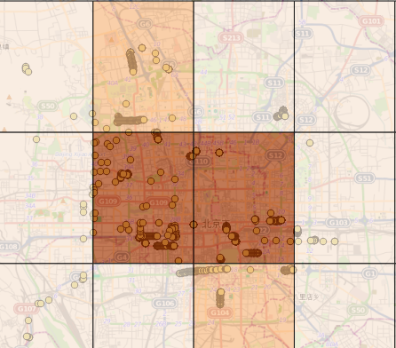

Figure 3-20 Before reduction for the Taxi drive trajectories with grid in different colors size for 1000 m Grid using Quantum GIS Application

The above figure 3-20 has been segregated based on the following ranges.

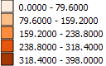

Similarly, the user can find the 1000 meters grid for the after reduction GPS data of T-drive trajectories:

Figure 3-21 After reduction for the Taxi drive trajectories with grid in different colors on size for 1000m Grid using Quantum GIS Application
The sample grid size of above figure 3-21 is follows:

Now, based on the figure 3-20 and figure 3-21 the following origin-destination matrix has been obtained.

InputID(Taxi Number) | TargetID(Location) | Distance
7146 | 116.33088 , 39.97506 | 0.001491
7146 | 116.33179 , 39.975 | 0.000912
7146 | 116.33184 , 39.97477 | 0.000235
7146 | 116.33184 , 39.9746 | 0.00017

(Details of above data can be found in the appendix)
Table 3-23 The Origin-destination matrix for gps data before reduction for 50 meters grid
Following that, the user can see the after reduction origin-destination matrix below:

InputID(TaxiNumber) | TargetID(Location) | Distance
7146 | 116.33184, 39.97477 | 0.000235
7146 | 116.33184, 39.9746 | 0.00017
7146 | 116.33183, 39.97448 | 0.00012
7146 | 116.33184, 39.9746 | 0.00012
7146 | 116.33187, 39.97391 | 0.000216

(Details of above data can be found in the appendix)
Table 3-24 The Origin-destination matrix for gps data after reduction for 50 meters grid

Based on the above table 3-23 and table 3-24 and using naïve bayes classifier following computation and comparison was made.

 | Before |  | After
Taxi Number | Location | Distance | Location | Distance | Comments | Accuracy
7146 | 116.33184, 39.97477 | 0.000235 | 116.33184, 39.97477 | 0.000235 | Same | 100%
8179 | 116.30656, 40.02912 | 0.000696 | 116.30656, 40.02912 | 0.000696 | Same | 100%
8662 | 116.32004, 39.89005 | 1.00E-05 | 116.32004, 39.89005 | 1.00E-05 | Same | 100%
9109 | 116.3573, 39.86763 | 0.000983 | 116.3573, 39.86763 | 0.000983 | Same | 100%
9754 | 116.68199, 39.8263 | 2.24E-05 | 116.68199, 39.8263 | 2.24E-05 | Same | 100%
366 | 116.44955, 39.90726 | 4.24E-05 | 116.44955, 39.90726 | 4.24E-05 | Same | 100%
1131 | 116.45828, 39.8697 | 0.000242 | 116.45828, 39.8697 | 0.000242 | Same | 100%
1277 | 116.31719, 39.89534 | 9.85E-05 | 116.31719, 39.89534 | 9.85E-05 | Same | 100%
2237 | 116.20257, 39.8191 | 122.8357 | 116.20257, 39.8191 | 122.8357 | Same | 100%
2560 | 116.47156, 39.89803 | 1.41E-05 | 116.47156, 39.89803 | 1.41E-05 | Same | 100%
2669 | 116.45138, 39.98728 | 0.0005 | 116.45138, 39.98728 | 0.0005 | Same | 100%

(Details of above data can be found in the appendix)
Table 3-25 comparison and accuracy prediction using Naïve Bayes for 1000 meters grid

Discussions: Here in the above table 3-25, the user can see the accuracy, percentage of the data occurance before and after reduction, as 100%. Because, the input datasets of the above result is table 3-3 and that has been segregated in several parts separating each components of timestamp along with combining latitude and longitude into location and not taking minutes and seconds into consideration. Eventually, all traces generated in single minutes were merged into hours creating lots of duplicate record and rest distinct records were found to be similar. So, that the previous location and after reduction location are matched and the accuracy is 100%.
To add further in the research the author has presented the difference between each techniques used in this experiments and those are scrutinized below:
 | Principal Component Analysis(PCA) | Data Cleaning (DC)
Time & Space | - PCA saves time of the data analyst like researchers and enthusiastic. | The time taken for DC may be considerably lower due to the reluctance of the simple DC techniques.
Time & Space | - It allows the data reduction to be carried out within a limited storage space. | When the data reduction is carried out, there is high possibility of losing important information.
Environment | - It allows the researcher to control over the data reduction process. | The interface design of the environment may not be more realistic enough for some data enthusiastic in computation of DC process.
Environment | - The data reduction using PCA may cause data to be duplicated and empty. | The redistributable data may require manual adjustment of values in the source codes and can be frustrating.
Environment | - The risk of losing important information is highly reduced. | There is high possibility of losing important information.
Environment | - It allows the researchers to gather the performance of data reduction in little time depending on the size of the input data. | The measured performance may not be accurate in real world scenario due to ad-hoc process of computation.
Cost | - The use of PCA is economical in the sense that can be implemented by the advance IT users in considerable amount of time. | The use of DC is quite simple and less economical as well.
Experiment | - The multi – dimensional data are supported using Principal Components. | The multi – dimensional data are supported using DC techniques.
Experiment | - The result of R and Matlab shows the data reduction to be 8% of the GPS data. | The result of R and Matlab shows 65% for the GPS traces using duplicate records, empty records and noise computation.
Others | - It provides confidentiality and eliminates possible public embarrassment, too. | It does not provide any confidentiality due to ease of its implementation.
Others | - There are several possibilities of modifying PCA algorithms depending the need and wants of the users. | Being the one of the simplest techniques, there are few possibilities of modifications for new application.
Others | - Standardization of the PCA procedures is easier due to consistency in the assessment and retraining approaches. | There are sufficient applications in DC techniques.

Table 3-26 Comparison and differences between each technique

Chapter 4

Application Proposed

This chapter presents different phases of the software development life cycle that will be realized in the final product. For this six distinct phases were identified which were Preliminary Study Phase, Analysis Phase, Specification Phase, Development Phase, Evaluation Phase and Future Development. Each phase consists of a process and an execution plan. Detailed strategies that were adopted for each phase will be discussed in the following sections to deploy the solution for the problem discussed in chapter 1.

The following figure 4-1 illustrates the sequence of phases that was followed in this data reduction for the urban mobility analysis software development. Basically, in this figure processes are represented inside the rectangles and methodologies used for the process are enclosed in the circle. The processes are interlinked with each other by means of arrows. The boundaries of processes are represented by means of the dotted line.

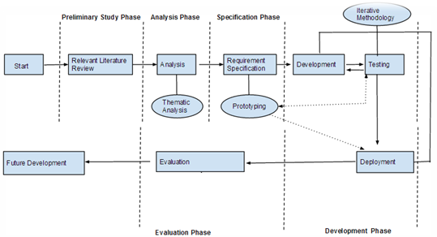
Figure 4-1 General methodology of artefact development.

Preliminary Study Phase

Preliminary study phase is the primary phase of the software development life cycle and research carried out in this phase formed the basis of the whole project. That involved collection of the primary research materials carried out by some renowned scientists or researchers in the field. The source of knowledge base for the phase can be attributed to the electronic journals, books, newspaper articles, letters etcetera. The resources were obtained through careful exploration of online journal repositories such as Google Scholar, college library, yahoo documents etcetera. Knowledge, ideas and directions garnered from the supervisor have also supported in the extension of the knowledgebase.
Specifically, the search focused on gathering the resources that dealt with the application of data reduction techniques to the outliers detection and future data prediction with machine learning techniques. Major technological advances that had paved the way for realization of such technical interventions have also been accounted for. Its scope and current influence on data reduction, as a means of several data reduction techniques, has been considered.
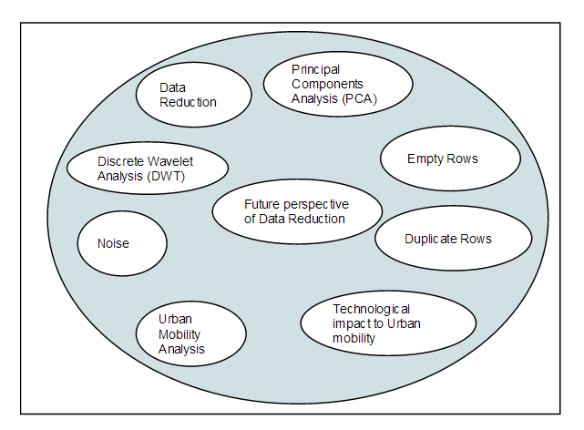
Figure 4-2 Keywords used for searching
Besides the electronic journals, another source of information that has remarkably aided in better understanding the significance of the project, is through the frequent discussions that were carried out with the supervisors, in order to gain insights of the real life experiences. The key elements that constituted in successful intervention during their activities were identified, interpreted and modeled into a group of requirement and overall project using the figure 4-2 keywords.
The research was carried in several facets. Firstly, the overall theoretical background that related to all the facets was identified. Then all of them were outlined into the document. Despite of having lots of researched in the field of GPS data reduction for Urban Mobility Analysis but only the relevant ones were shortlisted. After that, all the separate researched done by the college graduates were identified and start to summarize them to make the concise report for this project.
Hence, it can be concluded that the focus of this research was arrived initially at via an in-depth literature survey – identifying key technological developments within the data reduction setting. In particular it focused on establishing the state of the art in terms of data reduction and how these might add value within the GPS data reduction for urban mobility analysis.

Analysis Phase

Analysis phase forms the second and the most important phases in the Software Development Life Cycle (SDLC). This phase involved careful separation of the meaningful and vital information from the knowledge-base. The most valuable sources of information for the project were collected from the past research and supervisors. The challenge was to analyze the information obtained from such meetings. Various approaches were applied for the identification and extraction of subject matter from the abstract experiences.
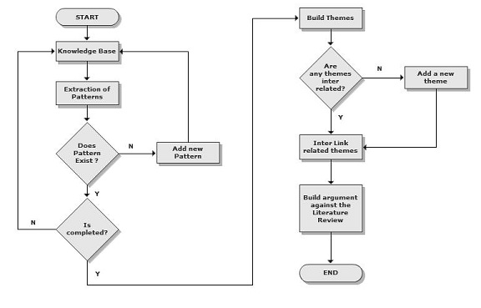
Figure 4-3 Thematic Analysis Process
As mentioned earlier, several discussions were transcribed with supervisors. A careful examination of data revealed some useful patterns. Any new information that was emerged was first attempted to relate to the already existed patterns. A new pattern was only formed when it failed to be categorized under any of the existing ones. The figure 4-3 shows the process that was carried out.
After all the possible patterns were identified, an attempt was made to break down the patterns into a group of sub-themes. The themes that were found to be similar were grouped under a single category. The fragments views linked together to form a full and meaning interpretation of the ideas that emanated from the transcribed data. Each identified themes were attached with an appropriate techniques to establish their significance with the data reduction.
A set of arguments were built out of the extracted themes that could be related to the relevant literature. Inferences were used to establish validity for the more abstract themes.

Specification Phase

The result of the thematic analysis is a set of themes that have been validated with the relevant state of arts. It is necessary to develop specific requirements out of the extracted themes. The process of creating such requirements was realized in this phase. Drafting of the requirement specification required careful selection of the appropriate themes and elaborate understanding for the data reduction techniques.
Functional as well as non functional requirements were identified and were given a specific identifier. The format of the identifier used is R#Serial_Number. A requirement specification description language was used to write down the requirements so that it could be easily understood and interpreted by different stakeholders of the system.
Altogether, about 10 potential requirements were identified. A grading mechanism was used to classify the set of requirements, so that they could be prioritized. Considering the limited time span of the project, only the functional requirements that have been identified as key to the success of the project have been fulfilled. The remaining specifications will be embarked as the candidates for the future development of the project.
Feasibility analysis was also carried out at this stage. Any requirements that were deemed unnecessary, unrelated or impossible to be included as a part of the final release were not taken into consideration putting label infeasible. In parallel to the development of the specifications, it was assured that the specifications could be realized given the current technology support for the data reduction, by adopting a prototyping method. A prototype of the final product was created which consisted of mainly the requirements that seemed challenging to the project at this stage.
The prototypes that were developed were constantly tested to guarantee the similar output during the real product development. All the prototypes that were developed were eventually used during the development phase. Such approach has facilitated in making the duration of the development cycle shorter and a lot easier.
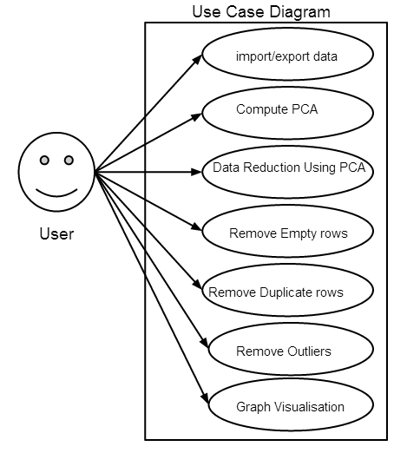
Figure 4-4 Use Case diagram for the data reduction application
Here, in the above use case diagram figure 4-4, some of the appropriate requirement has been identified from the outcome of the previous phases that have been illustrated in this use case. Effectively, the user can interact with the application in the above different features. The user can be any individual accessing the application. As, this application is for the reducing and finding the before and aftermath of the reduced data therefore first the user can import the data then compute the PCA then reduce the data using PCA, following, the user can remove duplicate, empty rows, outliers from data reduction application. In addition, the user can view the result of the reduction from the graph in the data reduction application.

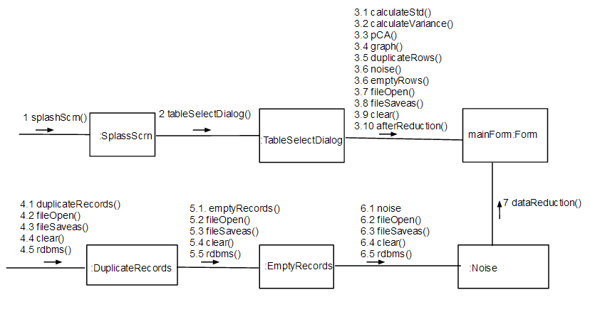
Figure 4-5 Communication diagram for data reduction using PCA, and Data cleaning

The above figure 4-5 gives the overview of the communication diagram means how the data reduction application is communicating between classes using which methods. Actually, first the actor will use splashScrn method of splashScrn class then the TableSelectDialog class will be open by the use of tableSelectDialog methods. After that the major operation are come into effects. That is the instance MainForm with FormObject using all those methods shown from 3.1 to 3.10 in above figure 4-5. As a result the PCA will be computed and the before and after reduction will be shown in the data reduction application. Following that, for data cleaning techniques, the user can see three classes namely, DuplicateRecords, EmptyRecords and Noise. In all those classes, there is the same name like its classes to function accordingly and the user can open file, savefile, clear results, and manipulate database from each of those classes. Finally, that result will be redirect to the mainForm instance then the user or actor can see the output of each of them.
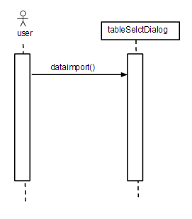
Figure 4-6 Sequence diagram for the data import
Here in figure 4-6, the user will use dataimport() function to the tableselctDialog class to the datatable for the mainForm instance to the form object of the data reduction application and those imported data will be used in following figure 4-7.
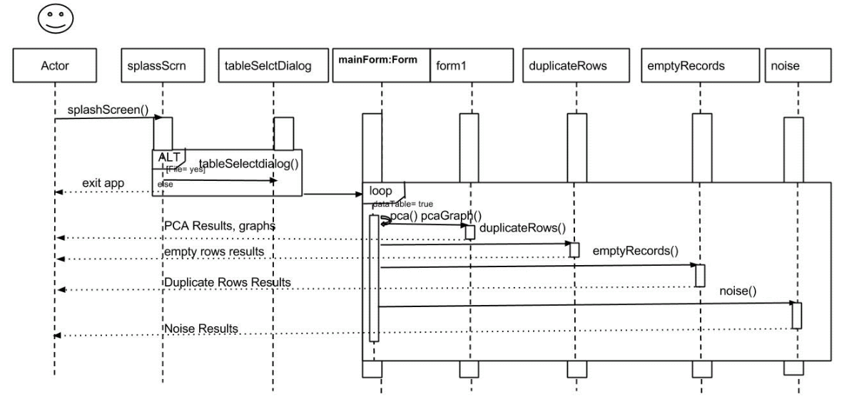
Figure 4-7 Sequence diagram for the data reduction application
Here in figure 4-7, the actor will open the application then the splash screen will be shown. After that the GUI license will be shown then the actor will click next and the tableSelectDialog() method insert the imported data into the datatable if the file or datatable has data then the action will forwarded to the mainForm class to the Form object else the actor will be prompted to close the application. If that data table has data then pca() methods will be executed then the variance, covariance, standard deviation, Eigen Vectors, Eigen Values, directions of the Eigen vectors and Eigen values results will be displayed to the user. Similarly, the same datatable used by the mainform class that will be accessed by the form1 class to execute the after reduction result and displayed to the actor. Then another duplicateRows(), emptyRecords(), noise() methods will be executed inside the loop to check each rows in the data table on duplicateRows, emptyRecords, noise class respectively and the respective results will be send to the actor.
Class diagram
The class diagram of the above project is given below. In which, C# provides us polymorphism through inheritance that means Inheritance-based polymorphism allows us to define methods in a base class and override them with derived class implementations. Therefore, if the user has a base class object that might be carrying one of several derived class objects, polymorphism when properly used allows the user to call a method that will work differently according to the type of derived class the object belongs to. So, the features has been implemented herein this project. The class diagram is given below.

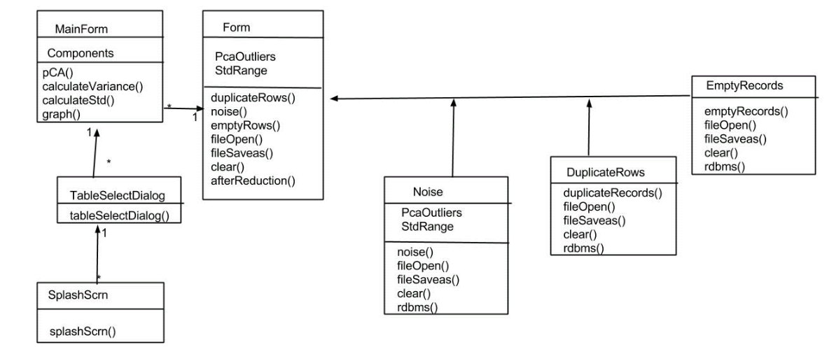
Figure 4-8 Class diagram of the data reduction application

Basically, the objective of showing this class diagram is to give the architectural structure of the data reduction application. And each class above does the same function as their name says means duplicate class removes duplicate rows, noise class removes the noise of the data, mainForm class does the design of the frontend etc. Eventually, that would be very convenient for the user to get familier with the application architecture. Summarizing, SplashScrn, TableSelectDialog, MainForm classes have many to one relation with the Form class respectively and there is one attribute in MainForm class while two components namely PcaOutliers and StdRange for Form class. And for the another techniques, data cleaning, the user can see Noise with two attributes, PcaOutliers and StdRange, and DuplicateRows and EmptyRecords do not contain any attributes nevertheless these three class of data cleaning have same number of methods. Moreoever, the three classes of the data cleaning have one to one relationship with the Form class.

Thematic Analysis

Meticulous studies have been carried out on the transcribed data collected from different groups consisting of statement of arts and supervisors. The figure 4-8 shows the thematic analysis carried out on the data.
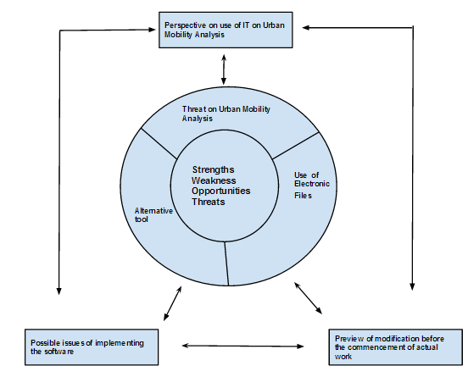
Figure 4-9 Thematic analysis carried out on the data
The above table 4-8 was used to recognize the patterns to produce themes which formed the essence of the requirements. Altogether, there were 9 themes, they are as follows
- Perspective on the use of IT in urban mobility analysis
- Possible issues of implementing the software
- Threat on the urban mobility analysis
- Use of electronic tool
- As an alternative tool
- Strength
- Weakness
- Opportunities
- Threats

Perspective on the use of IT in urban mobility analysis
The theme refers to the frequency of use of urban mobility analysis and Information Technology (IT) when carrying out the day-to-day activities. Basically, all the Computers, Networking, and affiliated information and communication technologies have changed the physical structure of metropolitan areas in the last five decades. For instance, reducing use of automobile has increased the corresponding home-to-work done through the virtual environment. Telecommuters usually eliminate several trips per day when they work from home. If this phenomenon rises in similar trend then it will obviously benefits the environment; including reduced emissions of pollutants and reduced fossil use.
Like other automobile, Telecommunications has become a force to shape the land use and transportation in cities. So, the cheaper space in the suburbs may be a crucial requirement for newer and smaller firms who are subscribers of new telecommunications technologies. The enhancing potential of telecommunications allows other organizations and businesses to operate more flexibly, however, that may not be achieved due to the inefficient spatial structure.
In fact, telecommuting has failed to meet the user expectation that could be due to unsatisfied human nature and ever growing technological development. There are several reasons like not being capable enough to imitate the same procedure as of direct control from management and relocated in a low cost location either by outsourcing or off shoring.
We will delve into each of the themes to show how they were derived and demonstrate what they imply. By thorough analysis on each of the themes we will arrive with the set of requirements. Further refinement will be carried out to form a group of actual requirements that will be fulfilled by the project. As mentioned earlier in the Chapter 3, not all the identified requirements will be candidate for the final release. Those requirements those are technically impossible or not supported by the current version of data reduction application will be labeled as infeasible. Those requirements that are considered as optional to the current release and strong candidate for the future release will be labeled as deferred. Those requirements that have high relevance to the project and have greater impact on the usability and completeness of the project will be marked as targeted. Finally, the requirements which are vague and do not have any relationship with the project are marked as Irrelevant. The following table summarizes the type of the requirements gathered.
Status | Description
Targeted | Most important requirements; Part of the final release.
Deferred | Optional requirement; candidate for future enhancements.
Infeasible | Not supported by current version of data cleaning and PCA application.
Out of scope | Abstract or irrelevant to the project.

Table 4-1 Requirements category
Designing the Data Reduction application for the GPS data of Urban Mobility Analysis could not suffice unless they were presented with the effective layout. This theme highlights the concerns of the end user to be able to view what was being included inside data sets. Clearly, there should be some mechanisms to show the real data inside the application. Only after such facility could the end user know the proportion and volume of the datasets. It could also mean that there could be a proper communication channel between the users to better explain and reason the future modifications.

Code | DRR1
Paraphrase | Reduce the data set using data reduction techniques
Meaning | Need an application for data reduction techniques
Requirement | Create application for data reduction for data cleaning and PCA techniques
Status | Targeted

Code | DRR2
Paraphrase | Manipulate the datasets from the application
Meaning | Need a open file, save output, exit the application
Requirement | Option to show open file, save output and exit the application
Status | Targeted

Code | DRR3
Paraphrase | Do not want to see any graph in principal component application.
Meaning | Need the detail of the principal components only without graph
Requirement | Remove all the graph that was created in PCA application
Status | Targeted

Code | DRR4
Paraphrase | Do not want to see many tabs in the application.
Meaning | Need the detail of the PCA application in much few screens.
Requirement | Removed all the extra details with the tabs in the form
Status | Targeted

Code | DRR5
Paraphrase | Datasets should be automatically upload on click
Meaning | Need the file up loader in the application.
Requirement | Options to upload the file in application
Status | Targeted

Code | DRR6
Paraphrase | User should see the result of the data reduction computation
Meaning | Need the space to view the result of the computation
Requirement | Options and separate forms to see the statistics result in application
Status | Targeted

Code | DRR7
Paraphrase | User notification on any error, unusual operation
Meaning | Need a notification place for the user error
Requirement | Message box or information on any errors
Status | Targeted

Code | DRR8
Paraphrase | Separate menu for different data cleaning techniques
Meaning | Need a place to select the data cleanings
Requirement | Options to click menu items and display result
Status | Targeted

Code | DRR9
Paraphrase | Implement the DWT techniques along with PCA analysis
Meaning | Use DWT algorithms in application
Requirement | Options to compute Discrete Wavelet Transform in PCA application
Status | Deffered

Code | DRR10
Paraphrase | User input for the data cleaning range computation
Meaning | Need an place to specify the range for data cleaning
Requirement | Options to put in text box for data cleaning
Status | Targeted

Code | DRR11
Paraphrase | Put every techniques in one application
Meaning | Need an place to see all reduction techniques in single application
Requirement | Options to select and compute data cleaning, PCA and DWT in one c# application
Status | Infeasible

Code | DRR12
Paraphrase | Implement the PHP application features in c# application
Meaning | Create data cleaning techniques in one application
Requirement | Use duplicate records, empty records, noise reduction in c# application
Status | Targeted

The user can see the entire requirement that the supervisors suggested in several occasions in the above table. Now, the user can find the possible issues of implementing the software
This theme deals with the organizational as well as technological hurdles may arise while implementation of the software. The use of technology in the field of Data Reduction (DRs) for the Urban Mobility Analysis has always been eclipsed by constraints posed on the available resources. For instance there is no proper institutional access to the IT access during their work. Problem of such can have serious consequences on the commencement of any IT related activities. Having defined IT access to resources is thus the foremost priority. Other issues were concerned with sharing of the progressing work with different team members as using their personal information drives would make others impossible to view the work.
With regards to the technologies issues, there was no guarantee that the software for Urban Mobility Analysis was capable of producing the color that exactly matched the one in our application. There is no proper way of determining the color coded of the application just by viewing the property. Then, the participants were wary about how much memory it would take to run the software because they knew that some computers would crash no matter how much memory they had. As per the users, the software needed some facelift externally so that the tools most often used by the Data Reduction (DRs) would be organized in a separate folder. This is also essential to promote the rapid development of work.
Based on above, following guideline can be established:
Code | DRR13
Paraphrase | How much of the memory it would take to build up the results.
Meaning | Avoid the memory hungry applications.
Requirement | Option to show the memory taken by the system while computing the results.
Status | Deferred

Threat on the urban mobility analysis
This theme relates mostly to the security of urban mobility analysis due to the introduction of such software. Obviously, some thoughts could emerge that use of such software would render urban mobility analysis GPS data loss, but on the positive note users should be more optimistic that the software could be a useful resource for the next generation of the urban mobility analysis.
Unfortunately, no guidelines could be extracted from the theme.
Code | DRR14
Paraphrase | The software would be an excellent tool for training new people such as students.
Meaning
Requirement | Ability to include a training module in the software.
Status | Deferred

Code | DRR15
Paraphrase | Data analyst couldn’t rely on someone else’s computations.
Meaning | They cannot rely on the result carried out by application.
Requirement | Out of Scope
Status | Out of Scope

Use of electronic file
This theme refers to the use of electronic files such as XLS to save and exchange their work. An Excel format guarantees that the work can be saved easily and can be viewed by all the users. Retrieval of the document was also essential. There were no clear mechanisms of doing such with regards to the current urban mobility analysis. Mailing of the document is not feasible. One way of achieving is to upload the document to a secure location so that it could be accessed by anyone when needed.
Following guidelines could be derived from the theme:
Code | DRR16
Paraphrase | Download the file in Excel format.
Meaning | Excel format is preferred.
Requirement | Ability to generate the XLS version of the results.
Status | Targeted

Code | DRR17
Paraphrase | Use of file system for uploading the files.
Meaning
Requirement | Ability to store the generated file in the file system of the network.
Status | Deferred

As an alternative tool
The users would be eager to introduce the use of this application as an assistive tool in GPS data reduction for urban mobility analysis. This application can be viewed as an aid to the urban mobility analysis and was never intended to replace or diminish the role of any other data reduction software. Instead, this software would add addition benefits for the youngsters who are interested to learn more about the data reduction advanced techniques.
Unfortunately, no guidelines could be generated for this theme.
Code | DRR18
Paraphrase | This software is an addition to the tool that can aid the process of Data reduction rather than acting as a complete substitute.
Meaning | Need for carrying to the home along with the use of software as an aid.
Requirement | Out of scope
Status | Out of scope

Strengths
The theme is related to the capabilities of the software. These Data Reductions (DRs) can be modified in different ways. Supervisors sought for the most efficient way of transforming the datasets so as to benefit the urban mobility analysis. The important thing that the software can accomplish was to generate all possible solutions and modifications as the datasets. Clearly, this is an efficient way of making a correct judgments based on all the possible datasets presented for the urban mobility analysis. The ability of the software to print the result, share them and even view the 3D image can be boom to the Data Reductions (DRs). Currently, such practice is out of the reach for urban mobility analysis for this project. Nevertheless, adding to the above list of strength, some of others are:
- Data reduction done by using PCA, Data cleaning techniques, DWT.
- Researched and experiment in detail about the Data reduction techniques, Data Compression techniques, Data cleaning techniques.
- PCA experiment and implementation using C# application.

Some of the guidelines that can be derived from the theme is as below:
Code | DRR19
Paraphrase | The use of software would clarify the datasets and present possible solutions.
Meaning
Requirement | Ability to present various solutions of the current datasets.
Status | Deferred

Code | DRR20
Paraphrase | The product is more tangible in the sense that it can exist in different formats and can be printed.
Meaning
Requirement | Ability to cope with different formats prints the result.
Status | Deferred

Weakness
The theme is related to weakness of the software that was seen. Even though, Data Reductions (DRs) software computes the result to resolve the problem illustrated in chapter 1. However, computation and further enhancement in the computation of several aspects of DWT are due to lack of proper library for mathematical calculation can be considered as weakness.
Following guideline can be established from the theme:
Code | DRR21
Paraphrase | The software should include all the available data reduction techniques.
Meaning
Requirement | Ability to compute all data reduction techniques to the real object.
Status | Deferred

Opportunities
This theme refers to the opportunities of the software to be used in Data Reduction (DRs) essentials. The current version of the software does not have the option to organize all the available different data reduction techniques into single software. That can create the ease manageability of the product. Following, that if the application can made viable to take the GPS traces connecting the GPS devices then that would pace up the speed of work and increase the usability of the software.
Code | DRR22
Paraphrase | The user could take GPS traces by GPS devices directly to data reduction application.
Meaning
Requirement | Option to connect GPS device into application.
Status | Out of scope

Threats
This theme is related to the threats posed by the use of software. The result that has been laid out should be safe so that there are no unusual results. The software does not provide any security measures such as protection of the input files and granting access only to the authorized personnel. It was also feared that the user with basic computer skills could modify the datasets in absence of the knowledge of the analyst. Another possible threat could be, sometime, difficulty in convincing basic user about the computation carried by him. Following guidelines were extracted from the theme:
Code | DRR23
Paraphrase | User might fears that if the result file comes into the hand of client, there would be possibility of being edited without the knowledge of the author.
Meaning
Requirement | Option to password-protect the file.
Status | Deferred

Code | DRR24
Paraphrase | User has to use commercial application within the application like Matlab, R etc
Meaning
Requirement | Integrate the Matlab and R with application
Status | Infeasible

The following table 4-2 summarizes the Targeted requirements. Each requirement has been associated with a Requirement ID.

ID | Description | Code
R1 | Create application for data reduction for data cleaning and PCA techniques | DRR1
R2 | Option to show open file, save output and exit the application | DRR2
R3 | Remove all the graph that was created in PCA application | DRR3
R4 | Removed all the extra details with the tabs in the form | DRR4
R5 | Options to upload the file in application | DRR5
R6 | Options and separate forms to see the statistics result in application | DRR6
R7 | Message box or information on any errors | DRR7
R8 | Options to click menu items and display result | DRR8
R9 | Options to compute Discrete Wavelet Transform in PCA application | DRR9
R10 | Options to put in text box for data cleaning | DRR10
R11 | Options to select and compute data cleaning, PCA and DWT in one c# application | DRR11
R12 | Use duplicate records, empty records, noise reduction in c# application | DRR12
R13 | Ability to generate the XLS version of the results. | DRR16

Table 4-2 List of identified requirements

Development Phase

After all the requirements were finalized during the specification phase, the next phase involved the actual product development. This phase include development, testing and deployment of the software. Keeping in mind the time frame of the project, the software development methodology that was considered appropriate for the project was the Iterative Development Methodology. Iterative development methodology is a cyclic development process and has been proved to be much more efficient that the traditional water fall model. The whole development cycle consisted of a set of iterations. A single iteration consisted of a separate development, testing and deployment cycle.
It was selected due to the rapid delivery of the product in the form of small chunks. At the end of the phase all the developed chunks were combined to form a fully functional module. System testing was then carried out on the final product.
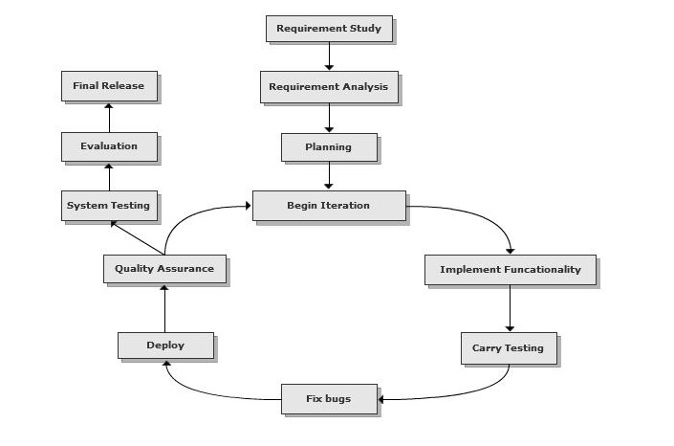
Figure 4-10 Iterative Development Methodology
[Adapted from http//davidhayden.com/blog/dave/archive/2005/02/14/828.aspx]
The above figure 4-10 shows the process of the iterative development methodology. The process started with the initial planning of the strategies that would be used during the development cycle. The tools that would be used for the development were decided upon. Microsoft visual studio was chosen as the most appropriate integrated development environment (IDE) for C#.
The project decided to have only two iterations. Iteration can also be considered as a milestone for the project. Requirements were mapped against the milestones. Each milestone consisted of five requirements. Test cases were developed for each milestone. At the end of a milestone, the test case for the current as well as all the previous milestones were verified so that bugs fixed at one stage did not have any detrimental effect on any other stages.
Bugs were fixed during the bug fixing cycle which is effectively between two milestones. All the bugs, if not most of them, were fixed before the beginning of the new milestone. The final bug fixing cycle addressed all the bugs that have been deferred for the next phase.
The deployment was incremental in the sense that current deployment consisted of product from all the previous iterations. Quality assurance was carried out at each stage. At the end, system testing was carried out on the final product.
The programming language used to develop the artifact was C# using Microsoft visual studio version 2012. The reason behind the above illustrated approach is to balance the limited time the current project has and the practical demonstration and evaluation needed for the chosen research literature. The methodology is effective considering the short span of development time. Division of the whole project on small development cycles is manageable and easier compared to when the project consisted of a single development, testing and development cycle. In other worlds it removes the overhead during the final testing and deployment stages. The final deployment of project will be carried out on the developer system and college premises, if necessary.

Evaluation Phase

The final phase used for the project was the evaluation phase. Evaluation is the means of verifying the correctness of the developed software, by getting feedback for the supervisors to test the product. The experiences of the users during the engagement of the product are collected. Software qualities such as effectiveness, completeness, extensibility, validity and robustness could be determined using this phase.
There is a need of evaluate every software product in order to determine the usability factor of the final product. A product that has not passed through this phase will fail to gather the targeted audiences. Evaluation of these products was carried out by supervisors.

Algorithms Developed for the Data Reduction Application

Till now the author elaborated the use and problem of the Urban mobility in Chapter 1 then the use of all the available feasible GPS data reduction techniques and validation techniques in chapter 2 following that the detailed process used to create the application using the SDLC standard and its several facets above. Basically, all these techniques and background is to create the Data reduction application for the GPS data of Urban Mobility Analysis to solve the problem statement illustrated in Chapter 1.
Hence, fulfilling those entire requirements illustrated in Chapter 3 using Chapter 2 for the Chapter 1 problem statement. Following algorithms or procedures have been deployed for the GPS data reduction application for the urban mobility analysis. The algorithms are divided into three parts:
- Data reduction using Principal Component Analysis (PCA)
- Data reduction using Data cleaning

Data reduction using Principal Component Analysis (PCA)

The GPS data reduction application for the urban mobility analysis has the following procedures:

- Load the data from the excel sheet to the memory using Excel Enterop.
- Copy the excel enterop to the data table.
- Clone the datatable into two datatable to manipulate column type as necessary.
- Copy all the empty rows to one data table and discard them. Eventually, all the data without empty rows will be inserted into another data table.
- From the collected datatable without empty rows all the duplicate records will be removed.
- After the duplicate data removed from the datatable, PCA computation process starts.
- First calculate the cumulative frequencies like Mean, Median, Mode, Standard deviation using Accord.Net component and display them in the data grid view.
- With the cumulative frequencies the Covariance matrix and Correlation matrix will be computed using Accord.NET component in the data grid view.
- Following that, Eigen vectors matrix, Principal Component base (ratio of principal components) and Z-scores will be computed and displayed in the datagrid view automatically from memory.
- Then project the Principal components by selecting the number of the components user would like to view. Then, using the Accord.Net components the computation will be shown in the screen.
- For the data reduction, the corresponding least possible Principal Components will be tallied to the Z-scores column and that value will be checked in the (Mean $±$ Standard Deviation * n), where n is the number of the standard deviation far from the mean.
- Finally all those data that are in between the illustrated value in above equation of point 11 will be displayed in the datagrid view.

Data reduction using Data cleaning

Above the author presented the algorithms for using the PCA and now the author has implemented the following algorithms for the data cleaning. And the process is:

- First the data is inserted into the memory using the Excel.Interop components.
- Then using the SqlClient that data is inserted into the SQL Server 2012 express edition database.
- After inserting into the SQL Server 2012 express edition database following different process will be applied for the data cleaning techniques:

- Empty Rows

- From the created table in the database as in the Appendix, the C# defined function will be used to communicate the database.
- Using the SQL (Structure Query Language) all the distinct rows will be returned and displayed in the datagrid view.
- And as a result, the before and after reduction statistics will be displayed in the result block under several textboxes.

- Duplicate records

- Using the C# defined function for the data communication with the front-end and back-end the data will be stored in the user created tables.

- From that table, using the SQL all the duplicate records will be taken out and others will be displayed in the datagird view.

- The user can alternatively see the particular duplicate records in another datagrid view by pressing the “Duplicate Records” blocks.

- Finally, all the result before and after reduction will be displayed in the result block of the application.

- Data segregation/ Noise Detection and removal

- The Noise detection was done using the

 | Mean $±$ Standard deviation * N | Equation 4-1

- For this, the loaded data above into the database using c# function will be considered.

- From those data, the TSQL (Transact Structure Query Language) procedure was created as in appendix. That procedure will be called from the C# and SQL Server database engine. That computes the range of data that falls inside the above illustrated Equation 4-1 and displayed in the data grid view.

- Finally, the user can view all the result of computation before and after reduction in the result block.

Data Reduction Application Overview

Using the above algorithms - If the user followed the procedure for the installation as in Appendix then the user can see the first screen after splash screen. That is the Principal components analysis technique implementation. That is the core implementation for the thesis. That was proven as the proper systematic reduction technique for the GPS data reduction for the urban mobility analysis by several experiments and theories provided before. On which we have two tabs, one is PCA computation and another is Data reduction. In PCA computation, the data is imported in the original data block. Then all other analysis will be performed as described block headings.

PCA

The process to do PCA includes the following:
Open file and select the file
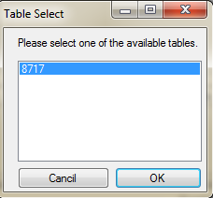
Select the sheet contained in your excel document and Press OK.
Then press Run Analysis for the first stages of PCA computation. Depending upon the volume of data, all the blocks will be populated immediately. Similarly, principal components analysis consists of several steps as described in the literature review, here also the user can see the several steps necessary to compute them.


Press “Yes” to proceed then the computation will start.
Then user can see following screen:
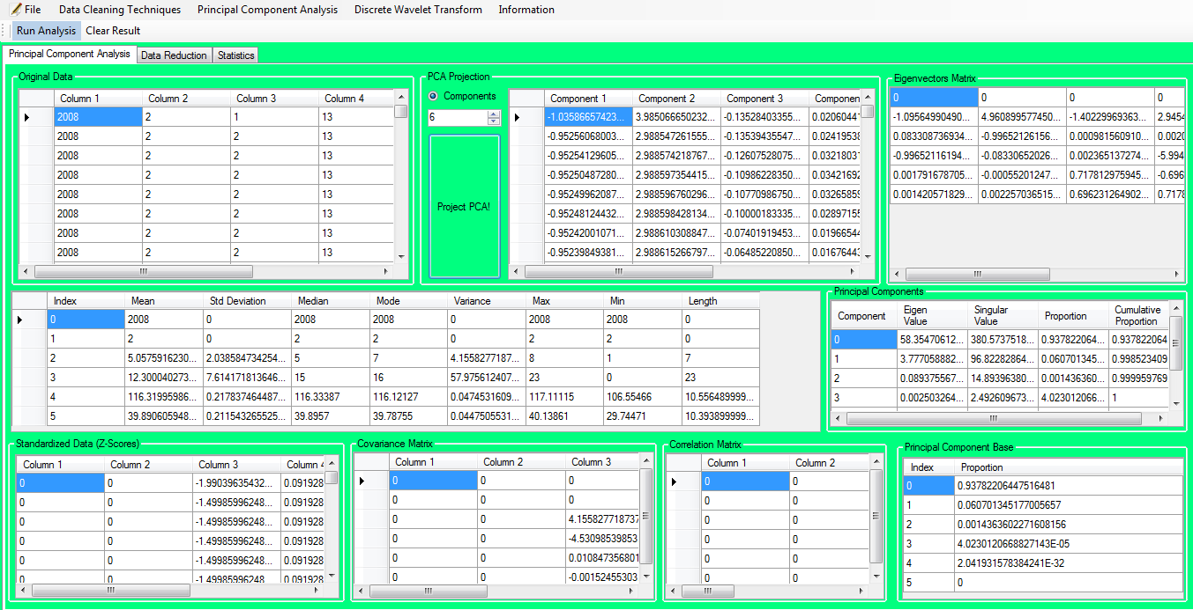
Figure 4-10 Computation of the result using the dataset as in Original data
Here, the user can see, Eigen Vectors Matrix, Cumulative frequency details, Principal Component’s overview, Z-scores, Covariance Matrix, Correlation Matrix and principal components proportion ratio under Principal Component Analysis tab.
To see the Principal components of the imported dataset, the user needs to press “Project PCA!” button in above figure. That looks like as following:

Here, user needs to select the number of components from drop down menu and press the “Project PCA!” then

Press “Yes” to both above screen
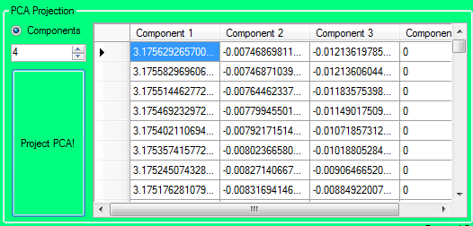
Based on the input data the above screen will be shown.
In the next tab, of Principal Components is Data Reduction:
Press “Click me” for data reduction button for data reduction using Principal Component Analysis.

Click “Yes” to both message to start data reduction process.
The user can see the following as the output,
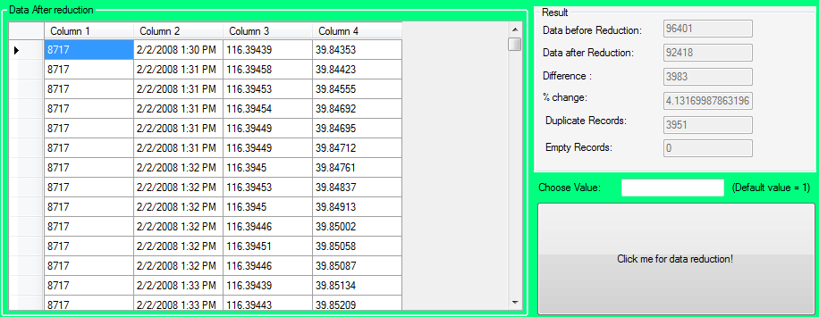
Here, in the above diagram, the user can choose the different values to determine number of times of standard deviation from the mean. The default value is 1. Similarly, the user can see the duplicates rows, empty rows within the datasets from this result set also. Those duplicates rows and empty rows are filtered before the above computation of deviation is done. The results can be seen like in above diagram. Accordingly, several new features have been added in the application. Among them, now the user can see the execution time taken by the application upon each calculation of Principal components. That is shown in the left down corner of the screen.
Basically, the above reduction is done using the Z-scores generated using Principal Component Analysis. And the computation is done using the
Mean $±$ (Standard Deviation * N).
Where, N is the number of times the standard deviation from the mean.
In the next section of the PCA, the user can see the statistics of the Principal Component Analysis computed above. That screen would be the following:

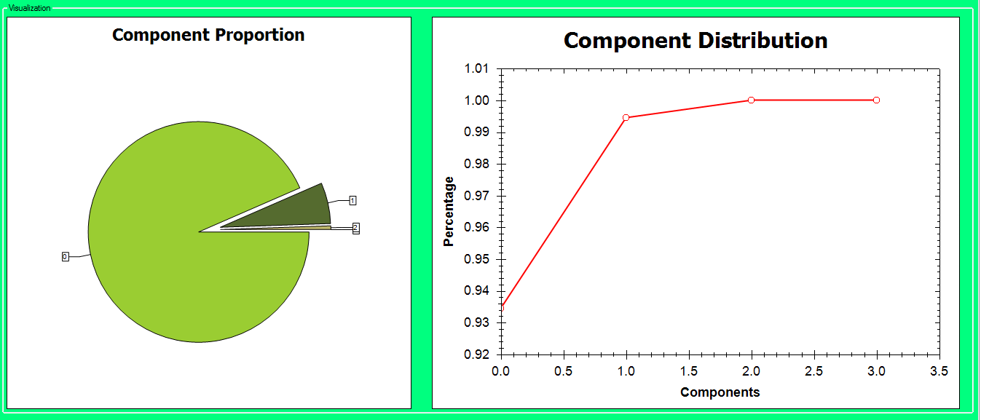

Here, the user can get the overview of the Component proportion and Component Distribution according to the result of the principal component analysis.
In the Component Proportion, the user can graphically view the different Principal Components proportion in the datasets. For example: in this above example the
PCA 1: 0.93459297563507415
PCA 2: 0.060015259937742253
PCA 3: 0.005391764427183557
PCA 4: 0

So, the Component Proportion graph shows the same and the component distribution graph shows the same in the percentage and components basis.
Finally, the user needs to save the document, to save the user needs to that is inside the file menu or use shortcut (CTRL+S). That results in opening of the save dialog box, which save the result in excel format at the user desired location. This saving process is valid for all the techniques used in this application.
Figure 4-11 Computation of the result using the dataset as in Original data
No the user can find the data cleaning techniques description below:
For the data cleaning the user can see the following screen as the menu item.
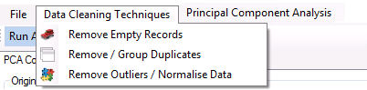

Empty Records:

Here the user can select the “Remove Empty Rows” from menu item for the data reduction using the compute button. Simultaneously, all the empty records would be removed in the after reduction datagrid. Then the result block will show the result before and after reduction with the clear and CLEAR button to clear the screen along with the CLOSE button to close the application.
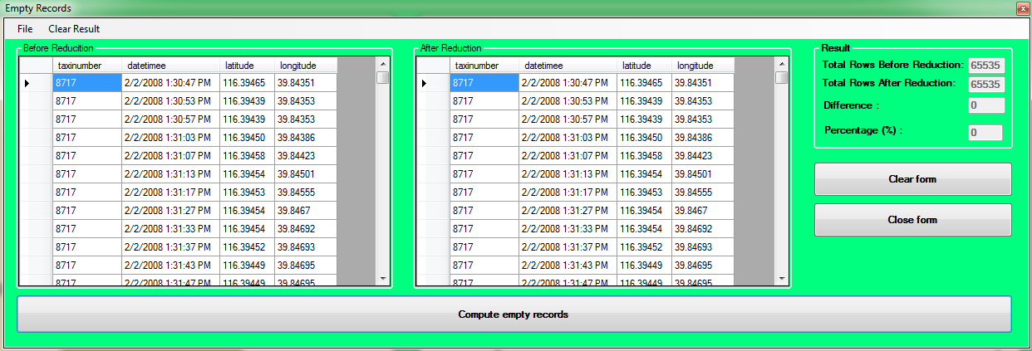
Finally, the user needs to save the document, to save the user needs to that is inside the file menu or use shortcut (CTRL+S). That opens the save dialog box, which makes the user to save the result in excel format at the user desired location. This process is valid for all the techniques used in this application.

Duplicate

To find out the duplicates records, the user needs to click the second menu item “Remove / Group Duplicates” of the data cleaning techniques. Then the user needs to import the file from the file, open menu item. Following that the data is inserted into the SQL Server 2012 database. Then the user can compute data using “Calculate the duplicate records” button. That results to display the result in the result block.
Here, the user can delete records from the database using “Delete records from database” and close the duplicate records window using “Close Form” button.
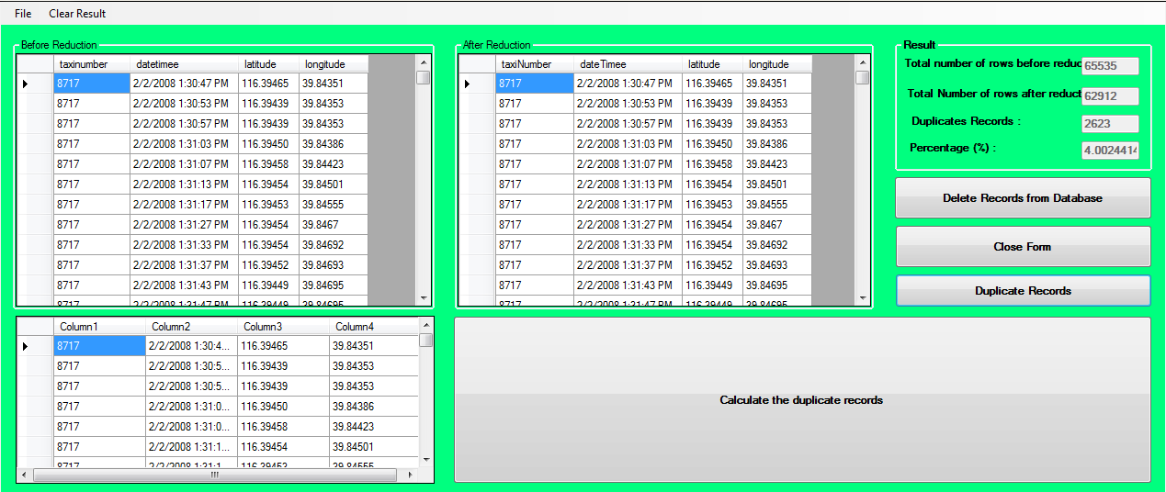
Here in the above screenshot, the “Delete Records from Database” helps user to delete record from the SQL SERVER 2012 database. While, “Close Form” helps to exit the form, “Duplicate Records” helps user to find duplicate records present in the dataset. Last, the user can do the computation for the duplicate records using “Calculate the duplicate records”.
Eventually, the user needs to save the document, to save the user needs to that is inside the file menu or use shortcut (CTRL+S). That opens the save dialog box, which makes the user to save the result in excel format at the user desired location. This process is valid for all the techniques used in this application.

Remove Outliers / Normalize data

For this technique, the user needs to click the third menu item (Remove Outliers / Normalize data) of the data cleaning techniques. That will make the following screen to be shown. If the user tried to compute without choosing the value (n) then the following screen will be shown else the result will be displayed. Basically, here in this technique, the user can find the data that is far from the mean. For that, the user needs to compute standard deviation and mean of the data. Then the “n” signifies for how many standard deviations are to consider while computing this techniques.
This form is using, Mean (+/-) Standard Deviation * n.
In other hand,

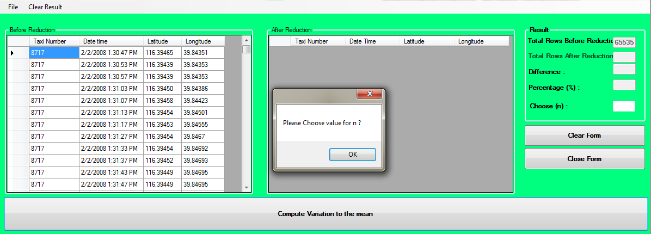
The overview of the noise along with the result is shown below. Here, the user can clear and close the screen using “Clear Form” and “Close Form” buttons respectively.
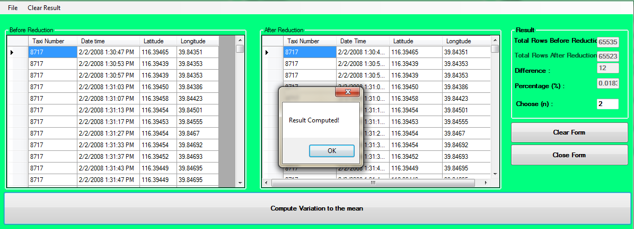

Eventually, the user needs to save the document, to save the user needs to that is inside the file menu or use shortcut (CTRL+S). That opens the save dialog box. That makes the user to save the result in excel format at the user desired location. This process is valid for all the techniques used in this application.
After the interface of the data reduction application, the user can find the future direction below.

Future Directions

Although, this is not a separate phase during the development of current software development, it was decided to include this section to give an insight into the future breakthroughs that are possible with this software. As, mentioned previously, all the requirements that have been identified during the requirement specification phase will not be implemented. Preference will be given to those which are more likely to have an impact on the usefulness of the data reduction for urban mobility analysis software.
Future enhancements are necessary for adding new features to the software that will increase the productivity of the users.
During the evaluation phase, the lack of time constraints resulted in the software not being tested. One of the future endeavors of the project will be to gather the appropriate audiences and measure more precisely the effectiveness of the project.
Due to the open nature of data reduction in C# application, it is appropriate to give back the product resulting from the project to the online open source community. There are plans to contribute any useful data reduction techniques that are developed during the project to the society. Consent will be provided for the necessary extension, distribution and further development of the software. The process will help in polishing and increasing the utilization of the software.

Chapter 5

In this chapter, the experiment and evaluated process were carried out with the artifact. This is one of the most important chapters, in which the product will be evaluated based on the experiments previously explained. This chapter gives the users results of the project and the views and comments demonstrated by the supervisors for the data reduction application.

Results

In the above experiment as in table 3-5, table 3-6, table 3-7, the author has tested experiment on the more than 1000 files presents in the T-taxi drive trajectories, which is the GPS traces collected for the Urban Mobility analysis. Basically, those trajectories contain several attributes as mentioned in chapter 2. So, the experiment was done on that.
The result for the each tools like Matlab, R and Data reduction application with 4 attributes as table 3-2 are shown below:
Techniques | Description | Before Reduction | After Reduction | Difference | Percentage(%)
PCA | 8117.CSV | 9000 | 6840 | 2160 | 24%
PCA | 7006.CSV | 2642 | 2635 | 7 | .2749
PCA | PCA1  PCA2  PCA3 | 2642 | 7 | 2635 | 99.723
PCA | PCA1  PCA2  PCA3 | 2642 | 2635 | 7 | .2749
PCA | PCA1  PCA2  PCA3 | 2642 | 2641.89 | 0.11 | .0045
PCA | 7016.txt | 2643 | 2570 | 73 | 2.67
PCA | PCA1  PCA2  PCA3 | 2643  2643  2643 | 1  2570  2642.84 | 2642  73  .15 | 99.9665  2.67  .0060
Data Cleaning | 7006.CSV | 2642 | 2486 | 156 | 5.90
Data Cleaning | Empty Rows  Duplicate & Invalid Records | 2642 | 2642 | 0 | 0
Data Cleaning | Empty Rows  Duplicate & Invalid Records | 2642 | 2486 | 156 | 5.90
Data Cleaning | 7016.txt | 2643 | 2202 | 440 | 16.6540
Data Cleaning | Empty Rows  Duplicate & Invalid Records | 2643 | 2643 | 0 | 0
Data Cleaning | Empty Rows  Duplicate & Invalid Records | 2643 | 2202 | 440 | 16.6540

(Details of above data can be found in the appendix)
Table 5-1 Result of Data Reduction using Matlab tools

Similarly, the following experiment was done using R, that is as follows:
Techniques | Description | Before Reduction | After Reduction | Difference | (%)
PCA | 7006.CSV | 2642 | 2589 | 53 | 2
PCA | PCA1  PCA2  PCA3 | 2642 | 53 | 2589 | 98
PCA | PCA1  PCA2  PCA3 | 2642 | 2589 | 53 | 2
PCA | PCA1  PCA2  PCA3 | 2642 | 2616 | 26 | . 01
PCA | 7016.txt | 2643 | 2141 | 502 | 19
PCA | PCA1  PCA2  PCA3 | 2643  2643  2643 | 503  2141  2617 | 2140  502  26 | 81  19  .01
Data Cleaning | 7006.CSV | 2642 | 2486 | 156 | 5.90
Data Cleaning | Empty Rows  Duplicate & Invalid Records | 2642 | 2642 | 0 | 0
Data Cleaning | Empty Rows  Duplicate & Invalid Records | 2642 | 2486 | 156 | 5.90
Data Cleaning | 7016.txt | 2643 | 2202 | 440 | 16.6540
Data Cleaning | Empty Rows  Duplicate & Invalid Records | 2643 | 2643 | 0 | 0
Data Cleaning | Empty Rows  Duplicate & Invalid Records | 2643 | 2202 | 440 | 16.6540

(Details of above data can be found in the appendix)
Table 5-2 Result of Data Reduction using R tools
Similarly, Result of Data reduction experiments using Data reduction application
Techniques | Description | Before Reduction | After Reduction | Difference | Percentage(%)
 | 7006.xls | 2642 | 2537 | 105 | 3.965
 | PCA1  PCA2  PCA3 | 2642 | 107 | 2535 | 95.969
 | PCA1  PCA2  PCA3 | 2642 | 2537 | 105 | 3.965
 | PCA1  PCA2  PCA3 | 2642 | 1641.8295 | .1705 | .06455
Data Cleaning | 7006.xls | 2642 | 2486 | 156 | 5.90
Data Cleaning | Empty Rows  Duplicate Records  Invalid Records | 2642 | 2642 | 0 | 0
Data Cleaning | Empty Rows  Duplicate Records  Invalid Records | 2642 | 2488 | 154 | 5.8289
Data Cleaning | Empty Rows  Duplicate Records  Invalid Records | 2642 | 2640 | 2 | .0757

(Details of above data can be found in the appendix)
Table 5-3 Result for Data Reduction using Data Reduction Application
Similarly, result comparison between the different techniques:
Techniques | Application | Description | Before Reduction | After Reduction | Difference | Percentage
PCA | MATLAB | 7006.csv | 2642 | 2635 | 7 | .2749
PCA | R | 7006.csv | 2642 | 2589 | 53 | 2
PCA | Data Reduction Application | 7006.xls | 2642 | 2537 | 105 | 3.965
Data cleaning | Matlab | 7006.csv | 2642 | 2486 | 156 | 5.90
Data cleaning | R | 7006.csv | 2642 | 2486 | 156 | 5.90
Data cleaning | Data Reduction Application | 7006.xls | 2642 | 2486 | 156 | 5.90
(Details of above data can be found in the appendix)
Table 5-4 Result comparison between the different techniques
In the above table, data reduction application is the one created in this project. Similarly, based on the above comparison table, it is visible that according to our problem statement in Chapter 1. Principal Component Analysis is better to resolve the problem that the author decided to carry out further research and by introducing software that will be specifically modified for the data reduction activities necessary during the urban mobility analysis. Alternatively, the user can find the data reduction application manual along with the software with this project. Hence, the project had demonstrated the practical feasibility of using such software for the data reduction techniques for GPS data reduction for Urban Mobility Analysis.
To validate the result obtained from Table 5-1, several tests were conducted on several other techniques usually used by several authors. The user can find the summary of those tests below:
Id | Datasets | Techniques | Prediction Equation | Accuracy | Comments
1 | 7006.csv | PCA | "- 0.001 * 2/2/08 13:35 ^ 1.000 + 9.705 * 116.314 ^ 4.000 - 49.767 * 39.895 ^ 4.000- 67.108" | 85%
2 | 7006.csv | Empty Records | "- 0.001 * 2/2/08 13:35 ^ 1.000 + 9.705 * 116.314 ^ 4.000 - 49.768 * 39.895 ^ 4.000- 67.108" | 82% | No Empty data on Sample Illustrated
3 | 7006.csv | Duplicate Records | "- 0.001 * 2/2/08 13:35 ^ 1.000 + 9.705 * 116.314 ^ 4.000 - 49.767 * 39.895 ^ 4.000- 67.108" | 78%
4 | 7006.csv | K-Means Clustering | "- 0.001 * 2/2/08 13:35 ^ 1.000 + 9.705 * 116.314 ^ 4.000 - 49.765 * 39.895 ^ 4.000- 67.108" | 75%
5 | 7006.csv | Expectation–maximization algorithm | "- 0.001 * 2/2/08 13:35 ^ 1.000 + 9.705 * 116.314 ^ 4.000 - 49.766 * 39.895 ^ 4.000- 67.108" | 50%
6 | 7006.csv | Hierarchical Clustering | "- 0.001 * 2/2/08 13:35 ^ 1.000 + 9.705 * 116.314 ^ 4.000 - 49.767 * 39.895 ^ 4.000- 67.108" | 80%
7 | 7006.csv | DBSCAN | "- 0.001 * 2/2/08 13:35 ^ 1.000 + 9.706 * 116.314 ^ 4.000 - 49.767 * 39.895 ^ 4.000- 67.108" | 75%

(Details of above data can be found in the appendix)
Table 5-5 Accuracy comparison between several algorithms using Rapid Miner tools
The above table 5-5 is the result obtained from the test conducted on 22 times in each file above. To elaborate further, the algorithm illustrated in chapter 2 Polynomial regression has been use to test the prediction of data points in each file with 22 different projections. Based on that using the dataminer tool called Rapid Miner the equation column is generated as in above table that predicts the data points of the file and the accuracy is computed by the data points availability before and after using each techniques that is illustrated in above table.

For the dataset 2 – without Minutes,
Tools | Techniques | Data Sets | Before Reduction  Coordinates | After Reduction  Coordinates | Generated Equation
Rapid Miner | Polynomial Regression | TaxiDriveTrajectories.csv | 8018,4,  116.31692,  40.03934 | 8018,4,  116.30999,  40.03834 | - 0.001 * Taxiid ^ 1.000 + 9.507 * time ^ 4.000 - 46.768 * latitude ^ 4.000 - 49.776 * longitude ^ 4.000 - 67.108
Rapid Miner | Polynomial Regression | TaxiDriveTrajectories1.csv | 7834,1,  116.42922,  39.90857 | 7834,1,  116.42922,  39.90857 | - 0.001 * Taxiid ^ 1.000 + 9.057 * time ^ 4.000 - 45.768 * latitude ^ 4.000 - 50.867 * longitude ^ 4.000 - 67.108
Rapid Miner | Polynomial Regression | TaxiDriveTrajectories2.csv | 8018,4,  116.31692,  40.03934 | 8018,4,  116.30990,  40.02991 | - 0.001 * Taxiid ^ 1.000 + 9.750 * time ^ 4.000 - 44.768 * latitude ^ 4.000 - 51.768 * longitude ^ 4.000 - 67.108

(Details of above data can be found in the appendix)
Table 5-6 Polynomial Regression Prediction for Validation for dataset 2 - without Minutes using Rapid miner
Alternatively, the same validation for the table 3-2, table 3-3 and table 3-4 have been verified using Naive Bayes Classifier.
Naive Bayes Classifier is a well known and simple technique use for the classification and prediction. Therefore, the author has implemented this based on the supervisor’s suggestion. Basically, the user can compute the naive bayes in following ways:
Brief introduction of the probability model can be view in Equation 5-1. Actually the probability model for a classifier is a conditional model. To illustrate; (StatSoft, 2013) let us see
 | p(C| F₁ , …….., F_{n}) | Equation 5-1
In the above equation 5-1, C is a dependent class variable with a small number of classes that is conditional on several feature variables F₁ through F_{n}. And to compute large number of n, the user need to restructure the equation 5.1 using Bayes’ theorem and that can be written as (StatSoft, 2013).

 | p(C| F₁ , …….., F_{n}) = $\frac{p\left(C\right) p (F1, …….,Fn|C)}{p(F1, …………,Fn)}$ | Equation 5-2

Alternatively, for basic familiarization purpose the above equation 5-2 can be written as (StatSoft, 2013)

 | Posterior = $\frac{Prior * Liklihood}{evidence}$ | Equation 5-3

Here in equation 5-3,
Posterior = p(C| F₁ , …….., F_{n}) = dependent class variable with several features variables
Prior = p(C) = probability of dependent class
Liklihood = p (F1,…….,Fn|C) = probability of features variables to dependent class.
Evidence = p(F₁,…………,F_{n}) = probability of features variables
Using the above either equation 5-2 or equation 5-3, the author has verified on each files 22 times and their accuracy was calculated. Finally, the following result was obtained.
For dataset 1,
Id | Datasets | Techniques | Accuracy | Comments
1 | 7006.csv | PCA | 95%
2 | 7006.csv | Empty Records | 98% | No Empty data on Sample Illustrated
3 | 7006.csv | Duplicate Records | 88%
4 | 7006.csv | K-Means Clustering | 85%
5 | 7006.csv | Expectation–maximization algorithm | 60%
6 | 7006.csv | Hierarchical Clustering | 90%
7 | 7006.csv | DBSCAN | 85%

(Details of above data can be found in the appendix)
Table 5-7 Accuracy computation using Naive Bayes Classifier
Reasons for Choosing PCA
The decision of using PCA is totally based on the practical experiment under the theoretical grounds described in chapter 2 of this project. Those reasons can be illustrated from the table 5-2 and table 5-3 other reasons are as follows:
Id | Datasets | Techniques | Accuracy
1 | 7006.csv | PCA | 85%
2 | 7006.csv | Duplicate Records | 78%
3 | 7006.csv | Hierarchical Clustering | 80%
4 | 7006.csv | Farthest First | 76%

(Details of above data can be found in the appendix)
Table 5-8 Top data reduction techniques based on Accuracy

For datasets 2,
Based on the theory provided in the Chapter 2 for Polynomial Rgression, the following result has been obtained.
Id | Datasets | Techniques | Prediction Equation | Accuracy
1 | TaxiDriveTrajectories.csv | PCA | - 0.001 * Taxiid ^ 1.000 + 9.507 * time ^ 4.000 - 46.768 * latitude ^ 4.000 - 49.776 * longitude ^ 4.000 - 67.108 | 85.5%
2 | TaxiDriveTrajectories.csv | Duplicate Records | - 0.001 * Taxiid ^ 1.000 + 9.506 * time ^ 4.000 - 46.776 * latitude ^ 4.000 - 49.667 * longitude ^ 4.000 - 67.108 | 77.9%
3 | TaxiDriveTrajectories.csv | K-Means Clustering | - 0.001 * Taxiid ^ 1.000 + 9.505 * time ^ 4.000 - 46.876 * latitude ^ 4.000 - 49.776 * longitude ^ 4.000 - 67.108 | 74%
4 | TaxiDriveTrajectories.csv | Expectation–maximization algorithm | - 0.001 * Taxiid ^ 1.000 + 9.503 * time ^ 4.000 - 46.788 * latitude ^ 4.000 - 49.677 * longitude ^ 4.000 - 67.108 | 56%
5 | TaxiDriveTrajectories.csv | Hierarchical Clustering | - 0.001 * Taxiid ^ 1.000 + 9.506 * time ^ 4.000 - 46.786 * latitude ^ 4.000 - 49.776 * longitude ^ 4.000 - 67.108 | 79%

(Details of above data can be found in the appendix)
Table 5-9 Prediction Probability using Polynomial Regression for dataset 2 using Rapid Miner
Note: In all of these probability experiments the empty rows have been removed because, basically, that can be easily taken out by the most of the data analysis tools and while doing these experiments the author has wipe out automatically by each tools and techniques illustrated.

Now, the user can find the Naïve Bayes classifier prediction based on the equation 5-2 for the dataset 2- without minutes below:

Id | Datasets | Techniques | Accuracy
1 | TaxiDriveTrajectories.csv | PCA | 88%
2 | TaxiDriveTrajectories.csv | Duplicate Records | 79%
3 | TaxiDriveTrajectories.csv | K-Means Clustering | 78%
4 | TaxiDriveTrajectories.csv | Expectation–maximization algorithm | 58%
5 | TaxiDriveTrajectories.csv | Hierarchical Clustering | 82%
6 | TaxiDriveTrajectories.csv | DBSCAN | 79%

(Details of above data can be found in the appendix)
Table 5-10 Naive Bayes accuracy using Dataset 2 - Without Minutes
Now the user can find the top 5 techniques suitable for each file in the data reduction of the GPS data for the Urban Mobility Analysis and they are:
Id | Datasets | Techniques | Accuracy
1 | TaxiDriveTrajectories.csv | PCA | 88%
2 | TaxiDriveTrajectories.csv | Duplicate Records | 79%
3 | TaxiDriveTrajectories.csv | Hierarchical Clustering | 82%
4 | TaxiDriveTrajectories.csv | DBSCAN | 79%

(Details of above data can be found in the appendix)
Table 5-11 top 5 techniques suitable for each files in the data reduction of the GPS data
The above table is the summary of the top 4 highest accuracy shown in the table 5-2 on each file as of datasets column.
  - The result obtained from the Matlab, R and several test conducted in the data cleaning shows that the result from the PCA is outstanding. Please refer to the result comparison table 5-4.
  - The result from the data cleaning techniques is totally ad-hoc because based on the empty rows, duplicate records and the data that are in the range of the normal distribution curve – the computation was done for Data Cleaning techniques.
  - The DWT - the several test conducted on the same file as of the PCA and Data Cleaning techniques show that the minimum frequencies data should be removed. That indicate the first column with the same name “Taxi number” should be removed. Unfortunately, that wouldn’t be feasible in this project because that column carry the information of all the taxi number at different period of time.
Alternatively, if the user wants to compute PCA of two attributes with timestamp (Date) and location (Latitude and Longitude) like in the figure 5-1 then the two principal components needs to be computed theoretically because principal components are directly proportional to the number of the attributes and its variables. However, practically, this does not happen because humans can differentiate the longitude and latitude in the location attributes but not the computer.
Date | Location
2/2/2008 13 | 116.32939,39.9751
2/2/2008 13 | 116.33088,39.97506
2/2/2008 13 | 116.33179,39.975
2/2/2008 13 | 116.33184,39.97477
2/2/2008 13 | 116.33184,39.9746
2/2/2008 13 | 116.33183,39.97448
2/2/2008 13 | 116.33182,39.97412
2/2/2008 13 | 116.33187,39.97391
2/2/2008 13 | 116.3321,39.97216
2/2/2008 13 | 116.33213,39.97183
2/2/2008 13 | 116.33218,39.97139

Table 5-12 Two attributes views of GPS data
The author has tried to compute that in several applications like in R, Matlab, Weka, and SPSS and found the following:
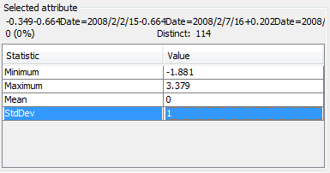
Figure 5-1 PCA result for the 2 attributes - timestamp and location using Weka tools
Here, in above figure, the cumulative frequency data from weka shows that mean= 0, standard deviation= 1, maximum data= 3.379 and minimum data -1.881. That proves the PCA is not feasible particularly in that case because if the cumulative frequency is 0 then the final result would be 0. Similarly, the result obtained from R was as follows:
Error in x - mean(x) : non-numeric argument to binary operator
In addition: Warning message:
In mean.default(x) : argument is not numeric or logical: returning NA

That illustrates that the PCA using timestamp and location (Latitude and Longitude) in this case particularly is not possible to compute PCA.

Instead, if the user segregates timestamp to year, month, hour and latitude and longitude like in following figure
TaxiNumber | Year | Month | Day | Hour | Latitude | Longitude
7146 | 2008 | 2 | 2 | 13 | 116.3294 | 39.9751
7146 | 2008 | 2 | 2 | 13 | 116.3309 | 39.97506
8179 | 2008 | 2 | 2 | 13 | 116.3318 | 39.975
8179 | 2008 | 2 | 2 | 13 | 116.3318 | 39.97477
8662 | 2008 | 2 | 2 | 13 | 116.3318 | 39.9746
8662 | 2008 | 2 | 2 | 13 | 116.3318 | 39.97448
9109 | 2008 | 2 | 2 | 13 | 116.3318 | 39.97412
9109 | 2008 | 2 | 2 | 13 | 116.3319 | 39.97391
9754 | 2008 | 2 | 2 | 13 | 116.3321 | 39.97216

Table 5-13 Data sample for segregating date
If the user tries to compute in the same form then the result would be as follow:
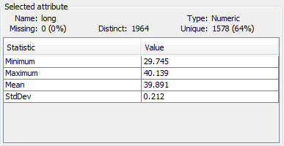
Figure 5-2 result of the cumulative frequency for above data using Weka tools
The above result of table 5-14 shows that PCA can be computed and data reduction is possible because PCA is computed using cumulative frequency. That means, the mean is 39.891 and standard deviation is .212. These data will compute the variance for the principal component analysis due to which the user can remove those containing less variance. So, the PCA needs the normal GPS data for the computation to use for the data reduction for urban mobility analysis. And rest of the reduction process is same as in the chapter 2.

Result Validation

Here in this section, the author is going to validate the work based with the completely different datasets from the original datasets in compare to variables, attributes and values itself. So, the author has used following two datasets.
Geo Trajectories
The following is the example of that datasets,

DataSet Identifier | Altitude | Days | Year | Time | Latitude | Longitude
0 | 201 | 39768.11 | 11/16/2008 | 2:44 | 40.01369 | 116.3063
0 | 243 | 39768.11 | 11/16/2008 | 2:44 | 40.01366 | 116.3061
0 | 235 | 39768.11 | 11/16/2008 | 2:44 | 40.01364 | 116.3063
0 | 243 | 39768.11 | 11/16/2008 | 2:44 | 40.01365 | 116.3062
0 | 225 | 39768.11 | 11/16/2008 | 2:44 | 40.0137 | 116.3063
0 | 198 | 39768.11 | 11/16/2008 | 2:44 | 40.0137 | 116.3064
0 | 173 | 39768.11 | 11/16/2008 | 2:44 | 40.01374 | 116.3065
0 | 149 | 39768.13 | 11/16/2008 | 3:05 | 40.01396 | 116.3064
0 | 154 | 39768.13 | 11/16/2008 | 3:06 | 40.01402 | 116.3064
0 | 161 | 39768.13 | 11/16/2008 | 3:06 | 40.01405 | 116.3064
0 | 166 | 39768.13 | 11/16/2008 | 3:06 | 40.01409 | 116.3063

Table 5-14 testing Geo Trajectories datasets with three months data
In the above table 5-15, the user can find the latitude, longitude, dataset identifier, and altitude, number of days, date, and time of the datasets. The above dataset was compiled from the Geo trajectories with three months data. (Zheng, Mining interesting locations and travel sequences from GPS trajectories, 2008). This GPS trajectory dataset was collected in (Microsoft Research Asia) Geolife project by 182 users in a period of over five years (from April 2007 to August 2012). (Lizhu Zhang, 2012) This dataset contains 17,621 trajectories with a total distance of 1,292,951 kilometres and a total duration of 50,176 hours. These trajectories were recorded by different GPS loggers and GPS-phones, and have a variety of sampling rates. (Zheng, Mining interesting locations and travel sequences from GPS trajectories, 2008) 91.5 percent of the trajectories are logged in a dense representation, e.g. every 1~5 seconds or every 5~10 meters per point.
Here, based on the Chapter 2 under Principal Component Analysis the following result was obtained:
Id | Datasets | Before Reduction | After Reduction | (%) Change
1 | 3monthsdatafromGeotrajectories.csv | 94620 | 91781 | 3

Table 5-15 PCA computation - 3 months Geo Trajectories data
Based on the chapter 3 under section Quality measures, the user can see the following test. In which two hypotheses can be withdrawn

 | H₀ : μ = .03  H_{A} : μ ≠ .03 | Equation 5-4

Like in the Chapter 3 under section Post evaluation, In above equation 5-4, μ= .03, that is the reduction rate and equation 5-4 says either the reduction rate is 3%, null hypothesis, or the reduction rate is not to equation 5-4 - 3%, alternative hypothesis. Therefore, let’s examine the Z-scores to verify that by following:
Z-scores:
From the above computation during PCA, (Ẋ) is .03 and standard deviation (б) is 11.173702106958826 and at confidence level of 95%, mean (μ) = 39787.500590761949.

The z-scores: Ƶ = $\frac{Ẋ - μ}{б/√n}$ = $\frac{.03-39787.500590761949 }{11.173702106958826/√94620}$ = - 11.57

According to the value obtained from z-scores the reduction rate is not equal to 3%. Therefore, alternative hypothesis is true. And that means the data lies below the mean due to negative Z-score value.

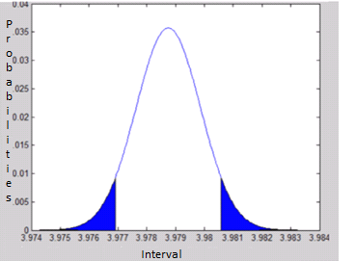
Figure 5-3 Normal distribution of above data reduction
According to the Table 5-3, the blue shaded area are considered as outliers and those have been reduced using the PCA.
Probability Plot

According the quality measures illustrated under Chapter 3 the following graph is obtained. Figure 5-4 (a) is for the data before reduction and Figure 5-4 (b) is for data after reduction.

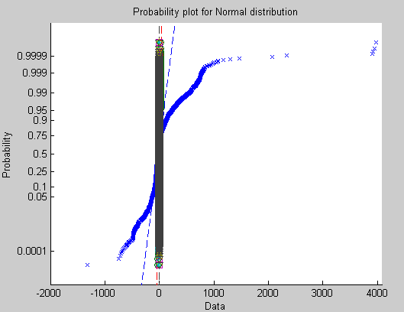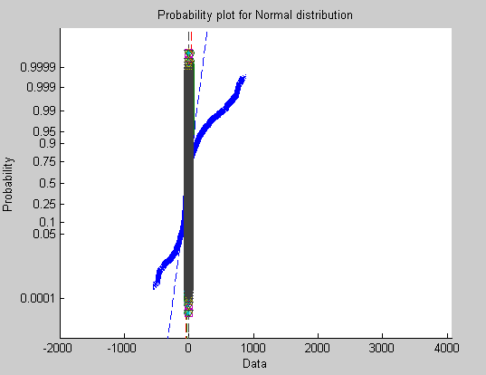
(a) Before Reduction (b) After reduction
Figure 5-4 Probability Plot before and after reduction
According to the Figure 5-3 (a) and (b), the lower and upper portions of the curly curve are removed after reduction. In the above figures, horizontal axis represents the data while the vertical axis represents the probability.
Similarly, the user can find the comparison between several other ten techniques to get the accuracies comparison as in table 5-2.
Id | Datasets | Techniques | Prediction Equation | Accuracy
1 | 3monthsdatafromGeotrajectories.csv | PCA | - 48.675 * 40.013694^ 5.000 - 8.990 * 116.306297 ^ 4.000 -0 - 2 * 201 -5.345 ^ 4.000- 3* 39768.11422 ^ 4.000 + 0.001 * 11/16/2008 ^ 1.000 + 0.001 *2:44:00 ^ 1.500 + 66.999 | 87%
2 | 3monthsdatafromGeotrajectories.csv | Duplicate Records | - 48.674 * 40.013694^ 5.000 - 8.991 * 116.306297 ^ 4.000 -0 - 2 * 201 -5.344 ^ 4.000- 3* 39768.11422 ^ 4.000 + 0.001 * 11/16/2008 ^ 1.000 + 0.001 *2:44:00 ^ 1.500 + 66.999 | 80%
3 | 3monthsdatafromGeotrajectories.csv | K-Means Clustering | - 48.696 * 40.013694^ 5.000 - 8.992 * 116.306297 ^ 4.000 -0 - 2 * 201 -5.343 ^ 4.000- 3* 39768.11422 ^ 4.000 + 0.001 * 11/16/2008 ^ 1.000 + 0.001 *2:44:00 ^ 1.500 + 66.999 | 79%

(Details of above data can be found in the appendix)
Table 5-16 Accuracy prediction for the project verification using Polynomial regression with Rapid Miner tools.

Now, the author can find the accuracies using Polynomial regression and Naive Bayes Classification. Let us compare the accuracy between the different techniques in naive bayes classifiers based on the Naive Bayes Classification of equation 5-2 and equation 5-3.
Id | Datasets | Techniques | Accuracy
1 | 3monthsdatafromGeotrajectories.csv | PCA | 94%
2 | 3monthsdatafromGeotrajectories.csv | Duplicate Records | 86%
3 | 3monthsdatafromGeotrajectories.csv | K-Means Clustering | 84%
4 | 3monthsdatafromGeotrajectories.csv | Expectation–maximization algorithm | 60%
5 | 3monthsdatafromGeotrajectories.csv | Hierarchical Clustering | 92%
6 | 3monthsdatafromGeotrajectories.csv | DBSCAN | 86%

Table 5-17 Naives Bayes Classifier Comparison between techniques
Comparing the above table 5-17 and 5-18, following conclusion can be drawn,
Id | Datasets | Techniques | Accuracy
1 | 3monthsdatafromGeotrajectories.csv | Polynomial Regression | 87%
2 | 3monthsdatafromGeotrajectories.csv | Naive Bayes Classification | 94%

Table 5-18 Accuracy table for 3 months data from geo trajectories

Based on the result obtained from the above table 5-17 and using Naive Bayes Classifier as described in chapter 5, the user can see the predicted value for the 8:44 am and 14:57 pm.
The point at 8:44 am is latitude of 39.977957 and longitude 116.327119 at altitude of 147.
Another one is at 14:57pm is latitude of 40.01375 and longitude 116.306432 at altitude of 191.
Randomly generated data
Basically, the author has used another datasets that was randomly generated excel data for the validation of this project. That is as follows:
Stastistics 1 | Stastistics 2 | Identifier | Year
0.418311831 | 0.255943129 | 1 | 2030
0.234961404 | 0.905202938 | 2 | 2029
0.58411138 | 0.810415631 | 3 | 2028
0.979996391 | 0.315488498 | 4 | 2027
0.063436662 | 0.642733831 | 5 | 2026
0.811690715 | 0.31840049 | 6 | 2025
0.059742327 | 0.399710179 | 7 | 2024
0.77684477 | 0.1469666 | 8 | 2023
0.391387562 | 0.266765998 | 9 | 2022

Table 5-19 Randomly generated data for the validation of this project
The above table 5-20 is the randomly generated data with the first column as stastistics1 that contains double digits with 5 precisions, second column is stastics2 that contains another double with 5 precisions, third as idetifier that is integer and last one is the year that is for the random future year with year data. And, the above data sets contain 90000 records for this test.
Here, based on the chapter 2 under Principal Component Analysis the following result was obtained:
Id | Datasets | Before Reduction | After Reduction | Change-
1 | 3monthsdatafromGeotrajectories.csv | 90000 | 37800 | 42%

Table 5-20 Randomly generated 90000 records PCA Result
Based on the chapter 3 under section Quality Measures, the user can see the following test used for the verification.
H₀ : μ = .42  H_{A} : μ ≠ .42 | Equation 5-5

Like in the Chapter 3 under section Post evaluation, In above equation 5-5, that is the reduction rate and equation 5-4 means either the reduction rate is 42%, null hypothesis, or the reduction rate is not to equation 5-5 - 42%, alternative hypothesis. Therefore, let us examine the Z-scores to verify that by following:
Z-scores:

From the above computation during PCA, (Ẋ) is .42 and standard deviation (б) is 586.154843023582 and at confidence level of 95%, mean (μ) = 1015.5.

The z-scores: Ƶ = $\frac{Ẋ - μ}{б/√n}$ = $\frac{.42-1015.5 }{586.154843023582/√90000}$ = 1.95

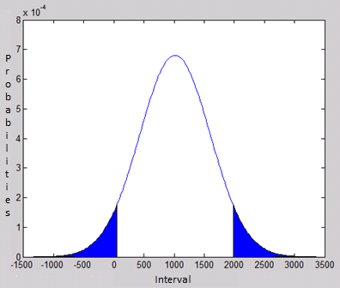
Figure 5-5 Normal distribution curve generated from above Z values computation
According to the value obtained from z-scores, which means the reduction rate is not equal to 42%. Therefore, alternative hypothesis is true. And that explains the data lies above the mean due to positive Z-score value.
Alternatively, Table 5-9, the blue shaded area is considered as outliers and those have been reduced using the PCA.
Probability Plot

According the quality measures illustrated under Chapter 3 the following graph is obtained. Figure (a) is for the data before reduction and Figure (b) is for data after reduction.
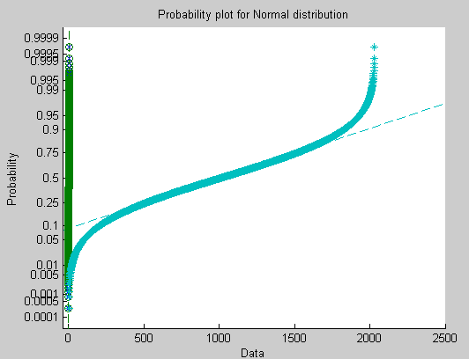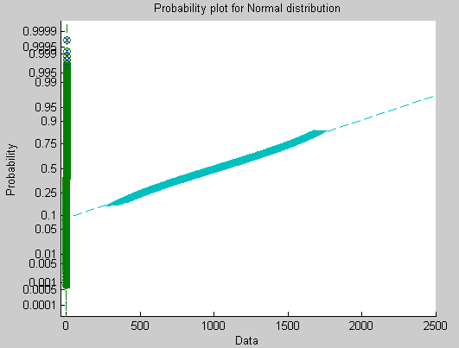
(a) Before reduction (b) After reduction
Figure 5-6 Probability plot for Normal Distribution
So, the data reduction was done using Principal Component Analysis. However, the other techniques like data cleaning techniques have been implemented in the application for the data reduction.
Similarly, the user can find the comparison between several other clustering techniques to get the accuracies comparison on random generated data like in table 5-2.
Id | Datasets | Techniques | Prediction Equation | Accuracy
1 | RandomlyGenerated90000Records.csv | PCA | - 11.674 * 2^ 9.000 - 6.3311 * 0.234961404 ^ 9.000 - 2.554*0.905202938 ^ 9.000- 1* 2029 ^ 9.000 + 23.999 | 47%
2 | RandomlyGenerated90000Records.csv | Duplicate Records | - 11.675 * 2^ 9.000 - 6.3312 * 0.234961404 ^ 9.000 - 2.553*0.905202938 ^ 9.000- 1* 2029 ^ 9.000 + 23.999 | 40%
3 | RandomlyGenerated90000Records.csv | K-Means Clustering | - 11.676 * 2^ 9.000 - 6.3313 * 0.234961404 ^ 9.000 - 2.552*0.905202938 ^ 9.000- 1* 2029 ^ 9.000 + 23.999 | 39%

(Details of above data can be found in the appendix)
Table 5-21 Accuracy comparison with several techniques on Random generated records using Rapid Miner tools
Now, the user can find the accuracies using Polynomial regression and Naive Bayes Classification. Let us compare the accuracies between the different techniques in naive bayes classifiers based on the Naive Bayes Classification of Equation 5-2 and Equation 5-3.
Id | Datasets | Techniques | Accuracy
1 | 3monthsdatafromGeotrajectories.csv | PCA | 52%
2 | 3monthsdatafromGeotrajectories.csv | Duplicate Records | 46%
3 | 3monthsdatafromGeotrajectories.csv | K-Means Clustering | 44%
4 | 3monthsdatafromGeotrajectories.csv | Expectation–maximization algorithm | 30%
5 | 3monthsdatafromGeotrajectories.csv | Hierarchical Clustering | 42%
6 | 3monthsdatafromGeotrajectories.csv | DBSCAN | 46%

Table 5-22 Naive Bayes comparison with different techniques on Random generated data
Discussions:
In the normal distribution curve in between Figure 5-3 and figure 5-7, the user might be wondering about the rows of reduction in the normal distribution probability plot that one figure 5-3 less rows removed in compare to figure 5-7, while still there is deviation in the graph. This is because of the use of PCA. In PCA, there are several components and that can computed in the choice of the user. In the above case, the first one is the geo trajectories data so the author selects the least components in contrast in the last one the author reduced data using the next to bigger one so the more rows were reduced. Actually, the above two verities are shown to show this relationship.
Now, the author can find the accuracies using Polynomial regression and Naive Bayes Classification. Based on the table 5-20 and table 5-21. The following conclusion have been drawn,
Id | Datasets | Techniques | Accuracy
1 | RandomlyGenerated90000Records.csv | Polynomial Regression | 47%
2 | RandomlyGenerated90000Records.csv | Naive Bayes Classification | 52%

Table 5-23 3-months data from Geo Trajectories
Result Verification
As, till now the user has witnessed the experiments with the several techniques and GIS application specially in the T-drive trajectories datasets that was provided with the thesis proposal. Now, the author will be presenting different dataset called Geo trajectories to verify the information loss is negligible and the PCA is reliable for the GPS data reduction for Urban Mobility analysis. That dataset consists of following parts:

DataSet Identifier | Altitude | Days | Year | month | Day | Time | Location
0 | 201 | 39768.11 | 2008 | 11 | 16 | 2 | 40.013694,116.306297
0 | 243 | 39768.11 | 2008 | 11 | 16 | 2 | 40.01366,116.30613
0 | 235 | 39768.11 | 2008 | 11 | 16 | 2 | 40.013638,116.306306
0 | 243 | 39768.11 | 2008 | 11 | 16 | 2 | 40.013647,116.306185
0 | 225 | 39768.11 | 2008 | 11 | 16 | 2 | 40.013699,116.306348
0 | 198 | 39768.11 | 2008 | 11 | 16 | 2 | 40.013702,116.306433
0 | 173 | 39768.11 | 2008 | 11 | 16 | 2 | 40.013738,116.306481
0 | 149 | 39768.13 | 2008 | 11 | 16 | 3 | 40.013962,116.306416

Table 5-24 Geo Trajectories datset sample for the result verification
Here, in the above table 5-25 the user can see following attributes:
DataSet Identifier: Data set identifier number
Altitude: altitude of the geo data source occurrence point
Days: total number of days of the geo data source occurrence point
Year: year of the geo data source occurrence point
Month: Month of the geo data source occurrence point
Day: day of the geo data source occurrence point
Location*: combination of latitude and longitude
Time: time in hour of the geo data source occurrence point

With the above datasets of more than 3 months data and 10% of the total datasets available for the Geo trajectories by using the sampling techniques mentioned in chapter 3, following procedures have been applied using several GIS application like ArcMaps, Quantum GIS, Google maps pro etc.
This result verification has been done using several approaches but mostly using the following procedures:

  - Plotting data in open street layer
  - Create a grid on the area
  - Assign each individual GPS sample to nearest cell
  - Assign colors to each cell indicating more or less samples
  - Origin-destination matrix
  - Compute and compare them

Based on the above procedures the user can see the open street layer with the data from Geo-trajectories below:

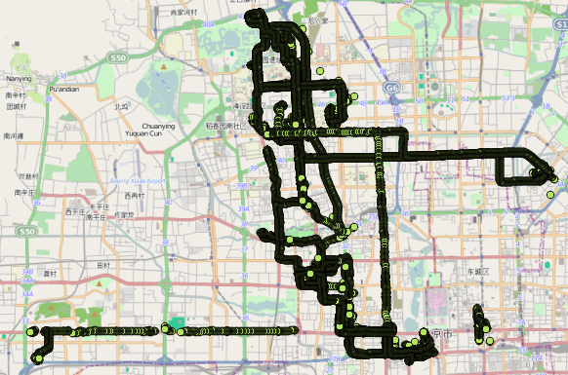

Figure 5-7 Before Reduction data in the Open street view of geo trajectories

Figure 5-8 After Reduction data in the Open street view of geo trajectories using Quantum GIS tools

Create a grid on the area

Now, like for the taxi-drive trajectories, here also the user can see the grid created with 50 meters in the above plotted data.

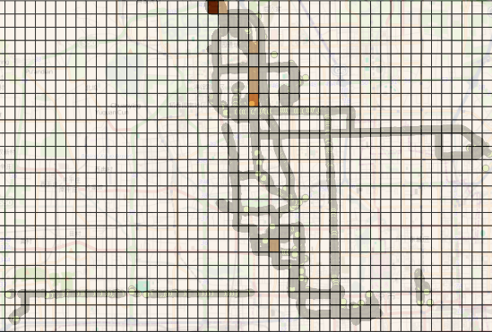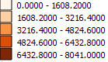
Figure 5-9 after Reduction data in the Open street view of geo trajectories for 50 meters using Quantum GIS tools
Here, in the above figure 5-9 the user can see the grid with the datasets embed inside the different colored grid. That color is based on the sample size in it. That is segregated based figure illustrated by side of the grid.
Following the objective of this experiment to know the information loss of the data reduction; the user can see the result from the Polynomial Regression to predict the location. And based on the times of the right result, the user can find the accuracy for the 50 meters grid of the Geo trajectories.
Tools | Hour | Coordinates | Predicted  Coordinates | Generated Equation | Accuracy
Rapid Miner | 2 | 40.013667,116.306188 | 40.013667,116.306188 | - 0.001 * Taxiid ^ 1.000 + 9.750 * month ^6.000 - 24.7867 + day ^6.000 - 24.768 –  hour ^6.000 - 24.568 -  location ^6.000 - 51.768 - 67.108 | 100%
Rapid Miner | 3 | 40.01425,116.305716 | 40.01425,116.305716 | - 0.001 * Taxiid ^ 1.000 + 9.750 * month ^6.000 - 24.7867 + day ^6.000 - 24.768 –  hour ^6.000 - 24.568 -  location ^6.000 - 51.768 - 67.108 | 100%
Rapid Miner | 4 | 39.986982,116.348175 | 39.986982,116.348175 | - 0.001 * Taxiid ^ 1.000 + 9.750 * month ^6.000 - 24.7867 + day ^6.000 - 24.768 –  hour ^6.000 - 24.568 -  location ^6.000 - 51.768 - 67.108 | 100%
Rapid Miner | 5 | 39.986547,116.347575 | 39.986547,116.347575 | - 0.001 * Taxiid ^ 1.000 + 9.750 * month ^6.000 - 24.7867 + day ^6.000 - 24.768 –  hour ^6.000 - 24.568 -  location ^6.000 - 51.768 - 67.108 | 100%

(Details of above data can be found in the appendix)
Table 5-25 accuracy for the 50 meters grid of the Geo.trajectories using Rapid Miner tools
Similarly, the author has illustrated the Naïve Bayes classifier in the chapter 3. And again here the author is going to implement the same algorithm to compute the accuracy of the 50 meters grid of the geo trajectories.

 | Before |  | After
Time in hour | Location | Distance | Location | Distance | comments | Accuracy
2 | 40.013667,116.306188 | 2.02E-05 | 40.013667,116.306188 | 2.02E-05 | equal | 100%
3 | 40.01425,116.305716 | 2.75E-05 | 40.01425,116.305716 | 2.75E-05 | equal | 100%
4 | 39.986982,116.348175 | 8.25E-06 | 39.986982,116.348175 | 8.25E-06 | equal | 100%
5 | 39.986547,116.347575 | 1.17E-05 | 39.986547,116.347575 | 1.17E-05 | equal | 100%
6 | 39.986169,116.348511 | 4.63E-05 | 39.986169,116.348511 | 4.63E-04 | less | 80%

(Details of above data can be found in the appendix)
Table 5-26 accuracy of the 50 meters grid of the geo trajectories using Naive Bayes Classifier
Discussion: Here in the above table 5-27, the user can see the accuracy to be much similar; almost above 90% in average. That indicate that the prediction done using the Naive Bayes classifier and Polynomial is same for the 50 meters grid of the before reduction data for the geo trajectories.
Similarly, the user can see the similar result for the 500 meters grid of the before reduction data in the open street view of geo trajectories.

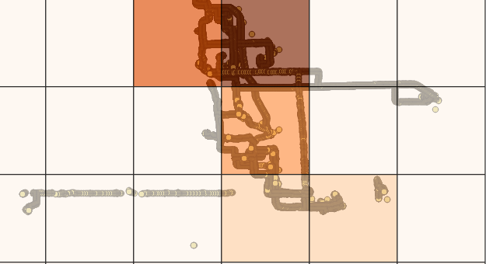
Figure 5-10 after Reduction data in the Open street view of geo trajectories for 500 meters using Quantum GIS tools
That color segregation is based on the following:
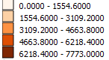
In the above figure 5-10 the user can see the before reduction data in the open street view of geo trajectories for 500 meters. Along that, the user can see the grid with data and different colors. Basically, like in the above experiments of taxi-trajectories, that colors get changed based on the sample size present in it.
Now, using the experiment of above table 5-12 and table 5-13 and the Polynomial regression as mentioned in the chapter 2. The following computation is done.

Tools | Hour | Coordinates | Predicted  Coordinates | Generated Equation | Accuracies
Rapid Miner | 2 | 40.013667,116.306188 | 40.013667,116.306188 | - 0.001 * Taxiid ^ 1.000 + 9.750 * month ^6.000 - 24.7867 + day ^6.000 - 24.768 –  hour ^6.000 - 24.568 -  location ^6.000 - 51.768 - 67.108 | 100%
Rapid Miner | 3 | 40.01425,116.305716 | 40.01425,116.305716 | - 0.001 * Taxiid ^ 1.000 + 9.750 * month ^6.000 - 24.7867 + day ^6.000 - 24.768 –  hour ^6.000 - 24.568 -  location ^6.000 - 51.768 - 67.108 | 100%
Rapid Miner | 4 | 39.986982,116.348175 | 39.986982,116.348175 | - 0.001 * Taxiid ^ 1.000 + 9.750 * month ^6.000 - 24.7867 + day ^6.000 - 24.768 –  hour ^6.000 - 24.568 -  location ^6.000 - 51.768 - 67.108 | 100%

(Details of above data can be found in the appendix)
Table 5-27 Polynomial regression accuracy computation for the 500 meters grid using Rapid Miner tools
Similarly, the user can see the experiment done in using Naïve Bayes classifier explaned in chapter 3. In this, the origin-destination matrix is computated and that is tallied to the data before and after reduction on the 500 meters grid. Eventually, based on the number of correct result the accuracy attributes is defined.

 | Before |  | After
Time in hour | Location | Distance | Location | Distance | comments | Accuracy
2 | 40.013667,116.306188 | 2.02E-05 | 40.013667,116.306188 | 2.02E-05 | equal | 100%
3 | 40.01425,116.305716 | 2.75E-05 | 40.01425,116.305716 | 2.75E-05 | equal | 100%
4 | 39.986982,116.348175 | 8.25E-06 | 39.986982,116.348175 | 8.25E-06 | equal | 100%
5 | 39.986547,116.347575 | 1.17E-05 | 39.986547,116.347575 | 1.17E-05 | equal | 100%
6 | 39.986169,116.348511 | 4.63E-05 | 39.986169,116.348511 | 4.63E-04 | less | 80%

(Details of above data can be found in the appendix)
Table 5-28 Naïve Bayes classifier prediction in the 500 meters geo-trajectories data, Time to Distance In Geo Trajectories

In the same way, the user can find the computation of the 1000 meters grid in the gro-trajectories data for the urban mobility analysis.
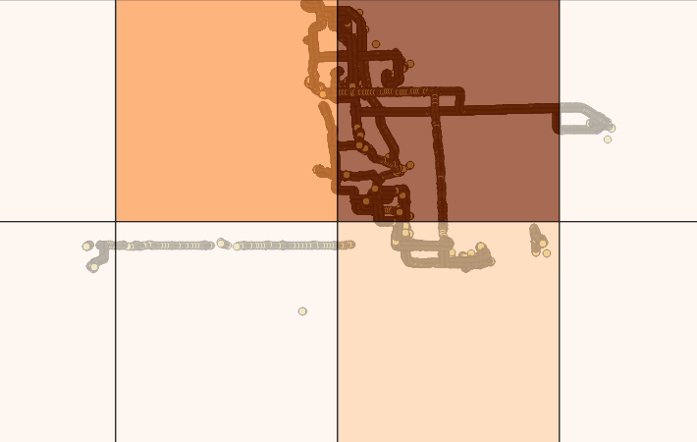
Figure 5-11 Before Reduction data in the Open street view of geo trajectories for 1000 meter using Quantum GIS tools
The color segregation based on the sample size in the above grid is done by following:
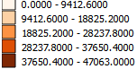
Using the open layer and the polynomial regression as mentioned in the chapter 2, the following computation has been done to compute the accuracy at different interval of hour and coordinates.The result of the above figure is given below:
Tools | Hour | Coordinates | Predicted  Coordinates | Generated Equation | Accuracy
Rapid Miner | 2 | 40.013667,116.306188 | 40.013667,116.306188 | - 0.001 * Taxiid ^ 1.000 + 9.750 * month ^6.000 - 24.7867 + day ^6.000 - 24.768 –  hour ^6.000 - 24.568 -  location ^6.000 - 51.768 - 67.108 | 100%
Rapid Miner | 3 | 40.01425,116.305716 | 40.01425,116.305716 | - 0.001 * Taxiid ^ 1.000 + 9.750 * month ^6.000 - 24.7867 + day ^6.000 - 24.768 –  hour ^6.000 - 24.568 -  location ^6.000 - 51.768 - 67.108 | 100%

(Details of above data can be found in the appendix)
Table 5-29 Polynomial regression accuracy prediction for the 1000 meters grid of Geo-trajectories using Rapid Miner tools
Similarly, like the user saw for the 500 meters grid, here also we are using naïve bayes classifier based on the origin-destination matrix computed from the GIS application and tallying the result before and after reduction of the data.

 | Before |  | After
Time in hour | Location | Distance | Location | Distance | comments | Accuracy
2 | 40.013667,116.306188 | 2.02E-05 | 40.013667,116.306188 | 2.02E-05 | equal | 100%
3 | 40.01425,116.305716 | 2.75E-05 | 40.01425,116.305716 | 2.75E-05 | equal | 100%
4 | 39.986982,116.348175 | 8.25E-06 | 39.986982,116.348175 | 8.25E-06 | equal | 100%
5 | 39.986547,116.347575 | 1.17E-05 | 39.986547,116.347575 | 1.17E-05 | equal | 100%
6 | 39.986169,116.348511 | 4.63E-05 | 39.986169,116.348511 | 4.63E-04 | less | 80%

(Details of above data can be found in the appendix)
Table 5-30 Naive Bayes Classifier for the 1000 Meters grid, Time to Distance In Geo Trajectories
The above shows that the data before and after reduction are similar for the Taxi drive trajectories and geo trajectories.
Based on the result obtained from the above table 5-18 and using Naive Bayes Classifier as described in Chapter 5 - the user can see the predicted value for the year 2021 is for the 0.797663158, 0.161171775,10. The same information could be found in either files of the data reduction.
Accordingly from table 5-31, for the geo-trajectories, the pickup time has been identified as 2 am at location 40.013667, 116.306188. And end time is identified as 23 pm at location 39.926205, 116.337153.
So, the above different varieties of experiments and specially from Table 5 9 ,Table 5-18 ,Table 5-24 for the PCA results shows that the PCA is the suitable data reduction techniques for the GPS data reduction for the urban mobility analysis. And the result of PCA application - data reduction application has the reliable and authenticates output. Hence, the user can be assured of the verified and validated result from PCA.

Thesis Summary

The thesis commenced with Chapter 1 by carrying out an in-depth analysis of the Urban Mobility Analysis and its challenges. Various advantages and disadvantages of urban mobility in respect to the information technologies have been discussed in detail. It also established why introducing urban mobility analysis for the data reduction to the data analyst can be beneficial. The chapter concluded by laying down the problem statement and motivation and objectives.
Chapter 2 identified that several data reduction techniques and using Principal components analysis is dominant in the data analysis in compare to several data cleaning techniques for the GPS traces of Urban Mobility analysis in detail. Various advantages and disadvantages of using such methods during research were recognized. It also established why introducing GPS data to future researcher can be beneficial. In particular, the chapter advocated the use of open source Data Reduction as the best candidate for analyzing future modifications of urban mobility analysis.
Chapter 3 discussed the evaluation of the different data reduction techniques using several commercial products like R and Matlab. It showed us the different stages of the evaluation and result obtained in each of them. The result was proved using different quality measures in either of products.
Chapter 4 discussed different phases of the software development life cycle (SDLC) beginning from analysis of the raw data to the delivery of the product. The whole cycle was divided into five phases namely Preliminary Study Phase, Analysis Phase, Specification Phase, Development Phase and Evaluation Phase. Preliminary Study Phase consisted of gathering relevant data from state of arts. Thematic Analysis was carried out the data and was analyzed in Analysis Phase. Requirements were formed in Specification Phase. The actual development and testing of the artifact was carried out in Development phase and finally it was evaluated in Evaluation Phase. Thematic analysis was carried out on the data collected via the state of arts. Several themes were extracted. Each theme served as a source of requirements for the project. The identified requirements were categorized, on the basis of their priority, into four groups namely targeted, differed, and infeasible and out of scope. The chapter concluded by listing all the requirements that belonged to the “targeted” category.
Chapter 5 and 6 deals with the verification of the result obtained above and the research contribution and the future development projections. Along with all the programming details that was used in computing the experiments as an Appendix.

Research Contributions

The Project makes three contributions to the society. They are:
  - Contribution to state of arts
  - Data reduction for the urban mobility analysis
  - Data reduction Open Source application
  - Data reduction Open Source community
Each of the contribution has been explained in the following section.

Contribution to State of Arts

In the state of arts, the author illustrated several techniques for the urban mobility’s different prospects, data reduction, clustering techniques, and several other tools that the researchers have been using since long time. However, the major contributions that this project made to the state of arts are
- Proper algorithms that is principal components analysis for the reduction of GPS data analysis. Due to which, the future researchers do not need to test again with the same algorithm for this type of GPS data for urban mobility analysis.
- Another contribution to the state of arts is the top 4 data clustering techniques that can be used for the data reduction namely hierchial clustering, DBSCAN, Kmeans and expectation-maximaisation clustering.

Data reduction for the urban mobility analysis

This is one of the primary contributions made by the thesis. It has been clearly presented in Chapter 4 and verified in Chapter 4. The several data reduction techniques have been discussed and verified using the commercial tools. The project has identified the key techniques that form the basic building blocks for the data reduction techniques.
Elaborating, the future researchers and society can see the usefulness of using Principal Component Analysis instead of data cleaning techniques for this type of urban mobility data analysis from this thesis. Following that the major components necessary for the data reduction techniques have been identified. Those components include, Dimensionality of data, Signal created by datasets, Frequencies of the data, and Variations in datasets.
Furthermore, the following contributions have been made to the society using data reduction for urban mobility analysis.
- The experiment verification of using PCA over other data reduction techniques by table 5-3.
- This project adds additional benefits of finding 4 best techniques used for data reduction for urban mobility analysis by table 5-4 and they are:
- PCA
- Duplicate Records
- Hierarchical Clustering
- DBSCAN

Data reduction Open Source application

This is another contribution made by the thesis. It has already been presented in Chapter 4 and verified in Chapter 5. The “Data Reduction Application”, artefact of this thesis, forms a stepping stone for the introduction of data reduction software for the urban mobility analysis. The intuitive and easy to use tool will save time for the data analyst to draw, plan and visualize the result of Principal Components analysis and data cleaning techniques in one single desktop application.
It came to knowledge that dimensionality, frequencies, signals generated by the datasets are essential for the data reduction application and selecting data reduction techniques. Other features include automatically processing of the datasets for the PCA in the memory of the application and data cleaning techniques using the database, saving the reduced datasets in excel using save button.
It has also made an indirect contribution to students, by giving them an opportunity to engage within the process and present their views. The positive and exceptional feedbacks received from several Information technology professionals during the evaluation period signify that the prospect of using “Data Reduction Application” as a tool for the data reduction techniques for urban mobility analysis is tremendous. Hence, it can be concluded that the project has addressed the needs of several partied by providing them with a reliable platform.

Data reduction open source community

The thesis makes contribution in creating a new open source community for the data reduction application. Developers wishing to modify or enhancing the features of the product are entitled to do so, as the source codes will be freely available. As product evolves, with rigorous testing and inclusion of more advanced features, it will be a step closer to realizing one of the objectives of the project.
Although, the models appear basic in terms of shape and size, it can invariably be modified using several data reduction modeling software.

Chapter 6

Future development Projections

The thesis can be extended in different ways as future developments. The following figure 0-1 illustrates the ideas.
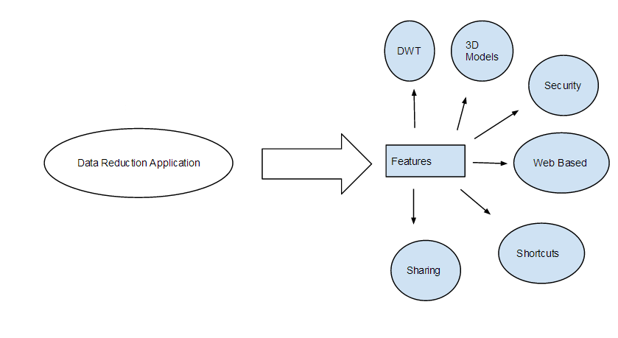
Figure 0-1 future projection of the project
One of the future prospects of the thesis is to increase the techniques in the software by adding another features on data compression technique named DWT (Discrete Wavelet Transform). This includes adding and reorganization of the buttons in the toolbar. Unnecessary and less frequently used buttons may be discarded or made invisible from the main application window. It is likely that the reproduced software will be more user-friendly and meaningful to the intended audience.
The current project doesn’t contain useful, albeit few 3D models necessary for the data analyst. New models can always be added easily to the software. Advanced models such as 3D graphs, 3D data visualizations can be developed using any 3D modeling software and integrated with the project. The process requires identification of the common models prevalent in the data reduction.
Another area that can be focused as a future endeavor for the project is the inclusion of some security features. Features such as password-protect for the generated results add reliability and trust towards the software by the user. Issues of the field indicate the possibility of modification of the file by not only other members but also by mistakes. By limiting the access to the closed loop of the appropriate practitioners, security can be increased.
The project may be developing into a web-based product so that the software may be more accessible to a wide audience without dependency upon any Operating System platforms. It would remove the hassle of installation and configuration of the product by the researchers. It also means that each generated result needs to be accessed via user login providing more security to its contents.
Other future projects of the software would be adding features that enable the analyst to share and collaborate easily with their colleagues. Adding such features would be useful to the data analyst. Similarly, another development can be adding shortcuts of the application. Usually, people prefer to have shortcuts in their desktop for accessing the application easily.

Conclusions

To this date, there has not been any documented technological assistance for the data reductions (DRs) to carry out the urban mobility analysis process. Although, some of them have relied on basic approaches to ease the process, such methods have not been standardized. It is agreed that use of any technology cannot replace the role of data analyst, but development of certain assistive tools can definitely be beneficial to them.
As urban mobility analysis required suitable modification of data sets, it was wise, if not necessary, to have a blueprint of the future modifications, so that the analyst could share the designs with the user. One of the better options identified by this project, was the use of GPS traces by GPS devices directly to data reduction application to show how the future developments would look like.
In addition, based on the experiment conducted on the Chapter 3 using the state of arts from Chapter 2 with the data prediction techniques - the following conclusion table can be drawn. In which the rapid miner was used with Polynomial Regression for several datasets and the after reduction coordinates was predicted based on the polynomial regression and naïve bayes table of the result in Table 6-1 Result comparison between the different techniques.

Id | Datasets | Techniques | Accuracy
1 | TaxiDriveTrajectories.csv | PCA | 88%
2 | TaxiDriveTrajectories.csv | Duplicate Records | 79%
3 | TaxiDriveTrajectories.csv | K-Means Clustering | 78%
4 | TaxiDriveTrajectories.csv | X-means Clustering | 69%
5 | TaxiDriveTrajectories.csv | Expectation–maximization algorithm | 58%

(Details of above data can be found in the appendix)
Table 6-1 Result comparisons with different techniques with taxi drive trajectories
Id | Datasets | Techniques | Accuracy
1 | 3monthsdatafromGeotrajectories.csv | PCA | 94%
2 | 3monthsdatafromGeotrajectories.csv | Duplicate Records | 86%
3 | 3monthsdatafromGeotrajectories.csv | K-Means Clustering | 84%
4 | 3monthsdatafromGeotrajectories.csv | X-means Clustering | 77%
5 | 3monthsdatafromGeotrajectories.csv | Expectation–maximization algorithm | 60%
6 | 3monthsdatafromGeotrajectories.csv | Cobweb | 58%
7 | 3monthsdatafromGeotrajectories.csv | Hierarchical Clustering | 92%
8 | 3monthsdatafromGeotrajectories.csv | DBSCAN | 86%
9 | 3monthsdatafromGeotrajectories.csv | Farthest First | 88%

Table 6-2 Top data reduction techniques based on Accuracy for GPS data of Urban Mobility Analysis with Geo trajectories.
Considering all the above verification and necessities that arose both through the state of art and supervisor suggestions, it was established that Data Reduction application was a great companion for the analyst during Urban mobility analysis. Most Importantly, Principal Component Analysis is considered to be wise method for the data reduction of GPS data for Urban Mobility Analysis. And features in the data reduction application allowed the user to view the result as was seen in the real world scenario of data reduction. And the fact that data reduction software, extension as well as the modification of the features was possible.
In addition, using the Naïve bayes classifier in Chapter 5 under result sections, for the verification time was predicted for the morning 8 am and evening 18 pm and that was based on the drop on and drop off location. Basically, that was checked based on the number of records occurring in particular time for different taxi number. And segregating the data and time into several attributes without considering seconds information the coordinates computed in morning 8 am and evening 18 pm are
Morning 8am – 116.3568000, 39.8979000
Evening 18pm – 116.3106500, 39.9790800

Thematic analysis was carried out on the collected data and set of requirement were formed. Each of the requirements was categorized into sub-categories such as Targeted, Deferred, Infeasible and Out of Scope. Only the targeted requirements were considered for the project. There were altogether 13 targeted requirements to fulfill the requirements, different algorithms was developed for the data reduction application and named as Data Reductions (DRs). On proper configuration of the plugin, a new menu could be seen in application.
Bi-plot diagram

Here in this validation, the user can see the validation of the data without outliers. On which, the result obtained from the above result comparison between different techniques are plotted in graph. The process of doing this is to use any data analysis application; however, the author has use Matlab and R application. For this user need to feed the before reduction and after reduction data for the Bi-plot that results the following figures.
Figure 6-1 normal probability graph before reduction and graph after reduction

After that, the user can see the trend of the data in the probability plot as shown in the figure 6.2-1. It is clearly visible that all the data that are below 0 and above 0.999 are widely dispersed in compare to the rest as in following graph. In the above diagram, X-axis represent for the total principal components scores while y axis represents the probability of those principal components scores. In the same way, there are two different dots in the above graph because one is blue are PCA1 and green is PCA2.
Evaluation of the software was carried out with personnel having advanced knowledge of data reduction. There were several evaluation sessions. Various useful feedbacks were generated from the process with supervisors. Results of the evaluation have been taken into consideration while designing and implementing this project.
Furthermore, the advantages and disadvantages of the research conducted are as follows:
 | Advantages | Disadvantages
Time Space | - The small and viable, very easy to use application has been created. That can be deployed in any windows systems. | Due to huge volume of the input GIS or different dimensional data could consume lots of space and time.
Environment | - This application is environment friendly and does not have any bad impact to the environment, on the top of that, every thing is soft copies for the input files. | The use of paper has been reduced.
Environment | - This data reduction application can be implemented without any impact on the windows operating system. | This data reduction application may not work in Linux machine.
Cost | - This data reduction application can be implemented in low cost with the license of Operating system and sqlserver database for the commercial use. | For commercial use, this application needs to pay for the license of Operating system and Sql Server database.
Others | - Use of .net 4.5 framework with C#, accord.net, sql server 2012 database. | Those are usually easy to manipulate in windows environment.
Others | - User friendly to use in Windows systems. | Could be time consuming on the linux systems .

Table 6.2-3 Advantages and disadvantages of the research
Finally, now the author would like to show the user to conclude the research by showing you the relationships between the objectives and the work done. Basically the data reduction application for the GIS data reduction for urban mobility analysis have been created with several communications with the supervisors taking consideration of the lots of data reduction algorithms and techniques and determining the best techniques and deploying them in practice with the AGILE software methodologies for the .Net framework using C# for the front end with accord.net, graph components and SQL Server 2012 for the backend. Following that that the result obtained from the newly built application was tallied in other research application like R, Matlab, Weka, Knime, SPSS, Rapid miner, GIS application with open layer for data testing and verification. This entire summary describes the whole work done in this project and fortunately all the objectives mentioned in chapter 1 has been identified and solved accordingly.
Any further information about this research can be obtained from the Informatics department of ESTGOH, Coimbra, Portugal.

References

Alex Berson, S. S. (2012). Building Data Mining Applications for CRM. Wiley.
Boersma, P. (10 de May de 2012). Principal component analysis. Obtido de Principal component analysis: http://www.fon.hum.uva.nl/praat/manual/Principal_component_analysis.html
Bugli, C. (2008). Comparison between Principal Component Analysis and Independent Component Analysis in Electroencephalograms Modelling. In P. L. Bugli, Comparison between Principal Component Analysis and Independent Component Analysis in Electroencephalograms Modelling (pp. 25-60).
D. Gibson, J. K. (1998). Clustering categorical data: An approach based on dynamic systems. In Proc. .
D. Gibson, J. K. (1998). Clustering categorical data: An approach based on dynamic systems. VLDB.
Documentation, U. N. (2011). Population Distribution, Urbanization, Internal Migration and Development: An International Perspective. Obtido de United Nations Documention: http://www.un.org/esa/population/publications/PopDistribUrbanization/PopulationDistributionUrbanization.pdf
Dubes., K. J. (1988.). Algorithms for Clustering Data. Printice Hall.
EMILY NAMEY, G. G. (2001). Data Reduction Techniques for Large Qualitative Data Sets.
Fisher, D. (1987). Knowledge acquisition via incremental conceptual clustering. Machine Learning.
HAMILTON, B. &. (1998). Urban Warfare Mobility Analysis, Naval. Obtido de Urban Warfare Mobility Analysis, Naval Surface Warfare Center Carderock Division: http://www.dtic.mil/cgi-bin/GetTRDoc?AD=ADA380145
Ian H. Witten, E. F. Data Mining Practical Machine Learning Tools and Techniques. A. Hall.
Jolliffe, I. (2002). Principal Component Analysis. New Your: Springer.
L. Parsons, E. H. (2004). Subspace Clustering for High Dimensional Data: A Review . SIGKDD Explorations.
Levine, J. H. (1997). Introduction to Data analysis: The Rules of Evidence. Obtido de The Rules of Evidence: http://www.dartmouth.edu/~mss/data%20analysis/Volume%20I%20pdf%20/006%20Intro%20(What%20is%20the%20weal.pdf
Lizhu Zhang, X. X.-Y. (2012). Geo GPS Trajectories. Obtido de Microsoft Research: http://research.microsoft.com/en-us/downloads/b16d359d-d164-469e-9fd4-daa38f2b2e13/
M S Swaminathan Research Foundation. (1988). Practitioner's Handbook on the Modelling of Dynamic Change in Ecosystems. In J. Jeffers, Practitioner's Handbook on the Modelling of Dynamic Change in Ecosystems (pp. 98-200). Chennai India: SCOPE - Scientific Committee On Problems of the Environment.
M. Ester, H. K. (1995). Knowledge discovery in large spatial databases: Focusing techniques identification.
McDonald, J. (2009). Outliers . In J. McDonald, Handbook of Biological Statistics (2nd ed.). (pp. 224-231). Sparky House Publishing, Baltimore, Maryland.
Michael R. Berthold, C. B. Guide to Intelligent Data Analysis How to Intelligently Make Sense of Real Data.
Networked Digital Library of Theses and Dissertations, F. S. (2005). THE DISCRETE WAVELET TRANSFORM . Obtido de THE DISCRETE WAVELET TRANSFORM : http://etd.lib.fsu.edu/
Nova southeastern University, M. (2013). Measures of Central Tendency. Obtido de Measures of Central Tendency: http://www.thearling.com/text/dmtechniques/dmtechniques.htm
Pei, J. H. (2009). Data Mining. In J. H. Pei, Data Mining Concepts Techniques.
Rodrigue, D. J.-P. (1998). THE GEOGRAPHY OF TRANSPORT SYSTEMS. Hofstra University, New York, USA.: Dept. of Global Studies & Geography.
S. Guha, R. R. (March 1999. ). ROCK: A robust clustering algorithm for categorical attributes. In ICDE'99, . Sydney, Australia.
Schikuta., E. Grid clustering: An efficient hierarchical clustering method for very large data sets. Proc. 1996 Int. Conf. on Pattern Recognition,.5. E. Schikuta. Grid clustering: An efficient hierarchical clustering method for very large data sets. Pro.
StatSoft. (2013). StatSoft Electronic Textbook. Obtido em 2013, de StatSoft Electronic Textbook: http://www.statsoft.com/Textbook/Naive-Bayes-Classifier
Transport, E. C. (2013). European Commission mobility and transport. Obtido de Mobility and Transport: http://ec.europa.eu/transport/urban/urban_mobility/urban_mobility_en.htm
University, H. (1992). Pollution Charges For Environmental Protection: A Policy Link Between Energy and Environment. Obtido de Population and Urbanization: http://www.hks.harvard.edu/fs/rstavins/Papers/Pollution_Charges.pdf
University, S. J. (2013). DEPARTMENT OF MATHEMATICS. Obtido de DEPARTMENT OF MATHEMATICS, SAN Jose State University: http://www.math.sjsu.edu
Zheng, Y. (2008). Mining interesting locations and travel sequences from GPS trajectories. Obtido em 2013, de Proceedings of International conference on World Wild Web (WWW 2009), Madrid Spain. ACM Press: 791-800.: http://research.microsoft.com/en-us/downloads/b16d359d-d164-469e-9fd4-daa38f2b2e13/
Zheng, Y. (2011). T-Drive trajectory data sample. Obtido de Microsoft Research: http://research.microsoft.com/apps/pubs/?id=152883
Zheng, Y. ( August 16, 2011). User Guide of T-Drive Data. In Y. Zheng, User Guide of T-Drive Data. Microsoft Research Asia.

Appendix

Data Reduction Application

This application, Data Reduction Application, has different data reduction techniques in it. Basically, Principal Components Analysis, Data Cleaning Techniques and Discrete Wavelet Transform (DWT). However, the DWT is totally optional and only works with the different kind of data then the GPS data. So, the user can see the one of the features of DWT as Face Detection on the images. To make it user friendly, the user can see several messages while importing data, saving data, data reduction, deleting rows, clearing screen, etc.

Application configuration

The application was created using following specification:
- Language: C# using Windows Forms
- Framework: .Net 4.5
- Other components: Accord.net
ZedGraph
Excel = Microsoft.Office.Interop.Excel
The application has two sections,
Database Configuration - The user needs to create a database in SQL SERVER 2012 R2 server with following authentication.
- User name: thesisdb
- Password: thesdb
- Database Name: thesdb

And following needs to be done by the user for the implementation of data cleaning techniques in the Sql Server 2012 database.
create table thesdb.dbo.tblThesis
(
taxinumber int,
datetimee datetime,
latitude decimal(18,5) ,
longitude decimal(18,5)
);

The procedure to compute outliers is,
USE [thesdb]
GO
/****** Object: Created by: Prakash Dhungana StoredProcedure [dbo].[outliersNoiseDetection] Script Date: 9/10/2013 12:07:09 PM ******/
SET ANSI_NULLS ON
GO
SET QUOTED_IDENTIFIER ON
GO
CREATE PROCEDURE outliersNoiseDetection
@valuee int
as
DECLARE
@Avg int,
@StDev int
BEGIN
SELECT @Avg = AVG(latitude), @StDev = STDEV(latitude)
FROM tblThesis
SELECT *
FROM tblThesis
where latitude >= @Avg + (@StDev * @valuee)
AND latitude =< @Avg – (@StDev * @valuee)
END

Application Setup

Operating System
- User is recommended to use Windows Operating system like XP, Vista, and Windows 7 etc.
- Further, additional memory is recommended for systems using Microsoft Windows operating systems, especially if those servers run anti-virus software, too.
- The application was created and deployed in the Windows 7 enterprise edition 64 bits system.

System Memory
- The recommended memory is shown in the tables below
- Users should review their memory needs and the memory limits for Microsoft operating systems when selecting a Windows operating system.
- User needs to be aware with the limits to the Java heap size, based upon whether users are using a 32- or 64-bit operating system. In general, user should select a 64-bit operating system for the Data Reduction application server.

Hard Drive Space
- 1GB minimum of hard drive space free for data storage on each server (application servers may need more, depending upon document storage requirements).
- Recommend 10,000 to 15,000 RPM hard drives or faster for database servers.
Virtual Machines
- Data Reduction application runs equally well on physical or virtual hardware (virtual machine), providing it meets the requirements below.
  - Note, virtual machines running Microsoft Windows operating systems seem to perform better on some virtual machine platforms than others.
  - Virtual machines running Linux perform equally well across the common virtual machine solutions.

Commonly Sized Systems (exact recommendations will depend upon # of concurrent users)
Server | CPU (min) | Memory
Application or Database | xeon 2.5ghz (dual core) | 1 GB
Application and Database | xeon 2.5ghz (dual core) | 2 GB

The Data Reduction application is to reduction the huge numbers of records using the Principal Components Analysis and Data Cleaning techniques for the GPS data. Similarly, to detect the face of the image using Discrete Wavelet Transform(optional for this project). Therefore, the volume of the data in and out from the application consumes resources. So, based on the performance testing the above configuration is recommended to users.

Connection strings
Inside the app.config or in the PrincipalComponentAnalysis.exe.config the user needs to change the following:
Server = Server Name like Prakash-PC\SQLEXPRESS
Database = Database name like thesdb
User Id = User name of database user like thesisdb
Password= password of the database user like thesdb

The app.config or in the PrincipalComponentAnalysis.exe.config looks like the following and embedded inside the set up folder attached with this report.
<appSettings>
<add key="ApplicationTitle" value="Data Reduction Application" />
<add key="ConnectionString" value="Server= Server Name;Database=database name;Integrated Security=True;User Id=User Name;Password=Password;" />
</appSettings>

Installation

The following “Data Reduction Application.exe” file is attached in the attachment. The user can click the link to use this application:


Screen 1:
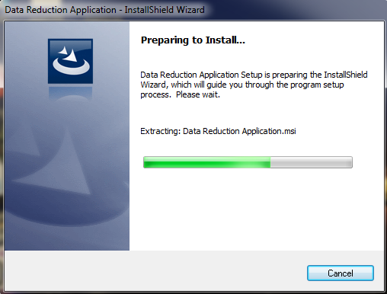

Screen 2:
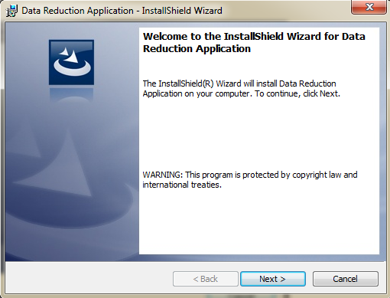
Click “Next >” to move to installation and “Cancel” to exit the installation.
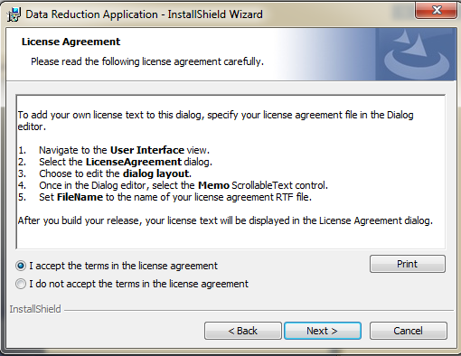
Click, “I accept the terms in the license agreement” and after that “Next” button. After this, the set up file will check the installation of two components like “.NET 4.5 framework” and “SQL SERVER”. If either of the components is missing the installation process will interrupt. If not, following screen will be shown
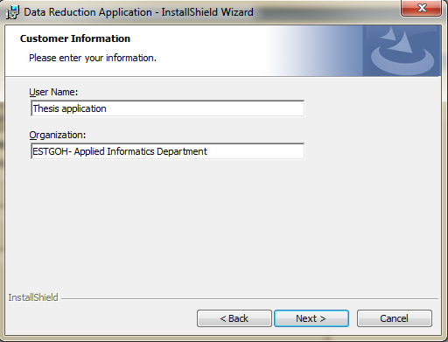
User needs to insert the “Username” and “Organization” then click “Next >”
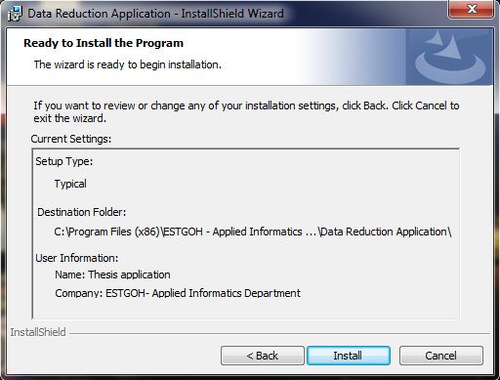
Click “Install” and “Cancel”.

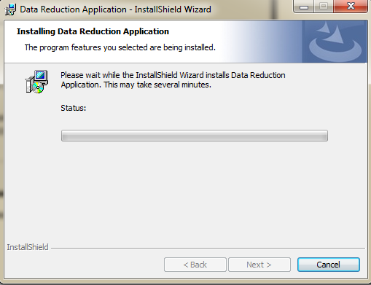

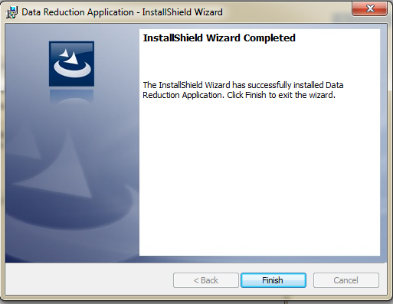

Click “Finish”.
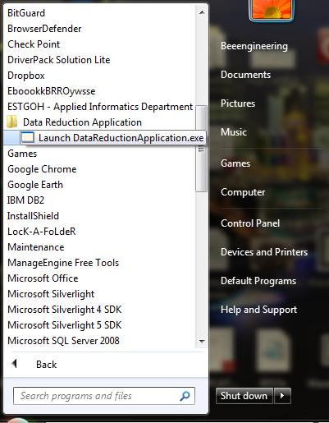
Click the “Launch DataReductionApplication.exe” to get the application running.

Techniques

Principal Component Analysis

Here, the user can see the first screen after splash screen. That is the Principal components analysis technique implementation which is the core implementation for the thesis. That was proven as the proper systematic reduction technique for the GPS data reduction for the urban mobility analysis by several experiments and theories provided before. On which we have two tabs, one is PCA computation and another is Data reduction. In PCA computation, the data is imported in the original data block. Then all other analysis will be performed as described block headings.
The process to do PCA includes the following:

Open file and select the file
Select the sheet contained in your excel document and Press OK.
Then press Run Analysis for the first stages of PCA computation. Depending upon the volume of data, all the blocks will be populated immediately. Similarly, as principal components analysis consists of several steps as described in the literature review.

Press “Yes” to proceed then the computation will start.
Then user can see following screen:
Here, the user can see, Eigen Vectors Matrix, Cumulative frequency details, Principal Component’s overview, Z-scores, Covariance Matrix, Correlation Matrix and principal components proportion ratio under Principal Component Analysis tab.
To see the Principal components of the imported dataset, the user needs to press “Project PCA!” button in above figure. That looks like as following:
Here, user needs to select the number of components from drop down menu and press the “Project PCA!” then
Press “Yes” to both above screen
Based on the input data the above screen will be shown.
In the next tab, of Principal Components is Data Reduction:
Press “Click me” for data reduction button for data reduction using Principal Component Analysis.
Click “Yes” to both message to start data reduction process.
The user can see the following as the output,
Here, in the above diagram, the user can choose the different values to determine number of times of standard deviation from the mean. The default value is 1. Similarly, the user can see the duplicates rows, empty rows within the datasets from this result set also. The duplicates rows and empty rows are filtered before the above computation of deviation is done. The results can be seen like in above diagram. Accordingly, several new features have been added in the application. Among them, now the user can see the execution time taken by the application upon each calculation of Principal components. That is shown in the left down corner of the screen.
Basically, the above reduction is done using the Z-scores generated using Principal Component Analysis. And the computation is done using the
Mean $±$ (Standard Deviation * N).
Where, N is the number of times the standard deviation from the mean.
In the next section of the PCA, the user can see the statistics of the Principal Component Analysis computed above. That screen would be the following:

Here, the user can get the overview of the Component proportion and Component Distribution according to the result of the principal component analysis.
In the Component Proportion, the user can graphically view the different Principal Components proportion in the datasets. For example: in this above example the
PCA 1: 0.93459297563507415
PCA 2: 0.060015259937742253
PCA 3: 0.005391764427183557
PCA 4: 0

So, the Component Proportion graph shows the same and the component distribution graph shows the same in the percentage and components basis.
Finally, the user needs to save the document, to save the user needs to that is inside the file menu or use shortcut (CTRL+S). That opens the save dialog box. That makes the user to save the result in excel format at the user desired location. This saving process is valid for all the techniques used in this application.

Data Cleaning Techniques

For the data cleaning the user can see the following screen as the menu item.
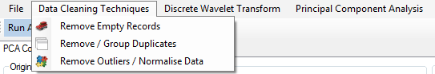

Empty Records:

Here the user can select the “Remove Empty Rows” from menu item for the data reduction using the compute button. Simultaneously, all the empty records would be removed in the after reduction datagrid. Then the result block will show the result before and after reduction with the clear and CLEAR button to clear the screen along with the CLOSE button to close the application.
Finally, the user needs to save the document, to save the user needs to that is inside the file menu or use shortcut (CTRL+S). That opens the save dialog box. That makes the user to save the result in excel format at the user desired location. This process is valid for all the techniques used in this application.

Duplicate

To find out the duplicates records, the user needs to click the second menu item “Remove / Group Duplicates” of the data cleaning techniques. Then the user needs to import the file from the file, open menu item. Following that the data is inserted into the SQL Server 2012 database. Then the user can compute data using “Calculate the duplicate records” button. That results to display the result in the result block.
Here, the user can delete records from the database using “Delete records from database” and close the duplicate records window using “Close Form” button.
Here in the above screenshot, the “Delete Records from Database” helps user to delete record from the SQL SERVER 2012 database. While, “Close Form” helps to exit the form, “Duplicate Records” helps user to find duplicate records present in the dataset. Last, the user can do the computation for the duplicate records using “Calculate the duplicate records”.
Eventually, the user needs to save the document, to save the user needs to that is inside the file menu or use shortcut (CTRL+S). That opens the save dialog box. That makes the user to save the result in excel format at the user desired location. This process is valid for all the techniques used in this application.

Remove Outliers / Normalize data

For this technique, the user needs to click the third menu item (Remove Outliers / Normalize data) of the data cleaning techniques. That will make the following screen to be shown. If the user tried to compute without choosing the value (n); the following screen will be shown else the result will be displayed. Basically, here in this technique, the user can find the data that is far from the mean. For that, the user needs to compute standard deviation and mean of the data. Then the “n” signifies for how many standard deviations are to consider while computing this techniques.
This form is using, Mean (+/-) Standard Deviation * n.
In other hand,

The overview of the noise along with the result is shown below. Here, the user can clear and close the screen using “Clear Form” and “Close Form” buttons respectively.

Eventually, the user needs to save the document, to save the user needs to that is inside the file menu or use shortcut (CTRL+S). That opens save dialog box. That makes the user to save the result in excel format at the user desired location. This process is valid for all the techniques used in this application.

Experiments result

Techniques | Description | Before Reduction | After Reduction | Difference | Percentage(%)
PCA | 8117.CSV | 9000 | 6840 | 2160 | 24%
PCA | 7006.CSV | 2642 | 2635 | 7 | .2749
PCA | PCA1  PCA2  PCA3 | 2642 | 7 | 2635 | 99.723
PCA | PCA1  PCA2  PCA3 | 2642 | 2635 | 7 | .2749
PCA | PCA1  PCA2  PCA3 | 2642 | 2641.89 | 0.11 | .0045
PCA | 7016.txt | 2643 | 2570 | 73 | 2.67
PCA | PCA1  PCA2  PCA3 | 2643  2643  2643 | 1  2570  2642.84 | 2642  73  .15 | 99.9665  2.67  .0060
PCA | 7834.txt | 4003 | 4001.6 | 14 | .0364
PCA | PCA1  PCA2  PCA3 | 4003  4003  4003 | 40  4001.6  4002.6 | 3962  14  .316 | 99.9557  .0364  .0079
PCA | 8018.txt | 2783 | 3992.2 | 9.8 | .3547
PCA | PCA1  PCA2  PCA3 | 2783  2783  2783 | 27.82  2764  3992.2 | 2755  18.8  9.8 | 99.9689  .6765  .3547
Data Cleaning | 7006.CSV | 2642 | 2486 | 156 | 5.90
Data Cleaning | Empty Rows  Duplicate & Invalid Records | 2642 | 2642 | 0 | 0
Data Cleaning | Empty Rows  Duplicate & Invalid Records | 2642 | 2486 | 156 | 5.90
Data Cleaning | 7016.txt | 2643 | 2202 | 440 | 16.6540
Data Cleaning | Empty Rows  Duplicate & Invalid Records | 2643 | 2643 | 0 | 0
Data Cleaning | Empty Rows  Duplicate & Invalid Records | 2643 | 2202 | 440 | 16.6540
Data Cleaning | 7834.txt | 4003 | 3427 | 575 | 14.3678
Data Cleaning | Empty Rows  Duplicate & Invalid Records | 4003 | 4003 | 0 | 0
Data Cleaning | Empty Rows  Duplicate & Invalid Records | 4003 | 3427 | 575 | 14.3678
Data Cleaning | 8018.txt | 2783 | 1904 | 878 | 31.5600
Data Cleaning | Empty Rows  Duplicate & Invalid Records | 2783 | 2783 | 0 | 0
Data Cleaning | Empty Rows  Duplicate & Invalid Records | 2783 | 1904 | 878 | 32.5600

Table 0-1 Result of Data Reduction Using Matlab
Techniques | Description | Before Reduction | After Reduction | Difference | Percentage(%)
PCA | 8117.csv | 85637 | 78686 | 6861 | 8
PCA | 7006.CSV | 2642 | 2589 | 53 | 2
PCA | PCA1  PCA2  PCA3 | 2642 | 53 | 2589 | 98
PCA | PCA1  PCA2  PCA3 | 2642 | 2589 | 53 | 2
PCA | PCA1  PCA2  PCA3 | 2642 | 2616 | 26 | . 01
PCA | 7016.txt | 2643 | 2141 | 502 | 19
PCA | PCA1  PCA2  PCA3 | 2643  2643  2643 | 503  2141  2617 | 2140  502  26 | 81  19  .01
PCA | 7834.txt | 4003 | 3883 | 720 | 18
PCA | PCA1  PCA2  PCA3 | 4003  4003  4003 | 721  3283  4001.8 | 3282  720  1.2 | 82  18  .03
PCA | 8018.txt | 2783 | 2769 | 14 | 5.90
PCA | PCA1  PCA2  PCA3 | 2783  2783  2783 | 946  1837  2769 | 1837  946  14 | 66  34  .5
Data Cleaning | 7006.CSV | 2642 | 2486 | 156 | 5.90
Data Cleaning | Empty Rows  Duplicate & Invalid Records | 2642 | 2642 | 0 | 0
Data Cleaning | Empty Rows  Duplicate & Invalid Records | 2642 | 2486 | 156 | 5.90
Data Cleaning | 7016.txt | 2643 | 2202 | 440 | 16.6540
Data Cleaning | Empty Rows  Duplicate & Invalid Records | 2643 | 2643 | 0 | 0
Data Cleaning | Empty Rows  Duplicate & Invalid Records | 2643 | 2202 | 440 | 16.6540
Data Cleaning | 7834.txt | 4003 | 3427 | 575 | 14.3678
Data Cleaning | Empty Rows  Duplicate & Invalid Records | 4003 | 4003 | 0 | 0
Data Cleaning | Empty Rows  Duplicate & Invalid Records | 4003 | 3427 | 575 | 14.3678
Data Cleaning | 8018.txt | 2783 | 1904 | 878 | 31.5600
Data Cleaning | Empty Rows  Duplicate & Invalid Records | 2783 | 2783 | 0 | 0
Data Cleaning | Empty Rows  Duplicate & Invalid Records | 2783 | 1904 | 878 | 32.5600

Table 0-2 Experiment result from the R application
Techniques | Description | Before Reduction | After Reduction | Difference | Percentage(%)
 | 7006.xls | 2642 | 2537 | 105 | 3.965
 | PCA1  PCA2  PCA3 | 2642 | 107 | 2535 | 95.969
 | PCA1  PCA2  PCA3 | 2642 | 2537 | 105 | 3.965
 | PCA1  PCA2  PCA3 | 2642 | 1641.8295 | .1705 | .06455
 | 7016.xls | 2643 | 2633 | 10 | .3783
 | PCA1  PCA2  PCA3 | 2643  2643  2643 | 13  2633  2641 | 2630  10  2 | 99.5246  .3850  .07567
 | 7834.xls | 4003 | 3993 | 10 | .2411
 | PCA1  PCA2  PCA3 | 4003  4003  4003 | 52  3961  3993 | 3951  42  10 | 98.711  1.047  .2411
 | 8018.xls | 2783 | 2495 | 288 | 10.36
 | PCA1  PCA2  PCA3 | 2783  2783  2783 | 439  2495  2768 | 2344  288  15 | 84.2468  10.3653  5.3877
Data Cleaning | 7006.xls | 2642 | 2486 | 156 | 5.90
Data Cleaning | Empty Rows  Duplicate Records  Invalid Records | 2642 | 2642 | 0 | 0
Data Cleaning | Empty Rows  Duplicate Records  Invalid Records | 2642 | 2488 | 154 | 5.8289
Data Cleaning | Empty Rows  Duplicate Records  Invalid Records | 2642 | 2640 | 2 | .0757
Data Cleaning | 7016.xls | 2643 | 2202 | 441 | 16.68
Data Cleaning | Empty Rows  Duplicate Records  Invalid Records | 2643 | 2643 | 0 | 0
Data Cleaning | Empty Rows  Duplicate Records  Invalid Records | 2643 | 2532 | 111 | 4.1997
Data Cleaning | Empty Rows  Duplicate Records  Invalid Records | 2643 | 2314 | 329 | 12.4479
Data Cleaning | 7834.xls | 4003 | 3427 | 576 | 14.38
Data Cleaning | Empty Rows  Duplicate Records  Invalid Records | 4003 | 4003 | 0 | 0
Data Cleaning | Empty Rows  Duplicate Records  Invalid Records | 4003 | 3864 | 139 | 3.4723
Data Cleaning | Empty Rows  Duplicate Records  Invalid Records | 4003 | 3567 | 436 | 10.8918
Data Cleaning | 8018.xls | 2783 | 1905 | 878 | 31.56
Data Cleaning | Empty Rows  Duplicate Records  Invalid Records | 2783 | 2783 | 0 | 0
Data Cleaning | Empty Rows  Duplicate Records  Invalid Records | 2783 | 1910 | 873 | 31.3690
Data Cleaning | Empty Rows  Duplicate Records  Invalid Records | 2783 | 2778 | 5 | .17966

Table 0-3 Experiment conducted using Data reduction application
Techniques | Application | Description | Before Reduction | After Reduction | Difference | Percentage
PCA | MATLAB | 7006.csv | 2642 | 2635 | 7 | .2749
PCA | MATLAB | 7016.txt | 2643 | 2570 | 73 | 2.67
PCA | MATLAB | 7834.txt | 4003 | 4001.6 | 14 | .0364
PCA | MATLAB | 8018.txt | 2783 | 3992.2 | 9.8 | .3547
PCA | R | 7006.csv | 2642 | 2589 | 53 | 2
PCA | R | 7016.txt | 2643 | 2141 | 502 | 19
PCA | R | 7834.txt | 4003 | 3883 | 720 | 18
PCA | R | 8018.txt | 2783 | 2769 | 14 | 5.90
PCA | Application | 7006.xls | 2642 | 2537 | 105 | 3.965
PCA | Application | 7016.xls | 2643 | 2202 | 441 | 16.68
PCA | Application | 7834.xls | 4003 | 3427 | 576 | 14.38
PCA | Application | 8018.xls | 2783 | 2495 | 288 | 10.36
Data cleaning | Matlab | 7006.csv | 2642 | 2486 | 156 | 5.90
Data cleaning | Matlab | 7016.txt | 2643 | 2202 | 440 | 16.6540
Data cleaning | Matlab | 7834.txt | 4003 | 3427 | 575 | 14.3678
Data cleaning | Matlab | 8018.txt | 2783 | 1904 | 878 | 31.5600
Data cleaning | R | 7006.csv | 2642 | 2486 | 156 | 5.90
Data cleaning | R | 7016.txt | 2643 | 2202 | 440 | 16.6540
Data cleaning | R | 7834.txt | 4003 | 3427 | 575 | 14.3678
Data cleaning | R | 8018.txt | 2783 | 1904 | 878 | 31.5600
Data cleaning | Application | 7006.xls | 2642 | 2486 | 156 | 5.90
Data cleaning | Application | 7016.xls | 2643 | 2202 | 441 | 16.68
Data cleaning | Application | 7834.xls | 4003 | 3427 | 576 | 14.38
Data cleaning | Application | 8018.xls | 2783 | 1905 | 878 | 31.56

Table 0-4 The result comparison between other application and data reduction application.

Techniques | Description | Before Reduction | After Reduction | Difference | (%)
PCA | TaxiDriveTrajectories.csv | 95000 | 92587 | 2413 | 3%
PCA | PCA1 | 95000 | 950 | 94050 | 99%
PCA | PCA2 | 95000 | 49400 | 45600 | 48%
PCA | PCA3 | 95000 | 73150 | 21850 | 23%
PCA | PCA4 | 95000 | 82650 | 12350 | 13%
PCA | PCA5 | 95000 | 92587 | 2413 | 3%
PCA | TaxiDriveTrajectories1.csv | 85000 | 82841 | 2159 | 3%
PCA | PCA1  PCA2  PCA3  PCA4 | 85000 | 85 | 84915 | 99.98%
PCA | PCA1  PCA2  PCA3  PCA4 | 85000 | 43724 | 41276 | 49%
PCA | PCA1  PCA2  PCA3  PCA4 | 85000 | 64880.5 | 20119.5 | 24%
PCA | PCA1  PCA2  PCA3  PCA4 | 85000 | 73848 | 11152 | 13%
PCA | PCA5 | 85000 | 83861 | 1139 | 1%
PCA | TaxiDriveTrajectories2.csv | 100000 | 97460 | 2540 | 3%
PCA | PCA1 | 100000 | 1000 | 99000 | 99%
PCA | PCA2 | 100000 | 52000 | 48000 | 48%
PCA | PCA3 | 100000 | 77000 | 23000 | 23%
PCA | PCA4 | 100000 | 87000 | 13000 | 13%
Data Cleaning | TaxiDriveTrajectories.csv | 95000 | 89395 | 5605 | 6%
Data Cleaning | Empty Rows  Duplicate & Invalid Records | 95000 | 95000 | 0 | 0%
Data Cleaning | Empty Rows  Duplicate & Invalid Records | 95000 | 89395 | 5605 | 6%
Data Cleaning | TaxiDriveTrajectories1.csV | 85000 | 70844.1 | 14155.9 | 17%
Data Cleaning | Empty Rows  Duplicate & Invalid Records | 85000 | 85000 | 0 | 0%
Data Cleaning | Empty Rows  Duplicate & Invalid Records | 85000 | 70844.1 | 14155.9 | 17%
Data Cleaning | TaxiDriveTrajectories2.csv | 100000 | 85632.2 | 14367.8 | 14%
Data Cleaning | Empty Rows  Duplicate & Invalid Records | 100000 | 100000 | 0 | 0%
Data Cleaning | Empty Rows  Duplicate & Invalid Records | 100000 | 85632.2 | 14367.8 | 14%

Table 0-5 Result of Data Reduction Using Matlab for without minutes
Techniques | Description | Before Reduction | After Reduction | Difference | (%)
PCA | TaxiDriveTrajectories.csv | 95000 | 93537 | 1463 | 3%
PCA | PCA1 | 95000 | 1900 | 93100 | 98%
PCA | PCA2 | 95000 | 51300 | 43700 | 46%
PCA | PCA3 | 95000 | 76000 | 19000 | 20%
PCA | PCA4 | 95000 | 83600 | 11400 | 12%
PCA | PCA5 | 95000 | 93537 | 1463 | 2%
PCA | TaxiDriveTrajectories1.csv | 85000 | 83011 | 1989 | 2%
PCA | PCA1 | 85000 | 2635 | 82365 | 97%
PCA | PCA2  PCA3  PCA4 | 85000 | 48314 | 36686 | 43%
PCA | PCA2  PCA3  PCA4 | 85000 | 66580.5 | 18419.5 | 22%
PCA | PCA2  PCA3  PCA4 | 85000 | 76398 | 8602 | 10%
PCA | PCA5 | 85000 | 83691 | 1309 | 2%
PCA | TaxiDriveTrajectories2.csv | 100000 | 97980 | 2020 | 2%
PCA | PCA1 | 100000 | 580 | 99420 | 99%
PCA | PCA2 | 100000 | 54000 | 46000 | 46%
PCA | PCA3 | 100000 | 78000 | 22000 | 22%
PCA | PCA4 | 100000 | 88000 | 12000 | 12%
PCA | PCA5 | 100000 | 98460 | 1540 | 2%
Data Cleaning | TaxiDriveTrajectories.csv | 95000 | 66500 | 28500 | 30%
Data Cleaning | Empty Rows  Duplicate & Invalid Records | 95000 | -95000 | 190000 | 200%
Data Cleaning | Empty Rows  Duplicate & Invalid Records | 95000 | 68400 | 26600 | 28%
Data Cleaning | TaxiDriveTrajectories1.csV | 85000 | 68294.1 | 16705.9 | 20%
Data Cleaning | Empty Rows  Duplicate & Invalid Records | 85000 | 82450 | 2550 | 3%
Data Cleaning | Empty Rows  Duplicate & Invalid Records | 85000 | 70844.1 | 14155.9 | 17%
Data Cleaning | TaxiDriveTrajectories2.csv | 100000 | 64000 | 36000 | 36%
Data Cleaning | Empty Rows  Duplicate & Invalid Records | 100000 | 96000 | 4000 | 4%
Data Cleaning | Empty Rows  Duplicate & Invalid Records | 100000 | 68000 | 32000 | 32%

Table 0-6 Result of Data Reduction Using R without Minutes
Techniques | Description | Before Reduction | After Reduction | Difference | Proportion
PCA | TaxiDriveTrajectories.csv | 95000 | 94994.87 | 5.13 | 0.000054
PCA | PCA1 | 95000 | 1900 | 93100 | 0.980000
PCA | PCA2 | 95000 | 90725 | 4275 | 0.045000
PCA | PCA3 | 95000 | 92910 | 2090 | 0.022000
PCA | PCA4 | 95000 | 94853.7 | 146.3 | 0.001540
PCA | PCA5 | 95000 | 94994.87 | 5.13 | 0.000054
PCA | TaxiDriveTrajectories1.csv | 85000 | 84986.91 | 13.09 | 0.000154
PCA | PCA1 | 85000 | 2635 | 82365 | 0.969000
PCA | PCA2  PCA3  PCA4 | 85000 | 81416.4 | 3583.6 | 0.042160
PCA | PCA2  PCA3  PCA4 | 85000 | 83166.55 | 1833.45 | 0.021570
PCA | PCA2  PCA3  PCA4 | 85000 | 83714.8 | 1285.2 | 0.015120
PCA | PCA5 | 85000 | 84986.91 | 13.09 | 0.000154
PCA | TaxiDriveTrajectories2.csv | 100000 | 99998.46 | 1.54 | 0.000015
PCA | PCA1 | 100000 | 580 | 99420 | 0.994200
PCA | PCA2 | 100000 | 95400 | 4600 | 0.046000
PCA | PCA3 | 100000 | 97800 | 2200 | 0.022000
PCA | PCA4 | 100000 | 99880 | 120 | 0.001200
PCA | PCA5 | 100000 | 99998.46 | 1.54 | 0.000015
Data Cleaning | TaxiDriveTrajectories.csv | 95000 | 66500 | 28500 | 0.30000
Data Cleaning | Empty Rows  Duplicate & Invalid Records | 95000 | 93100 | 1900 | 0.02000
Data Cleaning | Empty Rows  Duplicate & Invalid Records | 95000 | 68400 | 26600 | 0.28000
Data Cleaning | TaxiDriveTrajectories1.csV | 85000 | 68294.1 | 16705.9 | 0.19654
Data Cleaning | Empty Rows  Duplicate & Invalid Records | 85000 | 82450 | 2550 | 0.03000
Data Cleaning | Empty Rows  Duplicate & Invalid Records | 85000 | 70844.1 | 14155.9 | 0.16654
Data Cleaning | TaxiDriveTrajectories2.csv | 100000 | 64000 | 36000 | 0.36000
Data Cleaning | Empty Rows  Duplicate & Invalid Records | 100000 | 96000 | 4000 | 0.04000
Data Cleaning | Empty Rows  Duplicate & Invalid Records | 100000 | 68000 | 32000 | 0.32000

Table 0-7 Result of Data Reduction Using Data Reduction Application for without minutes
Techniques | Application | Description | Before Reduction | After Reduction | Difference | Percentage
PCA | MATLAB | TaxiDriveTrajectories.csv | 95000 | 92587 | 2413 | 3%
PCA | MATLAB | TaxiDriveTrajectories1.csv | 85000 | 82841 | 2159 | 3%
PCA | MATLAB | TaxiDriveTrajectories2.csv | 100000 | 97460 | 2540 | 3%
PCA | R | TaxiDriveTrajectories.csv | 95000 | 93537 | 1463 | 2%
PCA | R | TaxiDriveTrajectories1.csv | 85000 | 83011 | 1989 | 2%
PCA | R | TaxiDriveTrajectories2.csv | 100000 | 97980 | 2020 | 2%
PCA | Application | TaxiDriveTrajectories.csv | 95000 | 94994.87 | 5.13 | 0.000054
PCA | Application | TaxiDriveTrajectories1.csv | 85000 | 84986.91 | 13.09 | 0.000154
PCA | Application | TaxiDriveTrajectories2.csv | 100000 | 99998.46 | 1.54 | 0.000015
Data cleaning | Matlab | TaxiDriveTrajectories.csv | 95000 | 89395 | 5605 | 6%
Data cleaning | Matlab | TaxiDriveTrajectories1.csV | 85000 | 70844.1 | 14155.9 | 17%
Data cleaning | Matlab | TaxiDriveTrajectories2.csv | 100000 | 85632.2 | 14367.8 | 14%
Data cleaning | R | TaxiDriveTrajectories.csv | 95000 | 66500 | 28500 | 30%
Data cleaning | R | TaxiDriveTrajectories1.csV | 85000 | 68294.1 | 16705.9 | 20%
Data cleaning | R | TaxiDriveTrajectories2.csv | 100000 | 64000 | 36000 | 36%
Data cleaning | Application | TaxiDriveTrajectories.csv | 95000 | 66500 | 28500 | 0.3
Data cleaning | Application | TaxiDriveTrajectories1.csV | 85000 | 68294.1 | 16705.9 | 0.19654
Data cleaning | Application | TaxiDriveTrajectories2.csv | 100000 | 64000 | 36000 | 0.36

Table 0-8 Result comparison between the different techniques for without minutes
Tools | Techniques | Data Sets | Before Reduction  Coordinates | After Reduction  Coordinates | Generated Equation
Rapid Miner | Polynomial Regression | 7006.csv | 2/8/2008  17:38, 116.1587,  39.81083 | 2/8/2008 17:36,  116.159,  39.8108 | - 0.001 * COLUMN 2 ^ 1.000 + 9.705 * COLUMN 3 ^ 4.000  - 49.768 * COLUMN 4 ^ 4.000 - 67.108
Rapid Miner | Polynomial Regression | 7016.txt | 2/8/2008 17:38,  116.30442,  39.92012 | 2/8/2008 17:38,  116.30432,  39.92017 | - 0.001 * 2/2/08 13:35 ^ 1.000+ 9.705 * 116.314 ^ 4.000  - 49.767 * 39.895 ^ 4.000- 67.108
Rapid Miner | Polynomial Regression | 7834.txt | 2/8/2008 6:02,  116.9121,  40.37812 | 2/7/2008 6:04,  116.912,  40.37812 | - 0.001 * 2/2/08 13:35 ^ 1.000+ 9.705 * 116.497 ^ 4.000 - 49.767 * 39.892 ^ 4.000 - 67.108
Rapid Miner | Polynomial Regression | 8018.txt | 2/8/2008 17:38,  116.33988,  40.01571 | 2/8/2008 17:37,  116.33988,  40.01571 | 0.001 * COLUMN 2 ^ 1.000 + 9.705 * COLUMN 3 ^ 4.000 - 49.768 * COLUMN 4 ^ 4.000 - 67.108

Table 0-9 Polynomial Regression Prediction for Validation with minutes
Tools | Techniques | Data Sets | Before Reduction  Coordinates | After Reduction  Coordinates | Generated Equation
Rapid Miner | Polynomial Regression | TaxiDriveTrajectories.csv | 8018,4,  116.31692,  40.03934 | 8018,4,  116.30999,  40.03834 | - 9.557 * TaxiNumber ^ 1.000 + 1 * year ^ 1.000 - + 9.507 * time ^ 4.000 - 46.768 * latitude ^ 4.000 - 49.776 * longitude ^ 4.000 - 67.108
Rapid Miner | Polynomial Regression | TaxiDriveTrajectories1.csv | 7834,1,  116.42922,  39.90857 | 7834,1,  116.42922,  39.90857 | - 9.556 * TaxiNumber ^ 1.000 + 1 * year ^ 1.000 - + 9.506 * time ^ 4.000 - 46.786 * latitude ^ 4.000 - 49.777 * longitude ^ 4.000 - 67.108
Rapid Miner | Polynomial Regression | TaxiDriveTrajectories2.csv | 8018,4,  116.31692,  40.03934 | 8018,4,  116.30990,  40.02991 | - 9.555 * TaxiNumber ^ 1.000 + 1 * year ^ 1.000 - + 9.505 * time ^ 4.000 - 46.767 * latitude ^ 4.000 - 49.775 * longitude ^ 4.000 - 67.108

Table 0-10 Polynomial Regression Prediction for Validation without minutes

Tools | Techniques | TaxiNumber | Coordinates | Predicted  Coordinates | Generated Equation | Accuracies
Rapid Miner | Polynomial Regression | 7146 | 116.33088 , 39.97506 | 116.33088 , 39.97506 | - 9.507 * TaxiNumber ^ 1.000 + 1 * year ^ 1.000 - + 9.507 * time ^ 4.000 - 46.768 * latitude ^ 4.000 - 49.776 * longitude ^ 4.000 - 67.108 | 98%
Rapid Miner | Polynomial Regression | 8179 | 116.30572 , 40.03564 | 116.30672 , 40.03564 | - 9.506 * TaxiNumber ^ 1.000 + 1 * year ^ 1.000 - + 9.506 * time ^ 4.000 - 46.786 * latitude ^ 4.000 - 49.777 * longitude ^ 4.000 - 67.108 | 90%
Rapid Miner | Polynomial Regression | 8662 | 116.31995 , 39.89004 | 116.31996 , 39.89003 | - 9.505 * TaxiNumber ^ 1.000 + 1 * year ^ 1.000 - + 9.505 * time ^ 4.000 - 46.767 * latitude ^ 4.000 - 49.775 * longitude ^ 4.000 - 67.108 | 80%
Rapid Miner | Polynomial Regression | 9109 | 116.35408 , 39.86716 | 116.35408 , 39.86716 | - 9.504 * TaxiNumber ^ 1.000 + 1 * year ^ 1.000 - + 9.507 * time ^ 4.000 - 46.768 * latitude ^ 4.000 - 49.776 * longitude ^ 4.000 - 67.108 | 98%
Rapid Miner | Polynomial Regression | 9754 | 116.68199 , 39.8263 | 116.68198 , 39.82629 | - 9.507 * TaxiNumber ^ 1.000 + 1 * year ^ 1.000 - + 9.506 * time ^ 4.000 - 46.786 * latitude ^ 4.000 - 49.777 * longitude ^ 4.000 - 67.108 | 90%
Rapid Miner | Polynomial Regression | 366 |  | 116.45348 , 39.90729 | - 9.506 * TaxiNumber ^ 1.000 + 1 * year ^ 1.000 - + 9.505 * time ^ 4.000 - 46.767 * latitude ^ 4.000 - 49.775 * longitude ^ 4.000 - 67.108 | 89%
  116.45353 , 9.90732
Rapid Miner | Polynomial Regression | 1131 | 116.45847 , 39.86964 | 116.45847 , 39.86964 | - 9.505 * TaxiNumber ^ 1.000 + 1 * year ^ 1.000 - + 9.507 * time ^ 4.000 - 46.768 * latitude ^ 4.000 - 49.776 * longitude ^ 4.000 - 67.108 | 90%
Rapid Miner | Polynomial Regression | 1277 | 116.31412 , 39.89454 | 116.31412 , 39.89454 | - 9.504 * TaxiNumber ^ 1.000 + 1 * year ^ 1.000 - + 9.506 * time ^ 4.000 - 46.786 * latitude ^ 4.000 - 49.777 * longitude ^ 4.000 - 67.108 | 95%
Rapid Miner | Polynomial Regression | 2237 | 116.26868 , 39.93307 | 116.26868 , 39.93307 | - 9.507 * TaxiNumber ^ 1.000 + 1 * year ^ 1.000 - + 9.505 * time ^ 4.000 - 46.767 * latitude ^ 4.000 - 49.775 * longitude ^ 4.000 - 67.108 | 95%
Rapid Miner | Polynomial Regression | 2560 | 116.47158 , 39.89832 | 116.47158 , 39.89832 | - 9.506 * TaxiNumber ^ 1.000 + 1 * year ^ 1.000 - + 9.507 * time ^ 4.000 - 46.768 * latitude ^ 4.000 - 49.776 * longitude ^ 4.000 - 67.108 | 92%
Rapid Miner | Polynomial Regression | 2669 |  | 116.45087 , 39.98679 | - 9.505 * TaxiNumber ^ 1.000 + 1 * year ^ 1.000 - + 9.506 * time ^ 4.000 - 46.786 * latitude ^ 4.000 - 49.777 * longitude ^ 4.000 - 67.108 | 80%
  116.4508 , 39.98665
Rapid Miner | Polynomial Regression | 3015 | 116.41009 , 39.89176 | 116.41009 , 39.89176 | - 9.504 * TaxiNumber ^ 1.000 + 1 * year ^ 1.000 - + 9.505 * time ^ 4.000 - 46.767 * latitude ^ 4.000 - 49.775 * longitude ^ 4.000 - 67.108 | 95%
Rapid Miner | Polynomial Regression | 3557 | 116.16817 , 39.94461 | 116.16817 , 39.94461 | - 9.507 * TaxiNumber ^ 1.000 + 1 * year ^ 1.000 - + 9.507 * time ^ 4.000 - 46.768 * latitude ^ 4.000 - 49.776 * longitude ^ 4.000 - 67.108 | 95%
Rapid Miner | Polynomial Regression | 3579 |  | 116.40049 , 39.90341 | - 9.506 * TaxiNumber ^ 1.000 + 1 * year ^ 1.000 - + 9.506 * time ^ 4.000 - 46.786 * latitude ^ 4.000 - 49.777 * longitude ^ 4.000 - 67.108 | 82%
  116.40048 , 39.9035
Rapid Miner | Polynomial Regression | 3781 | 116.37051 , 39.96032 | 116.37051 , 39.96032 | - 9.506 * TaxiNumber ^ 1.000 + 1 * year ^ 1.000 - + 9.506 * time ^ 4.000 - 46.786 * latitude ^ 4.000 - 49.777 * longitude ^ 4.000 - 67.108 | 94%
Rapid Miner | Polynomial Regression | 4798 | 116.35046 , 39.89594 | 116.35046 , 39.89594 | - 9.505 * TaxiNumber ^ 1.000 + 1 * year ^ 1.000 - + 9.505 * time ^ 4.000 - 46.767 * latitude ^ 4.000 - 49.775 * longitude ^ 4.000 - 67.108 | 92%
Rapid Miner | Polynomial Regression | 5075 |  |  | - 9.504 * TaxiNumber ^ 1.000 + 1 * year ^ 1.000 - + 9.507 * time ^ 4.000 - 46.768 * latitude ^ 4.000 - 49.776 * longitude ^ 4.000 - 67.108 | 82%
  116.29649 , 9.98365
  116.29649 , 9.98365

Table 0-11prediction points in the dataset 2 without minutes

Before Reduction

InputID(Taxi Number) | TargetID(Location) | Distance
8662 | 116.31996 , 39.89003 | 1.41E-05
8662 | 116.31995 , 39.89004 | 1.41E-05
8662 | 116.32 , 39.89005 | 2.00E-05
8662 | 116.31999 , 39.89007 | 1.00E-05
8662 | 116.32 , 39.89007 | 1.00E-05
8662 | 116.32 , 39.89008 | 1.00E-05
8662 | 116.32001 , 39.89009 | 1.00E-05
8662 | 116.32 , 39.89007 | 1.00E-05
8662 | 116.31998 , 39.89005 | 2.00E-05
8662 | 116.32003 , 39.89004 | 1.00E-05
8662 | 116.32003 , 39.89004 | 1.00E-05
8662 | 116.32003 , 39.89004 | 1.00E-05
8662 | 116.32003 , 39.89004 | 1.00E-05
8662 | 116.32003 , 39.89004 | 1.00E-05
8662 | 116.32003 , 39.89004 | 1.00E-05
Note: Due to huge data, only the part is shown here, rest are in the thesis repositories.

Table 0-12 The Origin-destination matrix for the GPS data before reduction for 50 meters grid
After reduction

InputID(TaxiNumber) | TargetID(Location) | Distance
8179 | 116.30548, 40.03559 | 0.000245
8179 | 116.30572, 40.03564 | 0.000245
8179 | 116.30486, 40.03424 | 0.000372
8179 | 116.30467, 40.03456 | 0.000372
8179 | 116.30519, 40.0333 | 0.000373
8179 | 116.30506, 40.03365 | 0.000373
8179 | 116.30561, 40.03206 | 0.000522
8179 | 116.30543, 40.03255 | 0.000522
8179 | 116.30593, 40.03114 | 0.000285
8179 | 116.30584, 40.03141 | 0.000285
8179 | 116.30593, 40.03114 | 0.000531
8179 | 116.30656, 40.02912 | 0.000696
8179 | 116.30669, 40.02877 | 0.000373
8179 | 116.30656, 40.02912 | 0.000373
8179 | 116.30699, 40.02809 | 0.000106
Note: Due to huge data, only the part is shown here, rests are in the thesis repositories.

Table 0-13 The Origin-destination matrix for gps data after reduction for 50 meters grid
Before Reduction

InputID(Taxi Number) | TargetID(Location) | Distance
8662 | 116.31996 , 39.89003 | 1.41E-05
8662 | 116.31995 , 39.89004 | 1.41E-05
8662 | 116.32 , 39.89005 | 2.00E-05
8662 | 116.31999 , 39.89007 | 1.00E-05
8662 | 116.32 , 39.89007 | 1.00E-05
8662 | 116.32 , 39.89008 | 1.00E-05
8662 | 116.32001 , 39.89009 | 1.00E-05
8662 | 116.32 , 39.89007 | 1.00E-05
8662 | 116.31998 , 39.89005 | 2.00E-05
8662 | 116.32003 , 39.89004 | 1.00E-05
8662 | 116.32003 , 39.89004 | 1.00E-05
8662 | 116.32003 , 39.89004 | 1.00E-05
8662 | 116.32003 , 39.89004 | 1.00E-05
8662 | 116.32003 , 39.89004 | 1.00E-05
8662 | 116.32003 , 39.89004 | 1.00E-05
Note: Due to huge data, only the part is shown here, rest are in the thesis repositories.

Table 0-14 The Origin-destination matrix for gps data before reduction for 50 meters grid

After reduction

InputID(TaxiNumber) | TargetID(Location) | Distance
8179 | 116.30548, 40.03559 | 0.000245
8179 | 116.30572, 40.03564 | 0.000245
8179 | 116.30486, 40.03424 | 0.000372
8179 | 116.30467, 40.03456 | 0.000372
8179 | 116.30519, 40.0333 | 0.000373
8179 | 116.30506, 40.03365 | 0.000373
8179 | 116.30561, 40.03206 | 0.000522
8179 | 116.30543, 40.03255 | 0.000522
8179 | 116.30593, 40.03114 | 0.000285
8179 | 116.30584, 40.03141 | 0.000285
8179 | 116.30593, 40.03114 | 0.000531
8179 | 116.30656, 40.02912 | 0.000696
8179 | 116.30669, 40.02877 | 0.000373
8179 | 116.30656, 40.02912 | 0.000373
8179 | 116.30699, 40.02809 | 0.000106
Note: Due to huge data, only the part is shown here, rests are in the thesis repositories.

Table 0-15 The Origin-destination matrix for gps data before reduction for 500 meters grid
Before Reduction

InputID(Taxi Number) | TargetID(Location) | Distance
7146 | 116.33088 , 39.97506 | 0.001491
7146 | 116.33179 , 39.975 | 0.000912
7146 | 116.33184 , 39.97477 | 0.000235
7146 | 116.33184 , 39.9746 | 0.00017
7146 | 116.33183 , 39.97448 | 0.00012
7146 | 116.33184 , 39.9746 | 0.00012
7146 | 116.33187 , 39.97391 | 0.000216
7146 | 116.33182 , 39.97412 | 0.000216
7146 | 116.33213 , 39.97183 | 0.000331
7146 | 116.3321 , 39.97216 | 0.000331
7146 | 116.33223 , 39.97101 | 0.000383
7146 | 116.3323 , 39.97068 | 0.000337
7146 | 116.33223 , 39.97101 | 0.000337
7146 | 116.3325 , 39.96994 | 0.000352
7146 | 116.33253 , 39.96976 | 0.000182
7146 | 116.33255 , 39.96971 | 5.39E-05
Note: Due to huge data, only the part is shown here, rest are in the thesis repositories.
Table 0-16 The Origin-destination matrix for gps data before reduction for 50 meters grid
After reduction

InputID(TaxiNumber) | TargetID(Location) | Distance
7146 | 116.33184, 39.97477 | 0.000235
7146 | 116.33184, 39.9746 | 0.00017
7146 | 116.33183, 39.97448 | 0.00012
7146 | 116.33184, 39.9746 | 0.00012
7146 | 116.33187, 39.97391 | 0.000216
7146 | 116.33182, 39.97412 | 0.000216
7146 | 116.33213, 39.97183 | 0.000331
7146 | 116.3321, 39.97216 | 0.000331
7146 | 116.33223, 39.97101 | 0.000383
7146 | 116.3323, 39.97068 | 0.000337
7146 | 116.33223, 39.97101 | 0.000337
7146 | 116.3325, 39.96994 | 0.000352
7146 | 116.33253, 39.96976 | 0.000182
7146 | 116.33255, 39.96971 | 5.39E-05
7146 | 116.33253, 39.96976 | 5.39E-05
7146 | 116.33252, 39.96964 | 2.24E-05

Note: Due to huge data, only the part is shown here, rests are in the thesis repositories.
Table 0-17 The Origin-destination matrix for gps data after reduction for 50 meters grid
Techniques | Description | Before Reduction | After Reduction | Difference | Percentage(%)
PCA | 8117.CSV | 9000 | 6840 | 2160 | 24%
PCA | 7006.CSV | 2642 | 2635 | 7 | .2749
PCA | PCA1  PCA2  PCA3 | 2642 | 7 | 2635 | 99.723
PCA | PCA1  PCA2  PCA3 | 2642 | 2635 | 7 | .2749
PCA | PCA1  PCA2  PCA3 | 2642 | 2641.89 | 0.11 | .0045
PCA | 7016.txt | 2643 | 2570 | 73 | 2.67
PCA | PCA1  PCA2  PCA3 | 2643  2643  2643 | 1  2570  2642.84 | 2642  73  .15 | 99.9665  2.67  .0060
PCA | 7834.txt | 4003 | 4001.6 | 14 | .0364
PCA | PCA1  PCA2  PCA3 | 4003  4003  4003 | 40  4001.6  4002.6 | 3962  14  .316 | 99.9557  .0364  .0079
PCA | 8018.txt | 2783 | 3992.2 | 9.8 | .3547
PCA | PCA1  PCA2  PCA3 | 2783  2783  2783 | 27.82  2764  3992.2 | 2755  18.8  9.8 | 99.9689  .6765  .3547
Data Cleaning | 7006.CSV | 2642 | 2486 | 156 | 5.90
Data Cleaning | Empty Rows  Duplicate & Invalid Records | 2642 | 2642 | 0 | 0
Data Cleaning | Empty Rows  Duplicate & Invalid Records | 2642 | 2486 | 156 | 5.90
Data Cleaning | 7016.txt | 2643 | 2202 | 440 | 16.6540
Data Cleaning | Empty Rows  Duplicate & Invalid Records | 2643 | 2643 | 0 | 0
Data Cleaning | Empty Rows  Duplicate & Invalid Records | 2643 | 2202 | 440 | 16.6540
Data Cleaning | 7834.txt | 4003 | 3427 | 575 | 14.3678
Data Cleaning | Empty Rows  Duplicate & Invalid Records | 4003 | 4003 | 0 | 0
Data Cleaning | Empty Rows  Duplicate & Invalid Records | 4003 | 3427 | 575 | 14.3678
Data Cleaning | 8018.txt | 2783 | 1904 | 878 | 31.5600
Data Cleaning | Empty Rows  Duplicate & Invalid Records | 2783 | 2783 | 0 | 0
Data Cleaning | Empty Rows  Duplicate & Invalid Records | 2783 | 1904 | 878 | 32.5600

Table 0-18 Result of Data Reduction Using Matlab
Techniques | Description | Before Reduction | After Reduction | Difference | Percentage(%)
PCA | 7006.CSV | 2642 | 2589 | 53 | 2
PCA | PCA1  PCA2  PCA3 | 2642 | 53 | 2589 | 98
PCA | PCA1  PCA2  PCA3 | 2642 | 2589 | 53 | 2
PCA | PCA1  PCA2  PCA3 | 2642 | 2616 | 26 | . 01
PCA | 7016.txt | 2643 | 2141 | 502 | 19
PCA | PCA1  PCA2  PCA3 | 2643  2643  2643 | 503  2141  2617 | 2140  502  26 | 81  19  .01
PCA | 7834.txt | 4003 | 3883 | 720 | 18
PCA | PCA1  PCA2  PCA3 | 4003  4003  4003 | 721  3283  4001.8 | 3282  720  1.2 | 82  18  .03
PCA | 8018.txt | 2783 | 2769 | 14 | 5.90
PCA | PCA1  PCA2  PCA3 | 2783  2783  2783 | 946  1837  2769 | 1837  946  14 | 66  34  .5
Data Cleaning | 7006.CSV | 2642 | 2486 | 156 | 5.90
Data Cleaning | Empty Rows  Duplicate & Invalid Records | 2642 | 2642 | 0 | 0
Data Cleaning | Empty Rows  Duplicate & Invalid Records | 2642 | 2486 | 156 | 5.90
Data Cleaning | 7016.txt | 2643 | 2202 | 440 | 16.6540
Data Cleaning | Empty Rows  Duplicate & Invalid Records | 2643 | 2643 | 0 | 0
Data Cleaning | Empty Rows  Duplicate & Invalid Records | 2643 | 2202 | 440 | 16.6540
Data Cleaning | 7834.txt | 4003 | 3427 | 575 | 14.3678
Data Cleaning | Empty Rows  Duplicate & Invalid Records | 4003 | 4003 | 0 | 0
Data Cleaning | Empty Rows  Duplicate & Invalid Records | 4003 | 3427 | 575 | 14.3678
Data Cleaning | 8018.txt | 2783 | 1904 | 878 | 31.5600
Data Cleaning | Empty Rows  Duplicate & Invalid Records | 2783 | 2783 | 0 | 0
Data Cleaning | Empty Rows  Duplicate & Invalid Records | 2783 | 1904 | 878 | 32.5600

Table 0-19 Result of Data Reduction Using R

Techniques | Description | Before Reduction | After Reduction | Difference | Percentage(%)
 | 7006.xls | 2642 | 2537 | 105 | 3.965
 | PCA1  PCA2  PCA3 | 2642 | 107 | 2535 | 95.969
 | PCA1  PCA2  PCA3 | 2642 | 2537 | 105 | 3.965
 | PCA1  PCA2  PCA3 | 2642 | 1641.8295 | .1705 | .06455
 | 7016.xls | 2643 | 2633 | 10 | .3783
 | PCA1  PCA2  PCA3 | 2643  2643  2643 | 13  2633  2641 | 2630  10  2 | 99.5246  .3850  .07567
 | 7834.xls | 4003 | 3993 | 10 | .2411
 | PCA1  PCA2  PCA3 | 4003  4003  4003 | 52  3961  3993 | 3951  42  10 | 98.711  1.047  .2411
 | 8018.xls | 2783 | 2495 | 288 | 10.36
 | PCA1  PCA2  PCA3 | 2783  2783  2783 | 439  2495  2768 | 2344  288  15 | 84.2468  10.3653  5.3877
Data Cleaning | 7006.xls | 2642 | 2486 | 156 | 5.90
Data Cleaning | Empty Rows  Duplicate Records  Invalid Records | 2642 | 2642 | 0 | 0
Data Cleaning | Empty Rows  Duplicate Records  Invalid Records | 2642 | 2488 | 154 | 5.8289
Data Cleaning | Empty Rows  Duplicate Records  Invalid Records | 2642 | 2640 | 2 | .0757
Data Cleaning | 7016.xls | 2643 | 2202 | 441 | 16.68
Data Cleaning | Empty Rows  Duplicate Records  Invalid Records | 2643 | 2643 | 0 | 0
Data Cleaning | Empty Rows  Duplicate Records  Invalid Records | 2643 | 2532 | 111 | 4.1997
Data Cleaning | Empty Rows  Duplicate Records  Invalid Records | 2643 | 2314 | 329 | 12.4479
Data Cleaning | 7834.xls | 4003 | 3427 | 576 | 14.38
Data Cleaning | Empty Rows  Duplicate Records  Invalid Records | 4003 | 4003 | 0 | 0
Data Cleaning | Empty Rows  Duplicate Records  Invalid Records | 4003 | 3864 | 139 | 3.4723
Data Cleaning | Empty Rows  Duplicate Records  Invalid Records | 4003 | 3567 | 436 | 10.8918
Data Cleaning | 8018.xls | 2783 | 1905 | 878 | 31.56
Data Cleaning | Empty Rows  Duplicate Records  Invalid Records | 2783 | 2783 | 0 | 0
Data Cleaning | Empty Rows  Duplicate Records  Invalid Records | 2783 | 1910 | 873 | 31.3690
Data Cleaning | Empty Rows  Duplicate Records  Invalid Records | 2783 | 2778 | 5 | .17966

Table 0-20 Result for Data Reduction using Data Reduction Application
Techniques | Application | Description | Before Reduction | After Reduction | Difference | Percentage
PCA | MATLAB | 7006.csv | 2642 | 2635 | 7 | .2749
PCA | MATLAB | 7016.txt | 2643 | 2570 | 73 | 2.67
PCA | MATLAB | 7834.txt | 4003 | 4001.6 | 14 | .0364
PCA | MATLAB | 8018.txt | 2783 | 3992.2 | 9.8 | .3547
PCA | R | 7006.csv | 2642 | 2589 | 53 | 2
PCA | R | 7016.txt | 2643 | 2141 | 502 | 19
PCA | R | 7834.txt | 4003 | 3883 | 720 | 18
PCA | R | 8018.txt | 2783 | 2769 | 14 | 5.90
PCA | Application | 7006.xls | 2642 | 2537 | 105 | 3.965
PCA | Application | 7016.xls | 2643 | 2202 | 441 | 16.68
PCA | Application | 7834.xls | 4003 | 3427 | 576 | 14.38
PCA | Application | 8018.xls | 2783 | 2495 | 288 | 10.36
Data cleaning | Matlab | 7006.csv | 2642 | 2486 | 156 | 5.90
Data cleaning | Matlab | 7016.txt | 2643 | 2202 | 440 | 16.6540
Data cleaning | Matlab | 7834.txt | 4003 | 3427 | 575 | 14.3678
Data cleaning | Matlab | 8018.txt | 2783 | 1904 | 878 | 31.5600
Data cleaning | R | 7006.csv | 2642 | 2486 | 156 | 5.90
Data cleaning | R | 7016.txt | 2643 | 2202 | 440 | 16.6540
Data cleaning | R | 7834.txt | 4003 | 3427 | 575 | 14.3678
Data cleaning | R | 8018.txt | 2783 | 1904 | 878 | 31.5600
Data cleaning | Application | 7006.xls | 2642 | 2486 | 156 | 5.90
Data cleaning | Application | 7016.xls | 2643 | 2202 | 441 | 16.68
Data cleaning | Application | 7834.xls | 4003 | 3427 | 576 | 14.38
Data cleaning | Application | 8018.xls | 2783 | 1905 | 878 | 31.56

Table 0-21 Result comparison between the different techniques

Id | Datasets | Techniques | Prediction Equation | Accuracy | Comments
1 | 7006.csv | PCA | "- 0.001 * 2/2/08 13:35 ^ 1.000 + 9.705 * 116.314 ^ 4.000 - 49.767 * 39.895 ^ 4.000- 67.108" | 85%
2 | 7006.csv | Empty Records | "- 0.001 * 2/2/08 13:35 ^ 1.000 + 9.705 * 116.314 ^ 4.000 - 49.768 * 39.895 ^ 4.000- 67.108" | 82% | No Empty data on Sample Illustrated
3 | 7006.csv | Duplicate Records | "- 0.001 * 2/2/08 13:35 ^ 1.000 + 9.705 * 116.314 ^ 4.000 - 49.767 * 39.895 ^ 4.000- 67.108" | 78%
4 | 7006.csv | K-Means Clustering | "- 0.001 * 2/2/08 13:35 ^ 1.000 + 9.705 * 116.314 ^ 4.000 - 49.765 * 39.895 ^ 4.000- 67.108" | 75%
5 | 7006.csv | X-means Clustering | "- 0.001 * 2/2/08 13:35 ^ 1.000 + 9.705 * 116.314 ^ 4.000 - 49.767 * 39.895 ^ 4.000- 67.108" | 65%
6 | 7006.csv | Expectation–maximization algorithm | "- 0.001 * 2/2/08 13:35 ^ 1.000 + 9.705 * 116.314 ^ 4.000 - 49.766 * 39.895 ^ 4.000- 67.108" | 50%
7 | 7006.csv | Cobweb | "- 0.001 * 2/2/08 13:35 ^ 1.000 + 9.703 * 116.314 ^ 4.000 - 49.768 * 39.895 ^ 4.000- 67.108" | 49%
8 | 7006.csv | Hierarchical Clustering | "- 0.001 * 2/2/08 13:35 ^ 1.000 + 9.705 * 116.314 ^ 4.000 - 49.767 * 39.895 ^ 4.000- 67.108" | 80%
9 | 7006.csv | DBSCAN | "- 0.001 * 2/2/08 13:35 ^ 1.000 + 9.706 * 116.314 ^ 4.000 - 49.767 * 39.895 ^ 4.000- 67.108" | 75%
10 | 7006.csv | Farthest First | "- 0.001 * 2/2/08 13:35 ^ 1.000 + 9.705 * 116.314 ^ 4.000 - 49.765 * 39.895 ^ 4.000- 67.108" | 76%
11 | 7016.csv | PCA | "- 0.001 * 2/2/08 13:35 ^ 1.000 + 9.705 * 116.314 ^ 4.000- 49.767 * 39.895 ^ 4.000- 67.108" | 84%
12 | 7016.csv | Empty Records | "- 0.001 * 2/2/08 13:35 ^ 1.000 + 9.703 * 116.314 ^ 4.000- 49.768 * 39.895 ^ 4.000- 67.105" | 81% | No Empty data on Sample Illustrated
13 | 7016.csv | Duplicate Records | "- 0.001 * 2/2/08 13:35 ^ 1.000 + 9.705 * 116.314 ^ 4.000- 49.766 * 39.895 ^ 4.000- 67.107" | 76%
14 | 7016.csv | K-Means Clustering | "- 0.001 * 2/2/08 13:35 ^ 1.000 + 9.704 * 116.314 ^ 4.000- 49.766 * 39.895 ^ 4.000- 67.108" | 74%
15 | 7016.csv | X-means Clustering | "- 0.001 * 2/2/08 13:35 ^ 1.000 + 9.706 * 116.314 ^ 4.000- 49.7678* 39.895 ^ 4.000- 67.108" | 63%
16 | 7016.csv | Expectation–maximization algorithm | "- 0.001 * 2/2/08 13:35 ^ 1.000 + 9.707* 116.314 ^ 4.000- 49.766 * 39.895 ^ 4.000- 67.108" | 62%
17 | 7016.csv | Cobweb | "- 0.001 * 2/2/08 13:35 ^ 1.000 + 9.704 * 116.314 ^ 4.000- 49.767 * 39.895 ^ 4.000- 67.108" | 45%
18 | 7016.csv | Hierarchical Clustering | "- 0.001 * 2/2/08 13:35 ^ 1.000 + 9.705 * 116.314 ^ 4.000- 49.767 * 39.895 ^ 4.000- 67.108" | 79%
19 | 7016.csv | DBSCAN | "- 0.001 * 2/2/08 13:35 ^ 1.000 + 9.704 * 116.314 ^ 4.000- 49.766 * 39.895 ^ 4.000- 67.107" | 75%
20 | 7016.csv | Farthest First | "- 0.001 * 2/2/08 13:35 ^ 1.000 + 9.703 * 116.314 ^ 4.000- 49.767 * 39.895 ^ 4.000- 67.106" | 77%
21 | 7834.csv | PCA | "- 0.001 * 2/2/08 13:35 ^ 1.000 + 9.705 * 116.497 ^ 4.000 - 49.768 * 39.892 ^ 4.000 - 67.108" | 85%
22 | 7834.csv | Empty Records | "- 0.001 * 2/2/08 13:35 ^ 1.000 + 9.705 * 116.497 ^ 4.000 - 49.768 * 39.892 ^ 4.000 - 67.108" | 85% | No Empty data on Sample Illustrated
23 | 7834.csv | Duplicate Records | "- 0.001 * 2/2/08 13:35 ^ 1.000 + 9.705 * 116.497^ 4.000 - 49.768 * 39.892 ^ 4.000 - 67.106" | 77%
24 | 7834.csv | K-Means Clustering | "- 0.001 * 2/2/08 13:35 ^ 1.000 + 9.704 * 116.497 ^ 4.000 - 49.768 * 39.892 ^ 4.000 - 67.106" | 75%
25 | 7834.csv | X-means Clustering | "- 0.001 * 2/2/08 13:35 ^ 1.000 + 9.706 * 116.497 ^ 4.000 - 49.768 * 39.892 ^ 4.000 - 67.108" | 64%
26 | 7834.csv | Expectation–maximization algorithm | "- 0.001 * 2/2/08 13:35 ^ 1.000 + 9.703 * 116.497 ^ 4.000 - 49.769 * 39.892 ^ 4.000 - 67.108" | 53%
27 | 7834.csv | Cobweb | "- 0.001 * 2/2/08 13:35 ^ 1.000 + 9.705 * 116.497 ^ 4.000 - 49.767 * 39.892 ^ 4.000 - 67.109" | 50%
28 | 7834.csv | Hierarchical Clustering | "- 0.001 * 2/2/08 13:35 ^ 1.000 + 9.704 * 116.497 ^ 4.000 - 49.768 * 39.892 ^ 4.000 - 67.108" | 76%
29 | 7834.csv | DBSCAN | "- 0.001 * 2/2/08 13:35 ^ 1.000 + 9.703 * 116.497 ^ 4.000 - 49.768 * 39.892 ^ 4.000 - 67.108" | 80%
30 | 7834.csv | Farthest First | "- 0.001 * 2/2/08 13:35 ^ 1.000 + 9.701 * 116.497 ^ 4.000 - 49.768 * 39.892 ^ 4.000 - 67.108" | 73%
31 | 8018.csv | PCA | "- 0.001 * 2/2/08 13:51 ^ 1.000 + 9.705 * 116.343 ^ 4.000 - 49.768 * 40.023 ^ 4.000- 67.108" | 83%
32 | 8018.csv | Empty Records | "- 0.001 * 2/2/08 13:51 ^ 1.000 + 9.704 * 116.343 ^ 4.000 - 49.768 * 40.023 ^ 4.000- 67.108" | 84% | No Empty data on Sample Illustrated
33 | 8018.csv | Duplicate Records | "- 0.001 * 2/2/08 13:51 ^ 1.000 + 9.705 * 116.343 ^ 4.000 - 49.768 * 40.023 ^ 4.000- 67.108" | 77%
34 | 8018.csv | K-Means Clustering | "- 0.001 * 2/2/08 13:51 ^ 1.000 + 9.703 * 116.343 ^ 4.000 - 49.768 * 40.023 ^ 4.000- 67.108" | 79%
35 | 8018.csv | X-means Clustering | "- 0.001 * 2/2/08 13:51 ^ 1.000 + 9.703* 116.343 ^ 4.000 - 49.768 * 40.023 ^ 4.000- 67.108" | 69%
36 | 8018.csv | Expectation–maximization algorithm | "- 0.001 * 2/2/08 13:51 ^ 1.000 + 9.705 * 116.343 ^ 4.000 - 49.768 * 40.023 ^ 4.000- 67.108" | 55%
37 | 8018.csv | Cobweb | "- 0.001 * 2/2/08 13:51 ^ 1.000 + 9.704* 116.343 ^ 4.000 - 49.768 * 40.023 ^ 4.000- 67.108" | 51%
38 | 8018.csv | Hierarchical Clustering | "- 0.001 * 2/2/08 13:51 ^ 1.000 + 9.705 * 116.343 ^ 4.000 - 49.768 * 40.023 ^ 4.000- 67.108" | 80%
39 | 8018.csv | DBSCAN | "- 0.001 * 2/2/08 13:51 ^ 1.000 + 9.705 * 116.343 ^ 4.000 - 49.768 * 40.023 ^ 4.000- 67.108" | 81%
40 | 8018.csv | Farthest First | "- 0.001 * 2/2/08 13:51 ^ 1.000 + 9.701 * 116.343 ^ 4.000 - 49.768 * 40.023 ^ 4.000- 67.108" | 82%

Table 0-22 Accuracy comparison between several algorithms

Id | Datasets | Techniques | Accuracy | Comments
1 | 7006.csv | PCA | 95%
2 | 7006.csv | Empty Records | 98% | No Empty data on Sample Illustrated
3 | 7006.csv | Duplicate Records | 88%
4 | 7006.csv | K-Means Clustering | 85%
5 | 7006.csv | X-means Clustering | 75%
6 | 7006.csv | Expectation–maximization algorithm | 60%
7 | 7006.csv | Cobweb | 59%
8 | 7006.csv | Hierarchical Clustering | 90%
9 | 7006.csv | DBSCAN | 85%
10 | 7006.csv | Farthest First | 86%
11 | 7016.csv | PCA | 94%
12 | 7016.csv | Empty Records | 91% | No Empty data on Sample Illustrated
13 | 7016.csv | Duplicate Records | 86%
14 | 7016.csv | K-Means Clustering | 84%
15 | 7016.csv | X-means Clustering | 73%
16 | 7016.csv | Expectation–maximization algorithm | 72%
17 | 7016.csv | Cobweb | 55%
18 | 7016.csv | Hierarchical Clustering | 89%
19 | 7016.csv | DBSCAN | 85%
20 | 7016.csv | Farthest First | 87%
21 | 7834.csv | PCA | 95%
22 | 7834.csv | Empty Records | 95% | No Empty data on Sample Illustrated
23 | 7834.csv | Duplicate Records | 87%
24 | 7834.csv | K-Means Clustering | 85%
25 | 7834.csv | X-means Clustering | 74%
26 | 7834.csv | Expectation–maximization algorithm | 83%
27 | 7834.csv | Cobweb | 60%
28 | 7834.csv | Hierarchical Clustering | 86%
29 | 7834.csv | DBSCAN | 90%
30 | 7834.csv | Farthest First | 83%
31 | 8018.csv | PCA | 93%
32 | 8018.csv | Empty Records | 94% | No Empty data on Sample Illustrated
33 | 8018.csv | Duplicate Records | 87%
34 | 8018.csv | K-Means Clustering | 89%
35 | 8018.csv | X-means Clustering | 79%
36 | 8018.csv | Expectation–maximization algorithm | 65%
37 | 8018.csv | Cobweb | 61%
38 | 8018.csv | Hierarchical Clustering | 90%
39 | 8018.csv | DBSCAN | 91%
40 | 8018.csv | Farthest First | 92%

Table 0-23 Accuracy computation using Naive Bayes Classifier
Id | Datasets | Techniques | Accuracy
1 | 7006.csv | PCA | 85%
2 | 7006.csv | Duplicate Records | 78%
3 | 7006.csv | Hierarchical Clustering | 80%
4 | 7006.csv | Farthest First | 76%
5 | 7016.csv | PCA | 84%
6 | 7016.csv | Duplicate Records | 76%
7 | 7016.csv | Hierarchical Clustering | 79%
8 | 7016.csv | Farthest First | 77%
9 | 7834.csv | PCA | 85%
10 | 7834.csv | Duplicate Records | 77%
11 | 7834.csv | Hierarchical Clustering | 76%
12 | 7834.csv | DBSCAN | 80%
13 | 8018.csv | PCA | 83%
14 | 8018.csv | Hierarchical Clustering | 80%
15 | 8018.csv | DBSCAN | 81%
16 | 8018.csv | Farthest First | 82%

Table 0-24 Top data reduction techniques based on Accuracy
Id | Datasets | Techniques | Prediction Equation | Accuracy
1 | TaxiDriveTrajectories.csv | PCA | - 0.001 * Taxiid ^ 1.000 + 9.507 * time ^ 4.000 - 46.768 * latitude ^ 4.000 - 49.776 * longitude ^ 4.000 - 67.108 | 85.5%
2 | TaxiDriveTrajectories.csv | Duplicate Records | - 0.001 * Taxiid ^ 1.000 + 9.506 * time ^ 4.000 - 46.776 * latitude ^ 4.000 - 49.667 * longitude ^ 4.000 - 67.108 | 77.9%
3 | TaxiDriveTrajectories.csv | K-Means Clustering | - 0.001 * Taxiid ^ 1.000 + 9.505 * time ^ 4.000 - 46.876 * latitude ^ 4.000 - 49.776 * longitude ^ 4.000 - 67.108 | 74%
4 | TaxiDriveTrajectories.csv | X-means Clustering | - 0.001 * Taxiid ^ 1.000 + 9.504 * time ^ 4.000 - 46.678 * latitude ^ 4.000 - 49.567 * longitude ^ 4.000 - 67.108 | 66%
5 | TaxiDriveTrajectories.csv | Expectation–maximization algorithm | - 0.001 * Taxiid ^ 1.000 + 9.503 * time ^ 4.000 - 46.788 * latitude ^ 4.000 - 49.677 * longitude ^ 4.000 - 67.108 | 56%
6 | TaxiDriveTrajectories.csv | Cobweb | - 0.001 * Taxiid ^ 1.000 + 9.502 * time ^ 4.000 - 46.766 * latitude ^ 4.000 - 49.777 * longitude ^ 4.000 - 67.108 | 50%
7 | TaxiDriveTrajectories.csv | Hierarchical Clustering | - 0.001 * Taxiid ^ 1.000 + 9.506 * time ^ 4.000 - 46.786 * latitude ^ 4.000 - 49.776 * longitude ^ 4.000 - 67.108 | 79%
8 | TaxiDriveTrajectories.csv | DBSCAN | - 0.001 * Taxiid ^ 1.000 + 9.507* time ^ 4.000 - 46.776 * latitude ^ 4.000 - 49.767 * longitude ^ 4.000 - 67.108 | 77%
9 | TaxiDriveTrajectories.csv | Farthest First | - 0.001 * Taxiid ^ 1.000 + 9.505 * time ^ 4.000 - 46.768 * latitude ^ 4.000 - 49.765 * longitude ^ 4.000 - 67.108 | 76%
10 | TaxiDriveTrajectories1.csv | PCA | - 0.001 * Taxiid ^ 1.000 + 9.057 * time ^ 4.000 - 45.768 * latitude ^ 4.000 - 50.867 * longitude ^ 4.000 - 67.108 | 84.5%
11 | TaxiDriveTrajectories1.csv | Duplicate Records | - 0.001 * Taxiid ^ 1.000 + 9.056 * time ^ 4.000 - 45.766 * latitude ^ 4.000 - 50.867 * longitude ^ 4.000 - 67.108 | 77%
12 | TaxiDriveTrajectories1.csv | K-Means Clustering | - 0.001 * Taxiid ^ 1.000 + 9.055 * time ^ 4.000 - 45.778 * latitude ^ 4.000 - 50.867 * longitude ^ 4.000 - 67.108 | 75%
13 | TaxiDriveTrajectories1.csv | X-means Clustering | - 0.001 * Taxiid ^ 1.000 + 9.054 * time ^ 4.000 - 45.767 * latitude ^ 4.000 - 50.867 * longitude ^ 4.000 - 67.108 | 64%
14 | TaxiDriveTrajectories1.csv | Expectation–maximization algorithm | - 0.001 * Taxiid ^ 1.000 + 9.056 * time ^ 4.000 - 45.768 * latitude ^ 4.000 - 50.867 * longitude ^ 4.000 - 67.108 | 63%
15 | TaxiDriveTrajectories1.csv | Cobweb | - 0.001 * Taxiid ^ 1.000 + 9.055 * time ^ 4.000 - 45.767 * latitude ^ 4.000 - 50.867 * longitude ^ 4.000 - 67.108 | 46%
16 | TaxiDriveTrajectories1.csv | Hierarchical Clustering | - 0.001 * Taxiid ^ 1.000 + 9.057 * time ^ 4.000 - 45.767 * latitude ^ 4.000 - 50.867 * longitude ^ 4.000 - 67.108 | 78%
17 | TaxiDriveTrajectories1.csv | DBSCAN | - 0.001 * Taxiid ^ 1.000 + 9.056 * time ^ 4.000 - 45.765 * latitude ^ 4.000 - 50.867 * longitude ^ 4.000 - 67.108 | 76%
18 | TaxiDriveTrajectories1.csv | Farthest First | - 0.001 * Taxiid ^ 1.000 + 9.057 * time ^ 4.000 - 45.778 * latitude ^ 4.000 - 50.867 * longitude ^ 4.000 - 67.108 | 77%
19 | TaxiDriveTrajectories2.csv | PCA | - 0.001 * Taxiid ^ 1.000 + 9.750 * time ^ 4.000 - 44.768 * latitude ^ 4.000 - 51.768 * longitude ^ 4.000 - 67.108 | 85%
20 | TaxiDriveTrajectories2.csv | Duplicate Records | - 0.001 * Taxiid ^ 1.000 + 9.751 * time ^ 4.000 - 44.767 * latitude ^ 4.000 - 51.767 * longitude ^ 4.000 - 67.108 | 78%
21 | TaxiDriveTrajectories2.csv | K-Means Clustering | - 0.001 * Taxiid ^ 1.000 + 9.752 * time ^ 4.000 - 44.766 * latitude ^ 4.000 - 51.768 * longitude ^ 4.000 - 67.108 | 76%
22 | TaxiDriveTrajectories2.csv | X-means Clustering | - 0.001 * Taxiid ^ 1.000 + 9.753 * time ^ 4.000 - 44.768 * latitude ^ 4.000 - 51.769 * longitude ^ 4.000 - 67.108 | 66%
23 | TaxiDriveTrajectories2.csv | Expectation–maximization algorithm | - 0.001 * Taxiid ^ 1.000 + 9.753 * time ^ 4.000 - 44.767 * latitude ^ 4.000 - 51.767 * longitude ^ 4.000 - 67.108 | 54%
24 | TaxiDriveTrajectories2.csv | Cobweb | - 0.001 * Taxiid ^ 1.000 + 9.750 * time ^ 4.000 - 44.766 * latitude ^ 4.000 - 51.765 * longitude ^ 4.000 - 67.108 | 51%
25 | TaxiDriveTrajectories2.csv | Hierarchical Clustering | - 0.001 * Taxiid ^ 1.000 + 9.751 * time ^ 4.000 - 44.766 * latitude ^ 4.000 - 51.766 * longitude ^ 4.000 - 67.108 | 77%
26 | TaxiDriveTrajectories2.csv | DBSCAN | - 0.001 * Taxiid ^ 1.000 + 9.752 * time ^ 4.000 - 44.767 * latitude ^ 4.000 - 51.767 * longitude ^ 4.000 - 67.108 | 81%
27 | TaxiDriveTrajectories2.csv | Farthest First | - 0.001 * Taxiid ^ 1.000 + 9.753 * time ^ 4.000 - 44.768 * latitude ^ 4.000 - 51.766 * longitude ^ 4.000 - 67.108 | 74%

Table 0-25 Prediction Probability using Polynomial Regression for dataset 2
Id | Datasets | Techniques | Accuracy
1 | TaxiDriveTrajectories.csv | PCA | 88%
2 | TaxiDriveTrajectories.csv | Duplicate Records | 79%
3 | TaxiDriveTrajectories.csv | K-Means Clustering | 78%
4 | TaxiDriveTrajectories.csv | X-means Clustering | 69%
5 | TaxiDriveTrajectories.csv | Expectation–maximization algorithm | 58%
6 | TaxiDriveTrajectories.csv | Cobweb | 55%
7 | TaxiDriveTrajectories.csv | Hierarchical Clustering | 82%
8 | TaxiDriveTrajectories.csv | DBSCAN | 79%
9 | TaxiDriveTrajectories.csv | Farthest First | 78%
10 | TaxiDriveTrajectories1.csv | PCA | 89%
11 | TaxiDriveTrajectories1.csv | Duplicate Records | 78%
12 | TaxiDriveTrajectories1.csv | K-Means Clustering | 76%
13 | TaxiDriveTrajectories1.csv | X-means Clustering | 65%
14 | TaxiDriveTrajectories1.csv | Expectation–maximization algorithm | 63%
15 | TaxiDriveTrajectories1.csv | Cobweb | 47%
16 | TaxiDriveTrajectories1.csv | Hierarchical Clustering | 79%
17 | TaxiDriveTrajectories1.csv | DBSCAN | 79%
18 | TaxiDriveTrajectories1.csv | Farthest First | 78%
19 | TaxiDriveTrajectories2.csv | PCA | 86%
20 | TaxiDriveTrajectories2.csv | Duplicate Records | 77%
21 | TaxiDriveTrajectories2.csv | K-Means Clustering | 78%
22 | TaxiDriveTrajectories2.csv | X-means Clustering | 69%
23 | TaxiDriveTrajectories2.csv | Expectation–maximization algorithm | 56%
24 | TaxiDriveTrajectories2.csv | Cobweb | 53%
25 | TaxiDriveTrajectories2.csv | Hierarchical Clustering | 78%
26 | TaxiDriveTrajectories2.csv | DBSCAN | 83%
27 | TaxiDriveTrajectories2.csv | Farthest First | 75%
Table 0-26 Naive Bayes accuracy using Dataset 2 - Without Minutes
Id | Datasets | Techniques | Accuracy
1 | TaxiDriveTrajectories.csv | PCA | 88%
2 | TaxiDriveTrajectories.csv | Duplicate Records | 79%
3 | TaxiDriveTrajectories.csv | Hierarchical Clustering | 82%
4 | TaxiDriveTrajectories.csv | DBSCAN | 79%
5 | TaxiDriveTrajectories.csv | Farthest First | 78%
6 | TaxiDriveTrajectories1.csv | PCA | 89%
7 | TaxiDriveTrajectories1.csv | Duplicate Records | 78%
8 | TaxiDriveTrajectories1.csv | K-means Clustering | 76%
9 | TaxiDriveTrajectories1.csv | Hierarchical Clustering | 79%
10 | TaxiDriveTrajectories1.csv | DBSCAN | 79%
11 | TaxiDriveTrajectories2.csv | PCA | 86%
12 | TaxiDriveTrajectories2.csv | K-means Clustering | 78%
13 | TaxiDriveTrajectories2.csv | Hierarchical Clustering | 78%
14 | TaxiDriveTrajectories2.csv | DBSCAN | 83%
15 | TaxiDriveTrajectories2.csv | FartestFirst | 75%

Table 0-27 top 5 techniques suitable for each files in the data reduction of the GPS data

Id | Datasets | Techniques | Prediction Equation | Accuracy
1 | 3monthsdatafromGeotrajectories.csv | PCA | - 48.675 * 40.013694^ 5.000 - 8.990 * 116.306297 ^ 4.000 -0 - 2 * 201 -5.345 ^ 4.000- 3* 39768.11422 ^ 4.000 + 0.001 * 11/16/2008 ^ 1.000 + 0.001 *2:44:00 ^ 1.500 + 66.999 | 87%
2 | 3monthsdatafromGeotrajectories.csv | Duplicate Records | - 48.674 * 40.013694^ 5.000 - 8.991 * 116.306297 ^ 4.000 -0 - 2 * 201 -5.344 ^ 4.000- 3* 39768.11422 ^ 4.000 + 0.001 * 11/16/2008 ^ 1.000 + 0.001 *2:44:00 ^ 1.500 + 66.999 | 80%
3 | 3monthsdatafromGeotrajectories.csv | K-Means Clustering | - 48.696 * 40.013694^ 5.000 - 8.992 * 116.306297 ^ 4.000 -0 - 2 * 201 -5.343 ^ 4.000- 3* 39768.11422 ^ 4.000 + 0.001 * 11/16/2008 ^ 1.000 + 0.001 *2:44:00 ^ 1.500 + 66.999 | 79%
4 | 3monthsdatafromGeotrajectories.csv | X-means Clustering | - 48.678 * 40.013694^ 5.000 - 8.993 * 116.306297 ^ 4.000 -0 - 2 * 201 -5.343 ^ 4.000- 3* 39768.11422 ^ 4.000 + 0.001 * 11/16/2008 ^ 1.000 + 0.001 *2:44:00 ^ 1.500 + 66.999 | 68%
5 | 3monthsdatafromGeotrajectories.csv | Expectation–maximization algorithm | - 48.6666 * 40.013694^ 5.000 - 8.994 * 116.306297 ^ 4.000 -0 - 2 * 201 -5.342 ^ 4.000- 3* 39768.11422 ^ 4.000 + 0.001 * 11/16/2008 ^ 1.000 + 0.001 *2:44:00 ^ 1.500 + 66.999 | 54%
6 | 3monthsdatafromGeotrajectories.csv | Cobweb | - 48.675 * 40.013694^ 5.000 - 8.995 * 116.306297 ^ 4.000 -0 - 2 * 201 -5.342 ^ 4.000- 3* 39768.11422 ^ 4.000 + 0.001 * 11/16/2008 ^ 1.000 + 0.001 *2:44:00 ^ 1.500 + 66.999 | 44%
7 | 3monthsdatafromGeotrajectories.csv | Hierarchical Clustering | - 48.657 * 40.013694^ 5.000 - 8.996 * 116.306297 ^ 4.000 -0 - 2 * 201 -5.345 ^ 4.000- 3* 39768.11422 ^ 4.000 + 0.001 * 11/16/2008 ^ 1.000 + 0.001 *2:44:00 ^ 1.500 + 66.999 | 82%
8 | 3monthsdatafromGeotrajectories.csv | DBSCAN | - 48.677 * 40.013694^ 5.000 - 8.997 * 116.306297 ^ 4.000 -0 - 2 * 201 -5.345 ^ 4.000- 3* 39768.11422 ^ 4.000 + 0.001 * 11/16/2008 ^ 1.000 + 0.001 *2:44:00 ^ 1.500 + 66.999 | 78%
9 | 3monthsdatafromGeotrajectories.csv | Farthest First | - 48.671 * 40.013694^ 5.000 - 8.998 * 116.306297 ^ 4.000 -0 - 2 * 201 -5.344 ^ 4.000- 3* 39768.11422 ^ 4.000 + 0.001 * 11/16/2008 ^ 1.000 + 0.001 *2:44:00 ^ 1.500 + 66.999 | 78%

Table 0-28 Accuracy prediction for the project verification using Polynomial regression
Tools | Hour | Coordinates | Predicted  Coordinates | Generated Equation | Accuracy
Rapid Miner | 2 | 40.013667,116.306188 | 40.013667,116.306188 | - 0.001 * Taxiid ^ 1.000 + 9.750 * month ^6.000 - 24.7867 + day ^6.000 - 24.768 –  hour ^6.000 - 24.568 -  location ^6.000 - 51.768 - 67.108 | 100%
Rapid Miner | 3 | 40.01425,116.305716 | 40.01425,116.305716 | - 0.001 * Taxiid ^ 1.000 + 9.750 * month ^6.000 - 24.7867 + day ^6.000 - 24.768 –  hour ^6.000 - 24.568 -  location ^6.000 - 51.768 - 67.108 | 100%
Rapid Miner | 4 | 39.986982,116.348175 | 39.986982,116.348175 | - 0.001 * Taxiid ^ 1.000 + 9.750 * month ^6.000 - 24.7867 + day ^6.000 - 24.768 –  hour ^6.000 - 24.568 -  location ^6.000 - 51.768 - 67.108 | 100%
Rapid Miner | 5 | 39.986547,116.347575 | 39.986547,116.347575 | - 0.001 * Taxiid ^ 1.000 + 9.750 * month ^6.000 - 24.7867 + day ^6.000 - 24.768 –  hour ^6.000 - 24.568 -  location ^6.000 - 51.768 - 67.108 | 100%
Rapid Miner | 6 | 39.986169,116.348511 | 39.986169,116.348511 | - 0.001 * Taxiid ^ 1.000 + 9.750 * month ^6.000 - 24.7867 + day ^6.000 - 24.768 –  hour ^6.000 - 24.568 -  location ^6.000 - 51.768 - 67.108 | 80%
Rapid Miner | 7 | 40.015313,116.305494 | 40.015313,116.305494 | - 0.001 * Taxiid ^ 1.000 + 9.750 * month ^6.000 - 24.7867 + day ^6.000 - 24.768 –  hour ^6.000 - 24.568 -  location ^6.000 - 51.768 - 67.108 | 80%
Rapid Miner | 8 | 39.973784,116.314348 | 39.973784,116.314348 | - 0.001 * Taxiid ^ 1.000 + 9.750 * month ^6.000 - 24.7867 + day ^6.000 - 24.768 –  hour ^6.000 - 24.568 -  location ^6.000 - 51.768 - 67.108 | 100%
Rapid Miner | 9 | 40.013807,116.306544 | 40.013807,116.306544 | - 0.001 * Taxiid ^ 1.000 + 9.750 * month ^6.000 - 24.7867 + day ^6.000 - 24.768 –  hour ^6.000 - 24.568 -  location ^6.000 - 51.768 - 67.108 | 80%
Rapid Miner | 10 | 39.984097,116.327058 | 39.984097,116.327058 | - 0.001 * Taxiid ^ 1.000 + 9.750 * month ^6.000 - 24.7867 + day ^6.000 - 24.768 –  hour ^6.000 - 24.568 -  location ^6.000 - 51.768 - 67.108 | 80%
Rapid Miner | 11 | 40.014691,116.307111 | 40.014691,116.307111 | - 0.001 * Taxiid ^ 1.000 + 9.750 * month ^6.000 - 24.7867 + day ^6.000 - 24.768 –  hour ^6.000 - 24.568 -  location ^6.000 - 51.768 - 67.108 | 100%
Rapid Miner | 12 | 40.015105,116.305493 | 40.015105,116.305493 | - 0.001 * Taxiid ^ 1.000 + 9.750 * month ^6.000 - 24.7867 + day ^6.000 - 24.768 –  hour ^6.000 - 24.568 -  location ^6.000 - 51.768 - 67.108 | 80%
Rapid Miner | 13 | 39.923616,116.338577 | 39.923616,116.338577 | - 0.001 * Taxiid ^ 1.000 + 9.750 * month ^6.000 - 24.7867 + day ^6.000 - 24.768 –  hour ^6.000 - 24.568 -  location ^6.000 - 51.768 - 67.108 | 80%
Rapid Miner | 14 | 39.926225,116.3362 | 39.926225,116.3362 | - 0.001 * Taxiid ^ 1.000 + 9.750 * month ^6.000 - 24.7867 + day ^6.000 - 24.768 –  hour ^6.000 - 24.568 -  location ^6.000 - 51.768 - 67.108 | 85%
Rapid Miner | 22 | 37.445167,110.907983 | 37.445167,110.907983 | - 0.001 * Taxiid ^ 1.000 + 9.750 * month ^6.000 - 24.7867 + day ^6.000 - 24.768 –  hour ^6.000 - 24.568 -  location ^6.000 - 51.768 - 67.108 | 100%
Rapid Miner | 23 | 39.926205,116.337153 | 39.926205,116.337153 | - 0.001 * Taxiid ^ 1.000 + 9.750 * month ^6.000 - 24.7867 + day ^6.000 - 24.768 –  hour ^6.000 - 24.568 -  location ^6.000 - 51.768 - 67.108 | 80%

Table 0-29 accuracy for the 50 meters grid of the Geo trajectories

 | Before |  | After
Time in hour | Location | Distance | Location | Distance | comments | Accuracy
2 | 40.013667,116.306188 | 2.02E-05 | 40.013667,116.306188 | 2.02E-05 | equal | 100%
3 | 40.01425,116.305716 | 2.75E-05 | 40.01425,116.305716 | 2.75E-05 | equal | 100%
4 | 39.986982,116.348175 | 8.25E-06 | 39.986982,116.348175 | 8.25E-06 | equal | 100%
5 | 39.986547,116.347575 | 1.17E-05 | 39.986547,116.347575 | 1.17E-05 | equal | 100%
6 | 39.986169,116.348511 | 4.63E-05 | 39.986169,116.348511 | 4.63E-04 | less | 80%
7 | 40.015313,116.305494 | 6.40E-06 | 40.015313,116.305494 | 6.40E-05 | less | 80%
8 | 39.973784,116.314348 | 0.000110164 | 39.973784,116.314348 | 0.000110164 | equal | 100%
9 | 40.013807,116.306544 | 1.00E-06 | 40.013807,116.306544 | 1.00E-05 | less | 80%
10 | 39.984097,116.327058 | 1.92E-05 | 39.984097,116.327058 | 1.92E-04 | less | 80%
11 | 40.014691,116.307111 | 7.29E-05 | 40.014691,116.307111 | 7.29E-05 | equal | 100%
12 | 40.015105,116.305493 | 8.25E-06 | 40.015105,116.305493 | 8.25E-05 | less | 80%
13 | 39.923616,116.338577 | 0.000210535 | 39.923616,116.338577 | 0.000110535 | less | 80%
14 | 39.926225,116.3362 | 9.13E-05 | 39.926225,116.3362 | 9.13E-06 | more | 85%
22 | 37.445167,110.907983 | 0.000144361 | 37.445167,110.907983 | 0.000144361 | equal | 100%
23 | 39.926205,116.337153 | 1.14E-05 | 39.926205,116.337153 | 1.14E-04 | less | 80%

Table 0-30 accuracy of the 50 meters grid of the geo trajectories using Naive Bayes Classifier
Tools | Hour | Coordinates | Predicted  Coordinates | Generated Equation | Accuracies
Rapid Miner | 2 | 40.013667,116.306188 | 40.013667,116.306188 | - 0.001 * Taxiid ^ 1.000 + 9.750 * month ^6.000 - 24.7867 + day ^6.000 - 24.768 –  hour ^6.000 - 24.568 -  location ^6.000 - 51.768 - 67.108 | 100%
Rapid Miner | 3 | 40.01425,116.305716 | 40.01425,116.305716 | - 0.001 * Taxiid ^ 1.000 + 9.750 * month ^6.000 - 24.7867 + day ^6.000 - 24.768 –  hour ^6.000 - 24.568 -  location ^6.000 - 51.768 - 67.108 | 100%
Rapid Miner | 4 | 39.986982,116.348175 | 39.986982,116.348175 | - 0.001 * Taxiid ^ 1.000 + 9.750 * month ^6.000 - 24.7867 + day ^6.000 - 24.768 –  hour ^6.000 - 24.568 -  location ^6.000 - 51.768 - 67.108 | 100%
Rapid Miner | 5 | 39.986547,116.347575 | 39.986547,116.347575 | - 0.001 * Taxiid ^ 1.000 + 9.750 * month ^6.000 - 24.7867 + day ^6.000 - 24.768 –  hour ^6.000 - 24.568 -  location ^6.000 - 51.768 - 67.108 | 100%
Rapid Miner | 6 | 39.986169,116.348511 | 39.986169,116.348511 | - 0.001 * Taxiid ^ 1.000 + 9.750 * month ^6.000 - 24.7867 + day ^6.000 - 24.768 –  hour ^6.000 - 24.568 -  location ^6.000 - 51.768 - 67.108 | 80%
Rapid Miner | 7 | 40.015313,116.305494 | 40.015313,116.305494 | - 0.001 * Taxiid ^ 1.000 + 9.750 * month ^6.000 - 24.7867 + day ^6.000 - 24.768 –  hour ^6.000 - 24.568 -  location ^6.000 - 51.768 - 67.108 | 80%
Rapid Miner | 8 | 39.973784,116.314348 | 39.973784,116.314348 | - 0.001 * Taxiid ^ 1.000 + 9.750 * month ^6.000 - 24.7867 + day ^6.000 - 24.768 –  hour ^6.000 - 24.568 -  location ^6.000 - 51.768 - 67.108 | 100%
Rapid Miner | 9 | 40.013807,116.306544 | 40.013807,116.306544 | - 0.001 * Taxiid ^ 1.000 + 9.750 * month ^6.000 - 24.7867 + day ^6.000 - 24.768 –  hour ^6.000 - 24.568 -  location ^6.000 - 51.768 - 67.108 | 80%
Rapid Miner | 10 | 39.984097,116.327058 | 39.984097,116.327058 | - 0.001 * Taxiid ^ 1.000 + 9.750 * month ^6.000 - 24.7867 + day ^6.000 - 24.768 –  hour ^6.000 - 24.568 -  location ^6.000 - 51.768 - 67.108 | 80%
Rapid Miner | 11 | 40.014691,116.307111 | 40.014691,116.307111 | - 0.001 * Taxiid ^ 1.000 + 9.750 * month ^6.000 - 24.7867 + day ^6.000 - 24.768 –  hour ^6.000 - 24.568 -  location ^6.000 - 51.768 - 67.108 | 100%
Rapid Miner | 12 | 40.015105,116.305493 | 40.015105,116.305493 | - 0.001 * Taxiid ^ 1.000 + 9.750 * month ^6.000 - 24.7867 + day ^6.000 - 24.768 –  hour ^6.000 - 24.568 -  location ^6.000 - 51.768 - 67.108 | 80%
Rapid Miner | 13 | 39.923616,116.338577 | 39.923616,116.338577 | - 0.001 * Taxiid ^ 1.000 + 9.750 * month ^6.000 - 24.7867 + day ^6.000 - 24.768 –  hour ^6.000 - 24.568 -  location ^6.000 - 51.768 - 67.108 | 80%
Rapid Miner | 14 | 39.926225,116.3362 | 39.926225,116.3362 | - 0.001 * Taxiid ^ 1.000 + 9.750 * month ^6.000 - 24.7867 + day ^6.000 - 24.768 –  hour ^6.000 - 24.568 -  location ^6.000 - 51.768 - 67.108 | 85%
Rapid Miner | 22 | 37.445167,110.907983 | 37.445167,110.907983 | - 0.001 * Taxiid ^ 1.000 + 9.750 * month ^6.000 - 24.7867 + day ^6.000 - 24.768 –  hour ^6.000 - 24.568 -  location ^6.000 - 51.768 - 67.108 | 100%
Rapid Miner | 23 | 39.926205,116.337153 | 39.926205,116.337153 | - 0.001 * Taxiid ^ 1.000 + 9.750 * month ^6.000 - 24.7867 + day ^6.000 - 24.768 –  hour ^6.000 - 24.568 -  location ^6.000 - 51.768 - 67.108 | 80%

Figure 0-1 Polynomial regression accuracy computation for the 500 meters grid
 | Before |  | After
Hour | Location | Distance | Location | Distance | Comments | Accuracy
2 | 40.013667,116.306188 | 2.02E-05 | 40.013667,116.306188 | 2.02E-05 | Equal | 100%
3 | 40.01425,116.305716 | 2.75E-05 | 40.01425,116.305716 | 2.75E-05 | Equal | 100%
4 | 39.986982,116.348175 | 8.25E-06 | 39.986982,116.348175 | 8.25E-06 | Equal | 100%
5 | 39.986547,116.347575 | 1.17E-05 | 39.986547,116.347575 | 1.17E-05 | Equal | 100%
6 | 39.986169,116.348511 | 4.63E-05 | 39.986169,116.348511 | 4.63E-04 | Less | 80%
7 | 40.015313,116.305494 | 6.40E-06 | 40.015313,116.305494 | 6.40E-05 | Less | 80%
8 | 39.973784,116.314348 | 0.000110164 | 39.973784,116.314348 | 0.000110164 | equal | 100%
9 | 40.013807,116.306544 | 1.00E-06 | 40.013807,116.306544 | 1.00E-05 | Less | 80%
10 | 39.984097,116.327058 | 1.92E-05 | 39.984097,116.327058 | 1.92E-04 | Less | 80%
11 | 40.014691,116.307111 | 7.29E-05 | 40.014691,116.307111 | 7.29E-05 | equal | 100%
12 | 40.015105,116.305493 | 8.25E-06 | 40.015105,116.305493 | 8.25E-05 | Less | 80%
13 | 39.923616,116.338577 | 0.000210535 | 39.923616,116.338577 | 0.000110535 | Less | 80%
14 | 39.926225,116.3362 | 9.13E-05 | 39.926225,116.3362 | 9.13E-06 | more | 85%
22 | 37.445167,110.907983 | 0.000144361 | 37.445167,110.907983 | 0.000144361 | equal | 100%
23 | 39.926205,116.337153 | 1.14E-05 | 39.926205,116.337153 | 1.14E-04 | Less | 80%

Table 0-31 Naïve Bayes classifier prediction in the 500 meters geo-trajectories data, Time to Distance In Geo Trajectories
Tools | Hour | Coordinates | Predicted  Coordinates | Generated Equation | Accuracy
Rapid Miner | 2 | 40.013667,116.306188 | 40.013667,116.306188 | - 0.001 * Taxiid ^ 1.000 + 9.750 * month ^6.000 - 24.7867 + day ^6.000 - 24.768 –  hour ^6.000 - 24.568 -  location ^6.000 - 51.768 - 67.108 | 100%
Rapid Miner | 3 | 40.01425,116.305716 | 40.01425,116.305716 | - 0.001 * Taxiid ^ 1.000 + 9.750 * month ^6.000 - 24.7867 + day ^6.000 - 24.768 –  hour ^6.000 - 24.568 -  location ^6.000 - 51.768 - 67.108 | 100%
Rapid Miner | 4 | 39.986982,116.348175 | 39.986982,116.348175 | - 0.001 * Taxiid ^ 1.000 + 9.750 * month ^6.000 - 24.7867 + day ^6.000 - 24.768 –  hour ^6.000 - 24.568 -  location ^6.000 - 51.768 - 67.108 | 100%
Rapid Miner | 5 | 39.986547,116.347575 | 39.986547,116.347575 | - 0.001 * Taxiid ^ 1.000 + 9.750 * month ^6.000 - 24.7867 + day ^6.000 - 24.768 –  hour ^6.000 - 24.568 -  location ^6.000 - 51.768 - 67.108 | 100%
Rapid Miner | 6 | 39.986169,116.348511 | 39.986169,116.348511 | - 0.001 * Taxiid ^ 1.000 + 9.750 * month ^6.000 - 24.7867 + day ^6.000 - 24.768 –  hour ^6.000 - 24.568 -  location ^6.000 - 51.768 - 67.108 | 80%
Rapid Miner | 7 | 40.015313,116.305494 | 40.015313,116.305494 | - 0.001 * Taxiid ^ 1.000 + 9.750 * month ^6.000 - 24.7867 + day ^6.000 - 24.768 –  hour ^6.000 - 24.568 -  location ^6.000 - 51.768 - 67.108 | 80%
Rapid Miner | 8 | 39.973784,116.314348 | 39.973784,116.314348 | - 0.001 * Taxiid ^ 1.000 + 9.750 * month ^6.000 - 24.7867 + day ^6.000 - 24.768 –  hour ^6.000 - 24.568 -  location ^6.000 - 51.768 - 67.108 | 100%
Rapid Miner | 9 | 40.013807,116.306544 | 40.013807,116.306544 | - 0.001 * Taxiid ^ 1.000 + 9.750 * month ^6.000 - 24.7867 + day ^6.000 - 24.768 –  hour ^6.000 - 24.568 -  location ^6.000 - 51.768 - 67.108 | 80%
Rapid Miner | 10 | 39.984097,116.327058 | 39.984097,116.327058 | - 0.001 * Taxiid ^ 1.000 + 9.750 * month ^6.000 - 24.7867 + day ^6.000 - 24.768 –  hour ^6.000 - 24.568 -  location ^6.000 - 51.768 - 67.108 | 80%
Rapid Miner | 11 | 40.014691,116.307111 | 40.014691,116.307111 | - 0.001 * Taxiid ^ 1.000 + 9.750 * month ^6.000 - 24.7867 + day ^6.000 - 24.768 –  hour ^6.000 - 24.568 -  location ^6.000 - 51.768 - 67.108 | 100%
Rapid Miner | 12 | 40.015105,116.305493 | 40.015105,116.305493 | - 0.001 * Taxiid ^ 1.000 + 9.750 * month ^6.000 - 24.7867 + day ^6.000 - 24.768 –  hour ^6.000 - 24.568 -  location ^6.000 - 51.768 - 67.108 | 80%
Rapid Miner | 13 | 39.923616,116.338577 | 39.923616,116.338577 | - 0.001 * Taxiid ^ 1.000 + 9.750 * month ^6.000 - 24.7867 + day ^6.000 - 24.768 –  hour ^6.000 - 24.568 -  location ^6.000 - 51.768 - 67.108 | 80%
Rapid Miner | 14 | 39.926225,116.3362 | 39.926225,116.3362 | - 0.001 * Taxiid ^ 1.000 + 9.750 * month ^6.000 - 24.7867 + day ^6.000 - 24.768 –  hour ^6.000 - 24.568 -  location ^6.000 - 51.768 - 67.108 | 85%
Rapid Miner | 22 | 37.445167,110.907983 | 37.445167,110.907983 | - 0.001 * Taxiid ^ 1.000 + 9.750 * month ^6.000 - 24.7867 + day ^6.000 - 24.768 –  hour ^6.000 - 24.568 -  location ^6.000 - 51.768 - 67.108 | 100%
Rapid Miner | 23 | 39.926205,116.337153 | 39.926205,116.337153 | - 0.001 * Taxiid ^ 1.000 + 9.750 * month ^6.000 - 24.7867 + day ^6.000 - 24.768 –  hour ^6.000 - 24.568 -  location ^6.000 - 51.768 - 67.108 | 80%

Table 0-32 Polynomial regression accuracy prediction for the 1000 meters grid of Geo-trajectories
 | Before |  | After
Hour | Location | Distance | Location | Distance | Comments | Accuracy
2 | 40.013667,116.306188 | 2.02E-05 | 40.013667,116.306188 | 2.02E-05 | equal | 100%
3 | 40.01425,116.305716 | 2.75E-05 | 40.01425,116.305716 | 2.75E-05 | equal | 100%
4 | 39.986982,116.348175 | 8.25E-06 | 39.986982,116.348175 | 8.25E-06 | equal | 100%
5 | 39.986547,116.347575 | 1.17E-05 | 39.986547,116.347575 | 1.17E-05 | equal | 100%
6 | 39.986169,116.348511 | 4.63E-05 | 39.986169,116.348511 | 4.63E-04 | less | 80%
7 | 40.015313,116.305494 | 6.40E-06 | 40.015313,116.305494 | 6.40E-05 | less | 80%
8 | 39.973784,116.314348 | 0.000110164 | 39.973784,116.314348 | 0.000110164 | equal | 100%
9 | 40.013807,116.306544 | 1.00E-06 | 40.013807,116.306544 | 1.00E-05 | less | 80%
10 | 39.984097,116.327058 | 1.92E-05 | 39.984097,116.327058 | 1.92E-04 | less | 80%
11 | 40.014691,116.307111 | 7.29E-05 | 40.014691,116.307111 | 7.29E-05 | equal | 100%
12 | 40.015105,116.305493 | 8.25E-06 | 40.015105,116.305493 | 8.25E-05 | less | 80%
13 | 39.923616,116.338577 | 0.000210535 | 39.923616,116.338577 | 0.000110535 | less | 80%
14 | 39.926225,116.3362 | 9.13E-05 | 39.926225,116.3362 | 9.13E-06 | more | 85%
22 | 37.445167,110.907983 | 0.000144361 | 37.445167,110.907983 | 0.000144361 | equal | 100%
23 | 39.926205,116.337153 | 1.14E-05 | 39.926205,116.337153 | 1.14E-04 | less | 80%

Table 0-33 Naive Bayes Classifier for the 1000 Meters grid, Time to Distance In Geo Trajectories
Id | Datasets | Techniques | Accuracy
1 | TaxiDriveTrajectories.csv | PCA | 88%
2 | TaxiDriveTrajectories.csv | Duplicate Records | 79%
3 | TaxiDriveTrajectories.csv | K-Means Clustering | 78%
4 | TaxiDriveTrajectories.csv | X-means Clustering | 69%
5 | TaxiDriveTrajectories.csv | Expectation–maximization algorithm | 58%
6 | TaxiDriveTrajectories.csv | Cobweb | 55%
7 | TaxiDriveTrajectories.csv | Hierarchical Clustering | 82%
8 | TaxiDriveTrajectories.csv | DBSCAN | 79%
9 | TaxiDriveTrajectories.csv | Farthest First | 78%
10 | TaxiDriveTrajectories1.csv | PCA | 89%
11 | TaxiDriveTrajectories1.csv | Duplicate Records | 78%
12 | TaxiDriveTrajectories1.csv | K-Means Clustering | 76%
13 | TaxiDriveTrajectories1.csv | X-means Clustering | 65%
14 | TaxiDriveTrajectories1.csv | Expectation–maximization algorithm | 63%
15 | TaxiDriveTrajectories1.csv | Cobweb | 47%
16 | TaxiDriveTrajectories1.csv | Hierarchical Clustering | 79%
17 | TaxiDriveTrajectories1.csv | DBSCAN | 79%
18 | TaxiDriveTrajectories1.csv | Farthest First | 78%
19 | TaxiDriveTrajectories2.csv | PCA | 86%
20 | TaxiDriveTrajectories2.csv | Duplicate Records | 77%
21 | TaxiDriveTrajectories2.csv | K-Means Clustering | 78%
22 | TaxiDriveTrajectories2.csv | X-means Clustering | 69%
23 | TaxiDriveTrajectories2.csv | Expectation–maximization algorithm | 56%
24 | TaxiDriveTrajectories2.csv | Cobweb | 53%
25 | TaxiDriveTrajectories2.csv | Hierarchical Clustering | 78%
26 | TaxiDriveTrajectories2.csv | DBSCAN | 83%
27 | TaxiDriveTrajectories2.csv | Farthest First | 75%

Table 0-34 Result comparisons with different techniques with taxi drive trajectories
Id | Datasets | Techniques | Accuracy
1 | 3monthsdatafromGeotrajectories.csv | PCA | 94%
2 | 3monthsdatafromGeotrajectories.csv | Duplicate Records | 86%
3 | 3monthsdatafromGeotrajectories.csv | K-Means Clustering | 84%
4 | 3monthsdatafromGeotrajectories.csv | X-means Clustering | 77%
5 | 3monthsdatafromGeotrajectories.csv | Expectation–maximization algorithm | 60%
6 | 3monthsdatafromGeotrajectories.csv | Cobweb | 58%
7 | 3monthsdatafromGeotrajectories.csv | Hierarchical Clustering | 92%
8 | 3monthsdatafromGeotrajectories.csv | DBSCAN | 86%
9 | 3monthsdatafromGeotrajectories.csv | Farthest First | 88%

Table 0-35 Top data reduction techniques based on Accuracy for GPS data of Urban Mobility Analysis with Geo trajectories.

Class diagram detail

